

CAPSTONE PROJECT REPORT
Report 3 – Software Requirement Specification

– Hanoi, Oct 2026 –
Table of Contents
Change Log 5
Definition and Acronyms 6
I. Overall Requirements 6
1. Context Diagram 6
2. Main Business Flow 8
2.1 Procurement Needs and Planning (BF-01) 9
2.2 Equipment Receipt and Asset Registration (BF-02) 10
2.3 Inventory (BF-03) 11
2.4 Allocation and Handover (BF-04) 12
2.5 Transfer between Two Schools (BF-05) 13
2.6 Fault Report and Repair (BF-06) 14
2.7 Disposal and Asset Write-off (BF-07) 15
2.8 Form Life Cycle 16
2.9 Equipment Status Life Cycle 17
3. Conceptual Data Model 17
3.1 Entity Relationship Diagram 17
3.2 Entity Descriptions 18
3.3 Data Business Rules 21
4. User Requirements 23
4.1 Actors 23
4.2 Use Cases (UC) 24
4.3 Use Case Diagrams 29
4.4 Permission Matrix 43
5. System Functionalities 44
5.1 Screen Inventory 45
5.2 External API Inventory 48
5.3 Background Job Inventory 48
II. Use Case Specifications 49
1. Authentication 49
1.1 Sign in (HT-01) 49
2. Procurement Needs and Planning 50
2.1 Create a procurement proposal (NC-02) 50
2.2 Submit a procurement proposal (NC-03) 50
2.3 Approve a procurement proposal at school level (NC-04) 51
2.4 Approve a procurement proposal at DOET level (NC-05) 51
2.5 Create a procurement plan (NC-06) 51
2.6 Approve a procurement plan (NC-07) 52
2.7 Create a receipt form from a completed proposal (NC-09) 52
3. Equipment Receipt and Asset Registration 53
3.1 Create an equipment receipt form (PN-01) 53
3.2 Submit the receipt form (PN-04) 53
3.3 Approve the receipt form and register the asset (PN-05) 54
4. Inventory 55
4.1 Start an inventory round (KK-01) 55
4.2 Create an inventory form (KK-03) 55
4.3 Record the count results (KK-04) 55
4.4 Submit the inventory report (KK-06) 56
4.5 Approve the inventory report (KK-07) 56
III. Functional Requirements 57
1. System and Accounts 57
1.1 Authentication 57
1.2 User and Role Management 58
2. Organisation, Facilities and Catalogues 60
2.1 School Workspace 60
2.2 Minimum Equipment List 60
3. Equipment Records 61
3.1 Equipment List 61
3.2 Equipment Record 62
3.3 QR Label Printing and Lookup 62
4. Procurement Needs and Planning 63
4.1 Procurement Proposal List 63
4.2 Procurement Proposal Form 63
4.3 Procurement Proposal Details 64
4.4 Approval Dialogs 65
4.5 Procurement Plan Details 65
5. Equipment Receipt and Inventory 66
5.1 Receipt Form List 66
5.2 Receipt Form 66
5.3 Receipt Line Dialog 67
5.4 Receipt Form Details 68
5.5 Inventory Round Progress 68
5.6 Inventory Report 69
6. Dashboard and Reports 70
6.1 Dashboard 70
6.2 Reports 70
7. Common Screen Behaviours 71
IV. Non-Functional Requirements 71
1. External Interfaces 71
2. Quality Attributes 71
2.1 Usability 71
2.2 Performance 72
2.3 Security 72
V. Requirement Appendix 72
1. Business Rules 72
2. System Messages 73
3. Other Requirements 75

Change Log
Date | A* / M, D | In charge | Change Description
25/09/2026 | A | Luu Van Dong | First version of the Software Requirement Specification document (v0.9)
*A - Added, M - Modified, D - Deleted

Definition and Acronyms
Acronym / Term | Definition
SFEMS | School Facilities and Equipment Management System – the product of this project
DOET | Department of Education and Training of a province or city
MOET | Ministry of Education and Training
Upper-secondary school | Upper-secondary level – the school level of the schools within the project scope
HSMT | Tender documents of the Ho Chi Minh City DOET, Part 2, Chapter V – Technical requirements
Equipment | Teaching equipment and school assets; managed per item (each item has its own asset code) or by quantity (supplies, chemicals, small tools)
Equipment group | List of equipment types under the MOET circular on minimum teaching equipment; within the project scope, the upper-secondary level (Circular 39/2021)
Asset registration / asset write-off | Putting an asset into the school's asset register / taking an asset out of the register, always based on an approved form
Data scope | The permission rule that decides which records a role can view and edit
Sector database | The education sector database; connecting to it is outside the project scope (Report 1, LI-01)
UC | Use Case
Focus flows | The three focus business flows of the project: procurement needs and planning (BF-01), equipment receipt and asset registration (BF-02), inventory (BF-03)
Form | A business document in the system: procurement proposal, receipt form, inventory form, allocation and handover form, transfer form, borrowing and return form, repair form, disposal request. Equipment data changes only through forms
Approval step | The level that must approve the form now: the school leader or the DOET leader
Asset code | The unique code of an item, in the format TT.TR.MH.LT.ST.NC (province . school . subject . type . sequence number . year)
Storage | The storage of the school; an item that is not linked to any room is treated as being in storage
Filter | A rule that removes the records that nobody may view or edit; it applies to everyone
MSG | System message, listed in Section V.2
GBR | General business rule, listed in Section V.1
MinIO | File storage that uses the S3 protocol; it stores the content of attachments
DR | Data rule, listed in Section I.3.3
BF | Business flow, Section I.2

I. Overall Requirements

1. Context Diagram
Figure 1 is the context diagram of SFEMS within the project scope. It follows the rules of a level 0 data flow diagram. The circle in the middle is the whole system. Each rectangle is an external actor. Each arrow is a data flow; it is named after the form or data it carries and points in the direction the data moves. SFEMS is a web application shared by two levels: the DOET and the upper-secondary schools that the DOET manages directly. The system administrator handles technical operation. The five human actors are the actors in Section I.4.1. MinIO is a file storage placed outside the database: the system sends attachments to it and reads the content back when a user opens a file.
The flows on the diagram cover the platform part and the equipment management work across the life cycle. The three focus flows (procurement needs and planning, equipment receipt and asset registration, inventory) are shown in bold. Parts inside the system boundary are not drawn: the PostgreSQL database and the automatic processing. Teachers have no account, so they are not actors; the school equipment officer records borrowing, return and fault reports for teachers. The phone camera is used only to scan a QR label and open the equipment record, so it is not an actor either. This version does not connect to the education sector database or to any external business system (Report 1, LI-01).
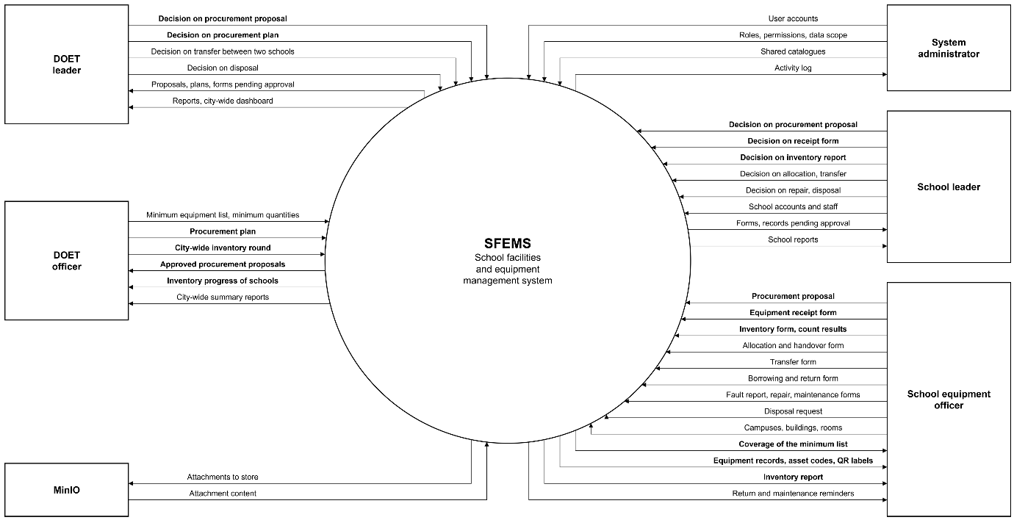
Figure 1: Context diagram of SFEMS
The table below lists the data flows in Figure 1 for each external actor.
External actor | Data into SFEMS | Data out of SFEMS
System administrator | User accounts; roles, access permissions and data scope; shared catalogues | Activity log
DOET leader | Approval decisions on procurement proposals; approval decisions on procurement plans; approval decisions on transfers between two schools; approval decisions on disposal | Proposals, plans and forms pending approval; city-wide reports and dashboard
DOET officer | Minimum equipment list and minimum quantities; procurement plans; city-wide inventory rounds | Approved procurement proposals; inventory progress of the schools; city-wide summary reports
School leader | Approval decisions on procurement proposals, receipt forms and inventory reports; approval decisions on allocation, transfer, repair and disposal; accounts and staff of the school | Forms and reports pending approval; reports of the school
School equipment officer | Procurement proposals; equipment receipt forms; inventory forms and count results; allocation and handover forms; transfer forms; borrowing and return forms; fault report, repair and maintenance forms; disposal requests; campuses, buildings, rooms | Coverage of the minimum list; equipment records, asset codes, QR labels; inventory reports; reminders of return dates and maintenance dates
MinIO (file storage) | Attachment content when a user opens a file | Attachments to be stored

2. Main Business Flow
The tender documents (HSMT Part 2, Chapter V) describe the whole equipment life cycle. The project specifies and builds this work for the DOET and the upper-secondary schools, in seven business flows. The three focus flows follow one another and form a closed loop. The school proposes buying the equipment it lacks, and the DOET makes the procurement plan (BF-01). When the equipment arrives, the school creates a receipt form; when the form is approved, the asset is registered (BF-02). When the time comes, the school runs an inventory of that same asset register (BF-03). The other four flows follow the equipment while it is in use: allocation and handover (BF-04), transfer between two schools (BF-05), fault report and repair (BF-06), and disposal and asset write-off (BF-07). Borrowing and return is daily work with no approval step, so it is not drawn as a separate flow.
The HSMT mentions only the DOET and the education units, and does not state who approves what. Within the project scope, every school is an upper-secondary school managed directly by the DOET, so the approval chain has only two levels: the school leader and the DOET leader. The approval steps below are proposed by the team and agreed with the supervisor. The following table sums up who creates and who approves each type of form.
Form | Who creates and submits | School-level approval | DOET-level approval | Who follows up
Procurement proposal | School equipment officer | School leader | DOET leader | DOET officer: views it to put it into a plan
Procurement plan | DOET officer | None | DOET leader | School: sees the plan name and plan status on its own proposal
Receipt form (asset registration) | School equipment officer | School leader | None | DOET officer: views it in lists and reports
Inventory round | DOET officer starts it | None | None | DOET leader and the schools: view the progress
Inventory form (inventory report) | School equipment officer | School leader | None | DOET officer: follows the progress of the round
Allocation and handover form | School equipment officer | School leader | None | None
Transfer form within a school | School equipment officer | School leader | None | None
Transfer form between two schools | School equipment officer of the sending school | School leader of the sending school | DOET leader | School equipment officer of the receiving school: confirms receipt
Borrowing and return form | School equipment officer (records for the teacher) | None | None | School leader: views overdue borrowed equipment
Repair form | School equipment officer | School leader, for an outside repair that has a cost | None | DOET officer: looks up the repair history
Disposal request | School equipment officer | School leader | DOET leader | None

Each approval step has three results: Approve – the form moves on; Return – the form goes back to Draft so that its creator can edit it and submit it again, and the form number stays the same; Reject – the form stops for good, and the equipment data stays unchanged. A procurement plan has only Approve and Return. Diagrams BF-01 to BF-07 are UML activity diagrams with swimlanes. Each lane is an actor or the system. The black dot is the start point, ◉ is the end, and ⊗ is the end of one branch. A diamond is a decision node; it has one incoming line, and each outgoing line shows its condition in [ ].

2.1 Procurement Needs and Planning (BF-01)
Basis and rules: HSMT 3.5.7 (summing up the needs of each unit, by area and by school level; rating priority), 2.2.4 (making investment and procurement plans). A school's proposal goes through two approval steps: the school leader, then the DOET leader. An approved proposal stays in the Approved state until a DOET officer puts it into a procurement plan; a proposal can be in one plan at most. When the DOET leader approves the plan, the system moves every proposal in the plan to Completed. A plan does not create receipt forms by itself: when the goods arrive, the school creates a draft receipt form from the completed proposal, once for each proposal.
Trigger: It is time to prepare the needs for the budget year, or the school finds that it has less equipment than the minimum quantity.
End condition: The plan is approved, the proposals in the plan are completed, and the school has created a draft receipt form when the goods arrive; or the proposal is rejected at one level and stops at that level.
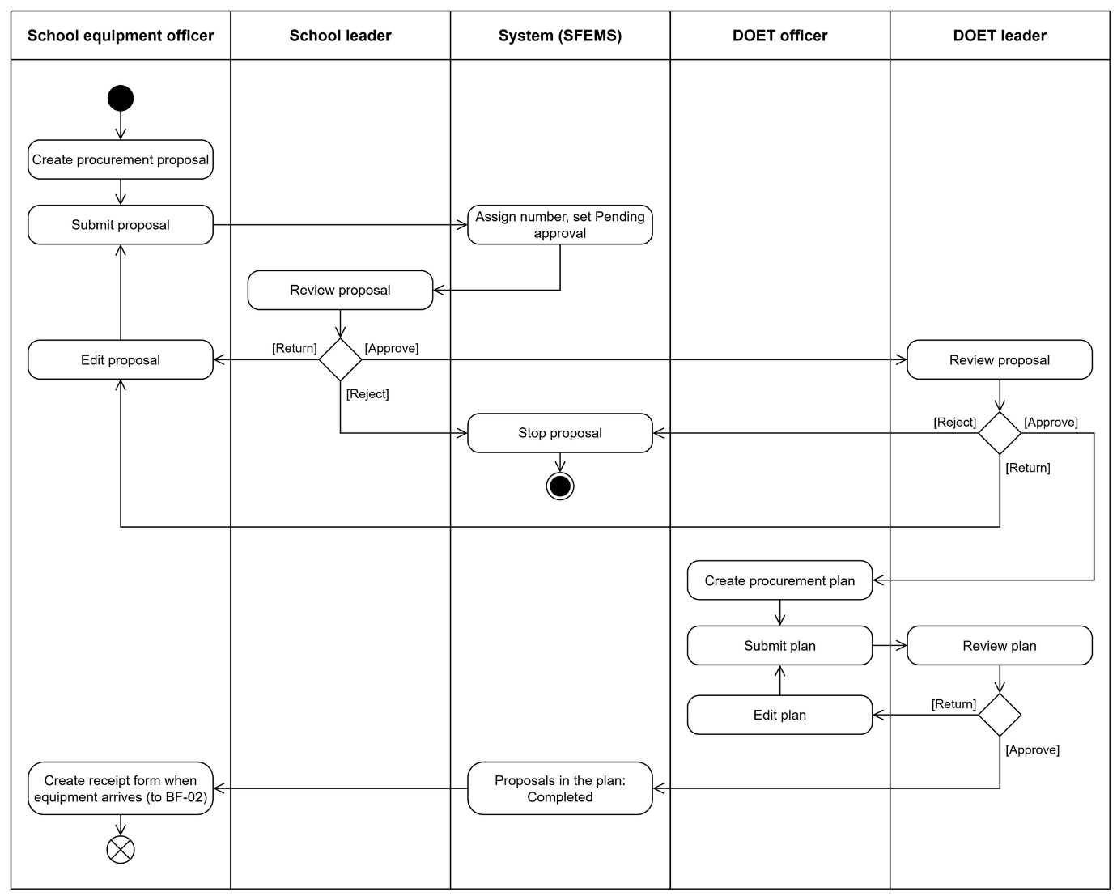
Figure 2: BF-01 Procurement needs and planning

2.2 Equipment Receipt and Asset Registration (BF-02)
Basis and rules: HSMT 3.5.3 (records, origin, original cost), 3.5.4 (asset code). The school equipment officer creates a receipt form when equipment arrives at the school. The form can be created from a completed procurement proposal (BF-01) or from surplus assets found in an inventory (BF-03). The form is approved at school level only. When the school leader approves it, the system registers the assets and gives them codes: for equipment managed per item, each item gets one record and one code; for supplies managed by quantity, there is one record that holds the quantity. The equipment is placed in the receiving room written on the form; if that field is empty, the equipment is in storage. A completed form cannot be edited or cancelled.
Trigger: Equipment arrives at the school, either bought under the plan, granted or donated; or an inventory finds surplus assets.
End condition: The form is approved and the equipment is in the asset register with an asset code; or the form is rejected and no asset is created.
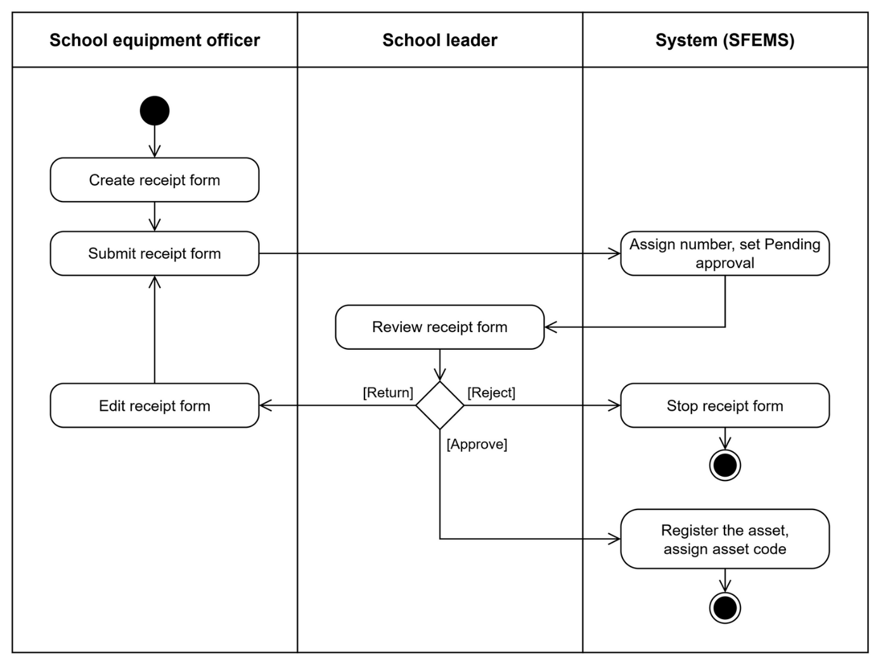
Figure 3: BF-02 Equipment receipt and asset registration

2.3 Inventory (BF-03)
Basis and rules: HSMT 3.5.5 (plan, round, comparison, discrepancy, report). A DOET officer starts an inventory round for the schools; a round has no approval step. A school creates an inventory form for a round or on its own, for the whole school or for one room. On saving, the system fixes the count sheet from the asset register, and the count sheet does not change with the register after that. The count is entered by hand on the count sheet: whether the item is found, in which room it is found, and what condition it is in. The system works out the discrepancies by itself. Every line must be counted before the form can be submitted. When the school leader approves the report, the system records the inventory history for each asset, marks missing assets as Reported lost and damaged assets as Damaged, and creates a draft receipt form for surplus assets.
The remaining discrepancies are handled in the matching flow: damaged assets go to fault report and repair (BF-06), missing assets go to disposal and asset write-off (BF-07), and assets in the wrong location are corrected with a transfer form within the school. The DOET leader does not approve the school's report but follows the progress of the round.
Trigger: A DOET officer starts an inventory round; or the school creates an inventory form on its own.
End condition: The inventory report is approved by the school leader and completed; or the report is rejected and the asset register stays unchanged.
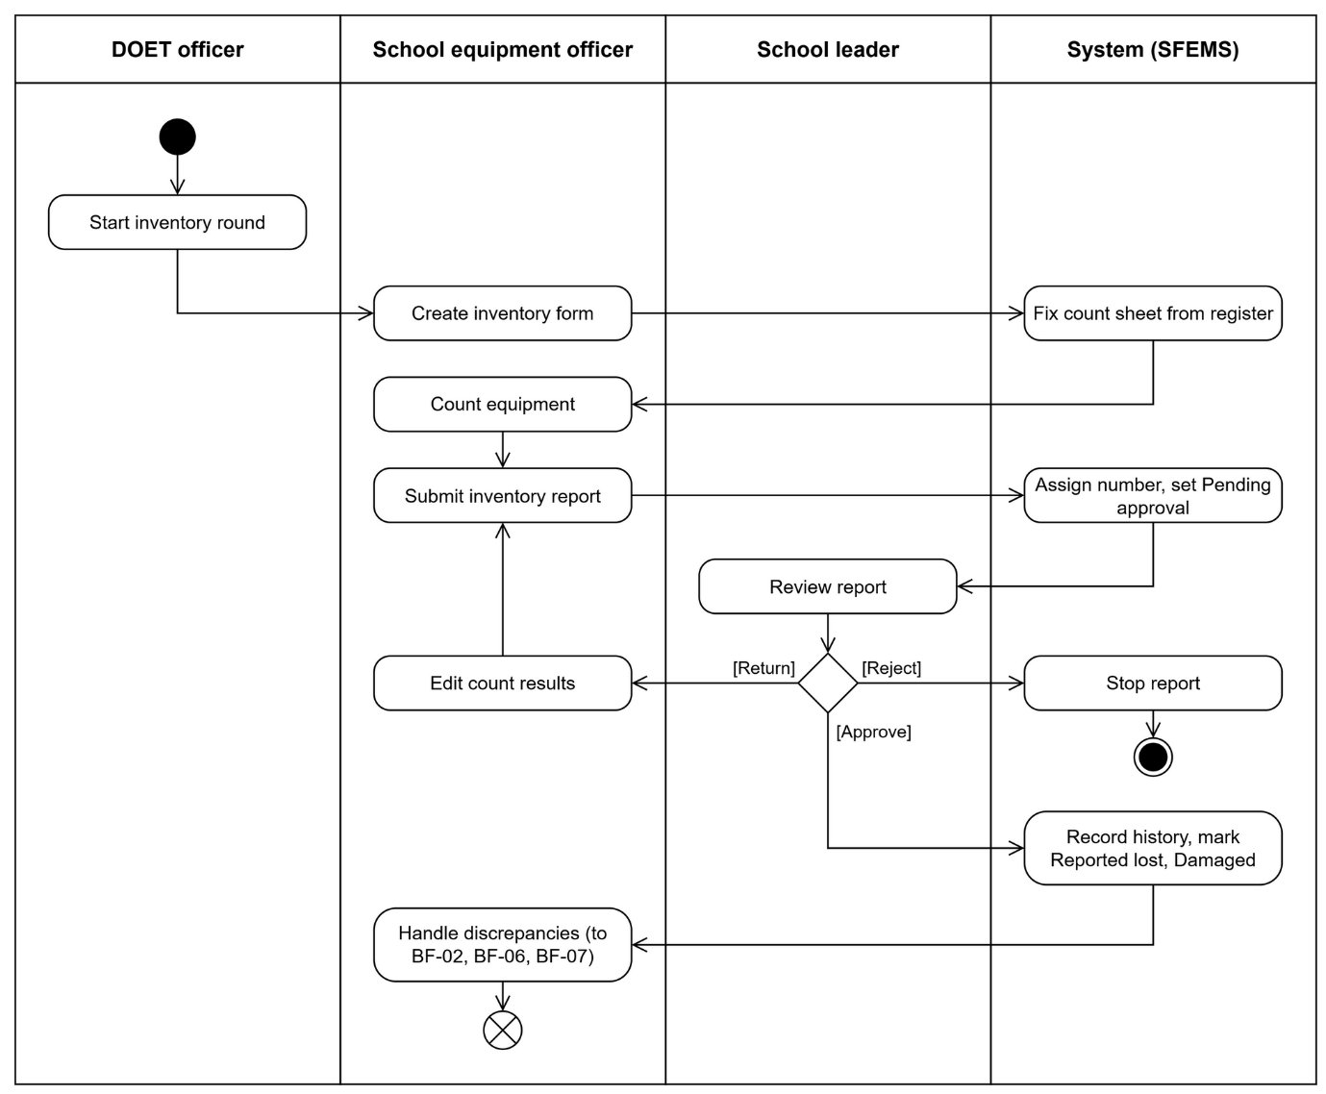
Figure 4: BF-03 Inventory

2.4 Allocation and Handover (BF-04)
Basis and rules: HSMT 3.5.3 (managing handover and allocation). The school equipment officer creates an allocation form for equipment that is in storage, and enters the receiving room or the receiving person. The school leader approves the form. After the form is approved, the school equipment officer hands over the equipment and confirms this in the system; only then does the system change the room and the holder of the equipment and record the history. Teachers have no account, so they sign for receipt on the handover record printed from the system.
Trigger: A room, a staff member or a teacher needs equipment that is in storage.
End condition: The equipment has been handed over to the room or the holder and the history is recorded; or the form is rejected and the equipment stays in storage.
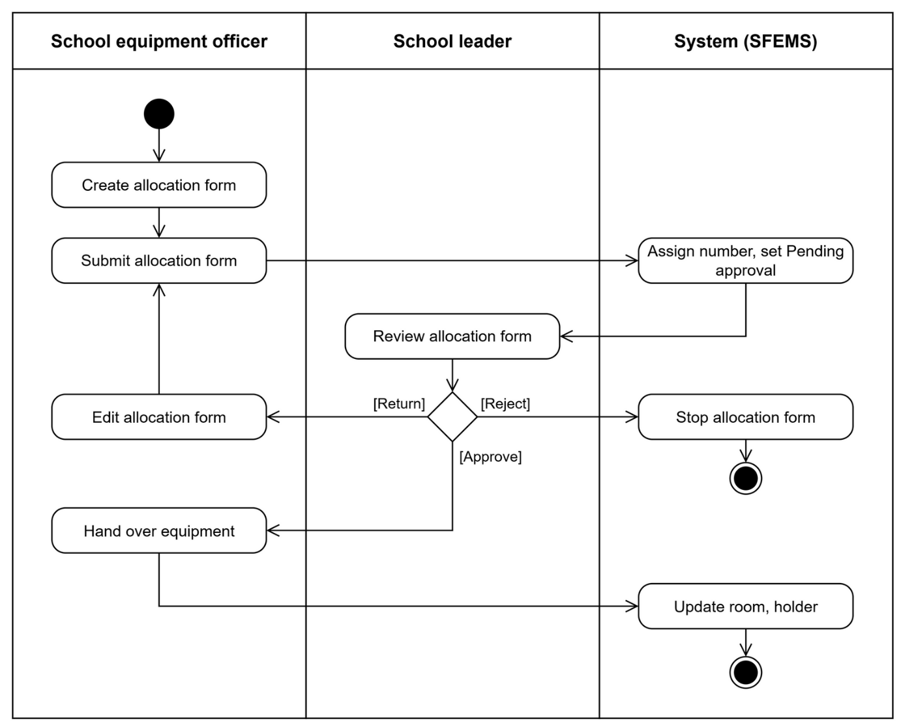
Figure 5: BF-04 Allocation and handover

2.5 Transfer between Two Schools (BF-05)
Basis and rules: HSMT 3.5.3 (managing handover, transfer and recall). A transfer form between two upper-secondary schools is approved first by the school leader of the sending school and then by the DOET leader. If either approval step rejects the form, the form stops and the equipment stays at the sending school. After the DOET approves, the receiving school checks the equipment. If items are missing or the condition is wrong, the form goes back to the sending school to fix this; at that point no asset write-off or asset registration is made. When the receiving school confirms, the system writes off the asset at the sending school and registers it at the receiving school in one transaction, and keeps the asset code and the history. A transfer within one school needs only the school leader's approval, so it is not drawn as a separate diagram.
Trigger: There is a decision to move equipment from one school to another.
End condition: The receiving school confirms that it has received everything, the sending side writes off the asset and the receiving side registers it; or the form is rejected and the equipment stays at the sending school.
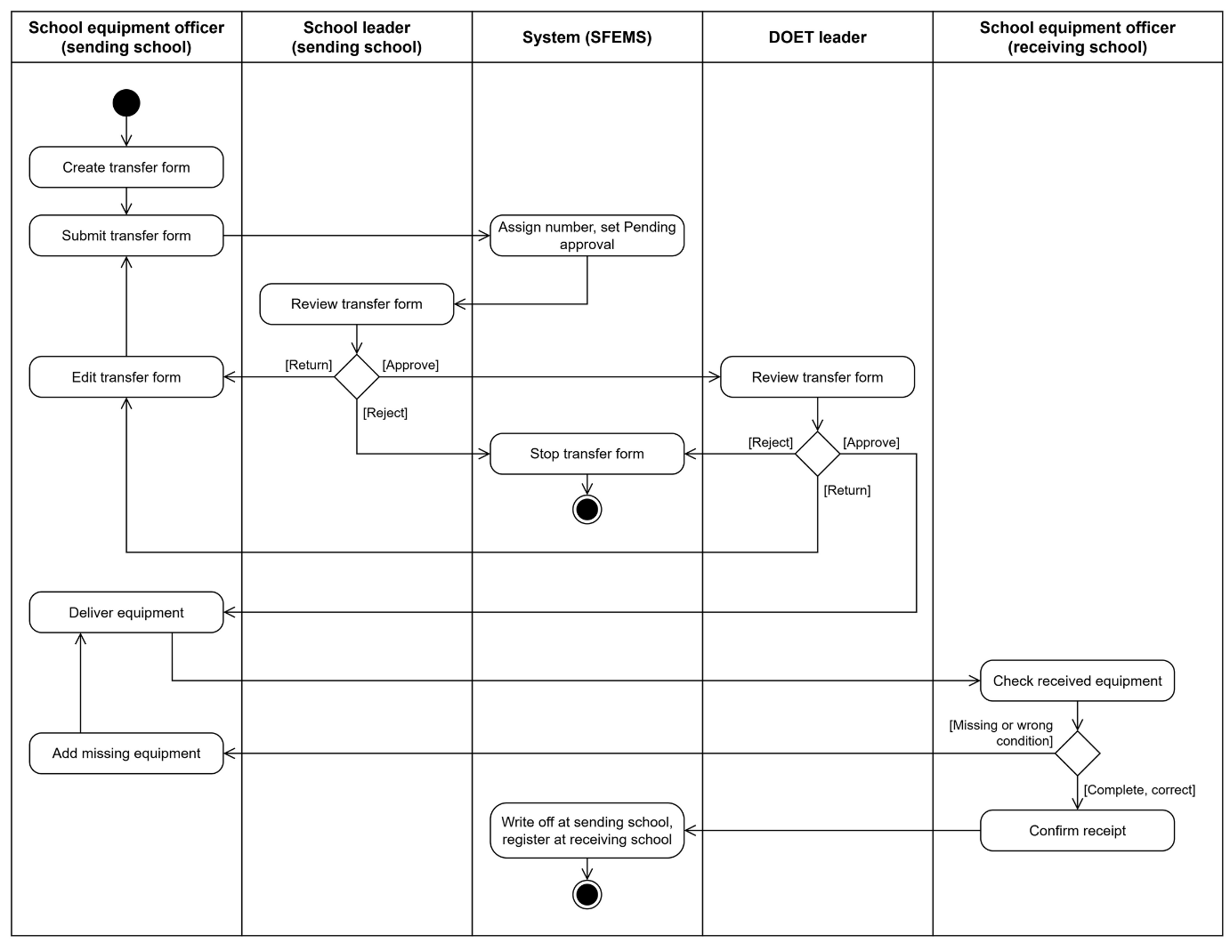
Figure 6: BF-05 Equipment transfer between two schools

2.6 Fault Report and Repair (BF-06)
Basis and rules: HSMT 3.5.6 (receiving repair requests, cost, result). The school equipment officer records a fault report for a teacher or after finding the fault personally; the equipment changes to the Damaged condition and stays in the register. There are four ways to handle it. Repair by the school at no cost and sending the item for warranty need no approval. For an outside repair that has a cost, the officer creates a repair form and submits it to the school leader for approval. If the item cannot be repaired, the officer creates a disposal request (BF-07). After the repair, the school equipment officer records the result: if the repair is done, the equipment returns to use; if it cannot be repaired, it moves to a disposal request. The regular maintenance plan and the reminders of maintenance due dates are described in use cases BH-06 and BH-07.
Trigger: A teacher or a staff member finds damaged equipment; borrowed equipment is returned damaged; or an inventory records damaged equipment (BF-03).
End condition: The equipment has been repaired and returns to use; or it is judged impossible to repair and moves to a disposal request (BF-07); or the repair form is rejected and the equipment keeps the Damaged condition.
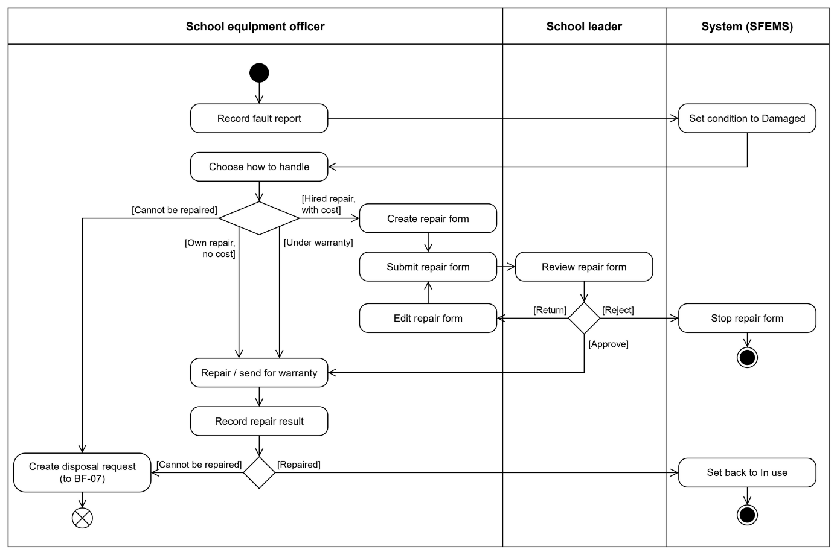
Figure 7: BF-06 Fault report and repair

2.7 Disposal and Asset Write-off (BF-07)
Basis and rules: HSMT 3.5.3 (disposal status), 2.2.2 (life cycle up to disposal). The school equipment officer creates a disposal request for equipment that has passed its useful life, is damaged and cannot be repaired, or is lost. The request goes through two approval steps: the school leader, then the DOET leader. The asset is written off only after the DOET leader has approved. The system takes the equipment out of the school's asset register but keeps its record and history. The disposal record is printed from the system for signing.
Trigger: Equipment has passed its useful life, cannot be repaired (BF-06), is lost (BF-03) or is no longer needed.
End condition: The request is approved by the DOET leader and the asset has been written off; or the request is rejected and the asset returns to its earlier condition.
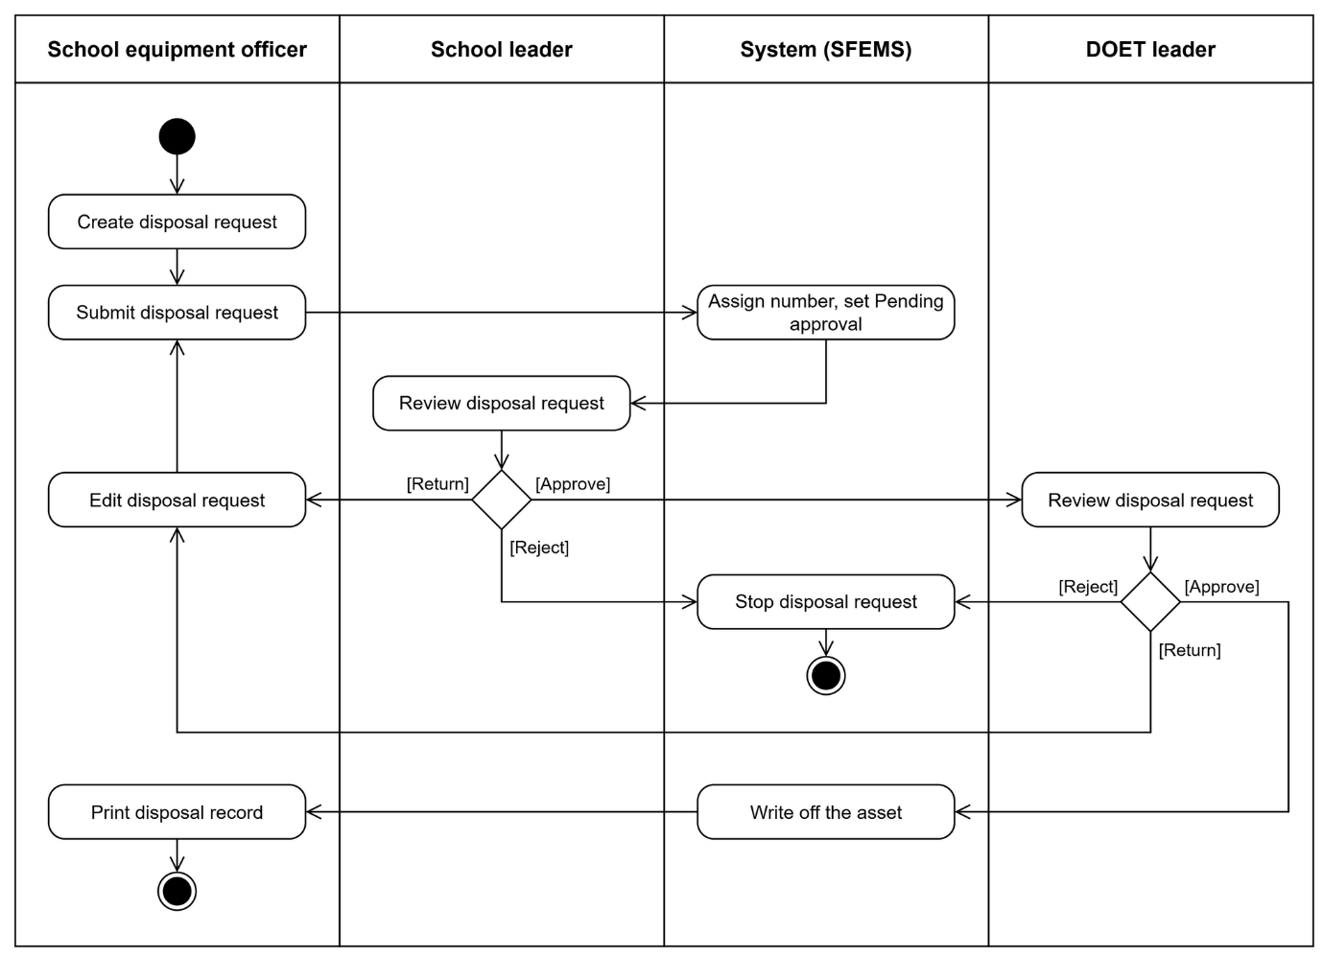
Figure 8: BF-07 Disposal and asset write-off

2.8 Form Life Cycle
Procurement proposals, receipt forms, inventory forms, allocation forms, transfer forms, repair forms and disposal requests share one life cycle. They differ only in the number of approval steps (see the table at the start of Section 2). Figure 9 is a UML state diagram: each rounded box is a state, each arrow label is an event, and conditions are written in [ ]. The form number is given at the first submission and stays the same when the form is returned. Only a draft form can be edited. A form that has been submitted before cannot be deleted, only cancelled. A procurement plan has its own, shorter life cycle: Draft → Pending approval → Approved, and it goes back to Draft when returned. An inventory round has no approval life cycle; it has only two states, Open and Closed.
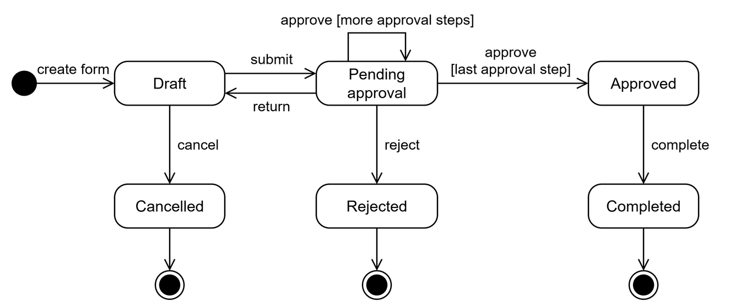
Figure 9: State life cycle of a form

2.9 Equipment Status Life Cycle
The seven business flows above all act on one object, the equipment. Figure 10 shows the statuses of an item from asset registration to asset write-off, as a UML state diagram. Each arrow label shows the event and the business flow that cause the status change. An item changes status only when the matching form is approved or confirmed; the status is not edited by hand. A transfer between two schools (BF-05) does not change the status but changes the managing school, so it is not drawn in the figure. Equipment in storage that has passed its useful life is also disposed of under BF-07, like equipment in use. Damaged is a condition of the equipment, recorded in a fault report or an inventory, and is not a separate status.
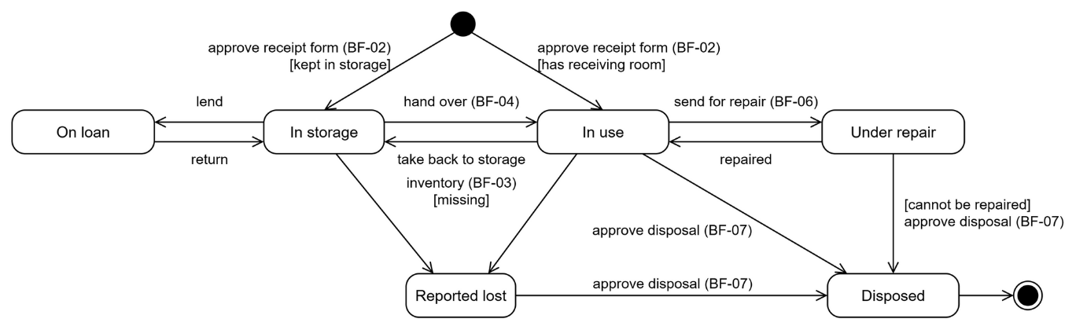
Figure 10: Status life cycle of equipment

3. Conceptual Data Model

3.1 Entity Relationship Diagram
Figure 11 is the conceptual data model of the part within scope, drawn in crow's foot notation. The label on each line is a business verb, read from the "one" side to the "many" side. To keep the figure easy to read, some relationships are not drawn and are stated in Section 3.2: every form, staff member, campus, room and item belongs to one school; proposal lines and inventory lines refer to the equipment list and to equipment; approval logs and attachments can be linked to many types of record, not only to receipt forms.
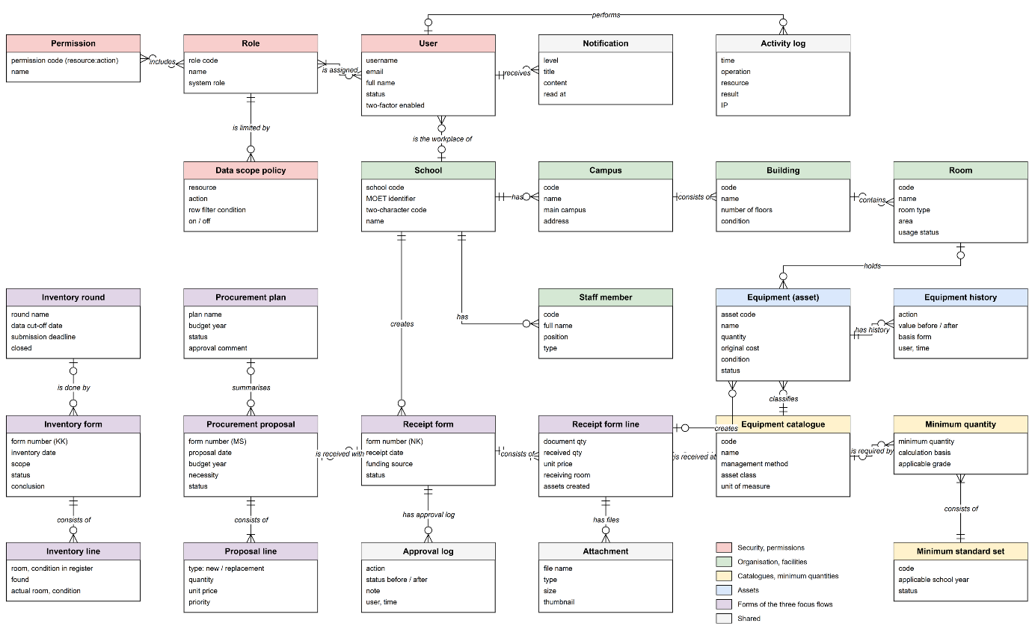
Figure 11: Conceptual data model (ERD)

3.2 Entity Descriptions
Each entity is described by its purpose, main business attributes, business identifier and states.
Entity: User
Purpose | The sign-in account of a staff member of the DOET or of a school.
Main business attributes | User name, email, full name, status, working unit (the DOET or a school), roles, whether two-factor authentication is on, last sign-in.
Business identifier | The user name is unique in the whole system; the email is unique in the whole system (not case-sensitive).
State / life cycle | Active · Inactive · Locked. Only an active account can sign in; the system administrator changes the status by hand.

Entity: Role, Permission and Data scope policy
Purpose | A role groups function permissions; a data scope policy defines which rows of a resource the role can reach.
Main business attributes | Role: code, name, description, whether it is a system role. Permission: a code in the form resource:action (view, write, delete, approve, export). Policy: resource, action, row filter condition, on or off.
Business identifier | The role code is unique; the permission code is unique.
State / life cycle | A system role cannot change its code and cannot be deleted. A policy that is no longer valid is isolated by the system automatically, so it does not break the application.

Entity: School
Purpose | An upper-secondary school; it owns all facilities data, equipment data and forms.
Main business attributes | School code, MOET identifier code, two-character code (a part of the asset code), name, ward or commune, number of classes, number of students.
Business identifier | The school code is unique; the MOET identifier code is unique.
State / life cycle | Active · Inactive.

Entity: Staff member
Purpose | A staff member or teacher of the school; this person can be in charge of a room, can manage equipment and can be given an account.
Main business attributes | Code, full name, type (teacher, staff), position, subject taught, phone, email, account.
Business identifier | The code is unique within the school; each staff member has at most one account.
State / life cycle | In use · No longer in use.

Entity: Campus, Building, Room
Purpose | The facilities of the school in three levels. A room is where equipment is placed, where the goods of a receipt form are received, and the scope of an inventory form.
Main business attributes | Campus: code, name, address, whether it is the main campus. Building: code, name, number of floors, year built, area, condition. Room: code, name, room type, floor, area, capacity, condition, usage, staff member in charge.
Business identifier | The code is unique within the school; each school has exactly one main campus. A room with the type Storage is treated as a storage.
State / life cycle | Condition: Good · Normal · Needs repair · Run-down · Badly damaged. Room usage: In use · Vacant · Under repair · Out of use.

Entity: Equipment catalogue item
Purpose | One type of equipment in the shared catalogues; it is different from each specific asset of a school.
Main business attributes | Code, name, subject, unit of measure, management method (per item or by quantity), asset class, whether it belongs to the minimum list, owning school (for equipment outside the list that a school adds by itself).
Business identifier | The code is unique in the whole system. Equipment outside the list must not have the same name as an item in the DOET list.
State / life cycle | In use · No longer in use.

Entity: Minimum standard set and Equipment minimum quantity
Purpose | The minimum teaching-equipment list for the upper-secondary level under MOET Circular 39/2021; each minimum quantity line says how many items a school must have.
Main business attributes | Set: code, version, school year of application, basis document. Minimum quantity: equipment in the catalogue, minimum quantity, calculation basis (per class, school, student, teacher, room), grade it applies to, optional or required.
Business identifier | Only one set is in effect at a time.
State / life cycle | Draft → In force → Expired. Only a draft can be edited.

Entity: Equipment (asset)
Purpose | One record in the asset register of the school: for equipment managed per item, each item has one record; for supplies managed by quantity, one record holds the quantity.
Main business attributes | Asset code, name, equipment in the catalogue, serial number, quantity, unit of measure, funding source, date received, original cost, remaining value, warranty end date, room, manager, condition, status, old code.
Business identifier | The asset code is unique within the school and follows the standard form TT.TR.MH.LT.ST.NC.
State / life cycle | In storage · In use · On loan · Under repair · Reported lost (after an inventory) · Disposed (Figure 10). Condition: Good · Fair · Average · Poor · Damaged · Not in use. The code, room, quantity, status and condition change only through a form.

Entity: Equipment history
Purpose | One line for each change of an item; it is the basis for tracing who changed what, and under which form.
Main business attributes | Action (asset registration, update, inventory…), changed field, values before and after, basis form, person who did it, time.
Business identifier | No business identifier.
State / life cycle | Lines are only added; they are not edited or deleted.

Entity: Procurement proposal and Proposal line
Purpose | The need of a school to buy equipment for one budget year.
Main business attributes | Form number, proposal date, budget year, funding source, justification, the plan that contains it, the receipt form already created. Line: equipment, new purchase or replacement, quantity, unit price, priority level, the quantity the school has and the quantity required by the minimum quantity at the time of saving.
Business identifier | The form number is MS-year-sequence number, unique within the school. An equipment type appears only once in a proposal.
State / life cycle | Draft → Pending approval (school, then the DOET) → Approved → Completed; Rejected; Cancelled.

Entity: Procurement plan
Purpose | The set of approved proposals that the DOET decides to buy in one budget year.
Main business attributes | Plan name, budget year, note, approval time and approver, approval comment.
Business identifier | No form number.
State / life cycle | Draft → Pending approval → Approved; when returned, it goes back to Draft.

Entity: Receipt form and Receipt form line
Purpose | The form that records the equipment a school receives; it is the basis for asset registration.
Main business attributes | Form number, receipt date, deliverer, funding source, supplier. Line: equipment, quantity on the document, quantity actually received, reason for the discrepancy, unit price, receiving room, invoice number, warranty, reason for the increase, number of assets created.
Business identifier | The form number is NK-year-sequence number, unique within the school.
State / life cycle | Draft → Pending approval → Completed (approval and asset registration in one transaction); Rejected; Cancelled.

Entity: Inventory round
Purpose | An inventory round that the DOET starts for the schools.
Main business attributes | Round name, data cut-off date, deadline for submitting the report, instructions, whether it is closed.
Business identifier | No two open rounds have the same data cut-off date.
State / life cycle | Open · Overdue (calculated) · Closed. There is no approval step.

Entity: Inventory form and Inventory line
Purpose | The inventory report of a school, for the whole school or for one room.
Main business attributes | Form number, name, inventory date, round, room, inventory team, conclusion. Line: equipment, room and condition in the register, whether it was found or not, actual room and condition. It comes with a list of surplus assets: equipment, quantity, room.
Business identifier | The form number is KK-year-sequence number, unique within the school.
State / life cycle | Draft (count in progress) → Pending approval → Completed; Rejected; Cancelled. Calculated discrepancy: Missing · Wrong location · Damaged · Surplus.

Entity: Approval log
Purpose | One line for each time a form changes its state.
Main business attributes | Form type and form code, action, states before and after, approval step, note, person who did it, time.
Business identifier | None.
State / life cycle | Lines are only added; they are not edited or deleted.

Entity: Attachment
Purpose | A file attached to a record: equipment, receipt form, receipt form line, procurement proposal, inventory form, school, basis document.
Main business attributes | Parent record, file name, type, size, object key in the file storage, whether it is the main image.
Business identifier | Each record has at most one main image.
State / life cycle | The permission to view, add and delete files follows the permission on the parent record.

Entity: Notification and Activity log
Purpose | A notification is sent to one user; the activity log records every write action and every data export.
Main business attributes | Notification: recipient, level, title, content, link, time read. Log: time, person who did it, action, resource, result, IP address.
Business identifier | None.
State / life cycle | Notification: unread → read. Log: lines are only added.

3.3 Data Business Rules
These are the data rules that cannot be read directly from the diagram. The last column says when the system checks the rule.
Code | Rule | Description | Checked when
DR-01 | User name and email are unique | No two accounts have the same user name or the same email; the check is not case-sensitive. | Create or edit an account
DR-02 | There is always one system administrator | The role of the last active system administrator cannot be removed, and this account cannot be locked or deleted; a user cannot delete the account that he or she is signed in with. | Change a role or status, delete an account
DR-03 | Codes within a school and shared codes | The codes of staff members, campuses, buildings, rooms and assets are unique within each school; the codes of shared catalogues are unique in the whole system. | Create, edit
DR-04 | The school of a record cannot be changed | A record or a form created for one school cannot be moved to another school. | Edit
DR-05 | One main campus | Each school has exactly one main campus; when a new main campus is chosen, the old one loses the mark automatically. | Create or edit a campus
DR-06 | Data of the same school | The campus, building and staff member in charge of a room; the room and manager of an item; the receiving room on a receipt form; the room where an item is found during an inventory – all of these must belong to the same school. | Create, edit, count
DR-07 | Management method follows the asset class | Only supplies and chemicals can be managed by quantity; equipment must be managed per item, and each item has its own code. | Create or edit an equipment catalogue item
DR-08 | One standard set in effect | Only one minimum standard set is in effect; only a draft can be edited; when a draft is put into effect, the old set expires. | Edit a standard set, put it into effect
DR-09 | Standard asset code | The code has the form TT.TR.MH.LT.ST.NC: province code, two-character school code, subject code, type (TB, PM, HL), three-digit sequence number, last two digits of the year. The system gives the code from the counter of the school; nobody types it by hand. | Approve a receipt form, give a standard code, enter opening balances
DR-10 | Limit of a code set | Each code set (school, subject, type, year) holds at most 999 assets. If the two-character school code or the subject code is missing, the system refuses and does not give a temporary code. | Submit and approve a receipt form
DR-11 | The record changes only through a form | The code, room, manager, quantity, status, condition and remaining value of an item cannot be edited directly on the record; the one exception is the first placement, when the item has no room yet. | Edit an equipment record
DR-12 | An asset in the register cannot be deleted | An item that is in the asset register cannot be deleted. | Delete an item
DR-13 | Only a draft form can be edited | A submitted form must be returned before it can be edited; a form that is approved, completed, rejected or cancelled stays unchanged. | Edit a form, record count results
DR-14 | The form number is given at submission | The form number has the form prefix-year-sequence number (MS, NK, KK) and is numbered separately by school, form type and year; it is given at the first submission and stays the same when the form is returned. | Submit
DR-15 | Approval at the right level | Only an account of the level that the form is waiting for can approve, return or reject it: at the school step, it is an account of that same school; at the DOET step, it is an account of the DOET. | Approve, return, reject
DR-16 | Return and rejection need a reason | The approver must write what needs to be fixed when returning a form, and must write the reason when rejecting it. | Return, reject
DR-17 | Delete and cancel a form | Only a draft form that has never been submitted can be deleted; a form that already has a number can only be cancelled. A proposal that is in a plan cannot be cancelled. | Delete, cancel
DR-18 | Procurement proposal | Each equipment type has one line; the quantity is greater than 0; the priority level is from 1 to 3; at submission the proposal must have at least one line and a justification. | Save, submit
DR-19 | A plan accepts only valid proposals | A proposal must be approved and must not be in another plan. A plan must have at least one proposal before it can be submitted. | Select proposals, submit a plan
DR-20 | A proposal is completed through its plan | A proposal cannot be completed by hand; it is completed only when the plan that contains it is approved. One receipt form can be created from each completed proposal. | Approve a plan, create a receipt form
DR-21 | A quantity discrepancy needs a reason | If the quantity actually received is different from the quantity on the document, the receipt form line must give the reason for the discrepancy. | Save, submit, approve a receipt form
DR-22 | Enough data to create assets | A line for equipment managed per item must have a funding source and a unit price, and the equipment in the catalogue must have a unit of measure; the form must have a deliverer, and each line must have a reason for the increase. | Submit and approve a receipt form
DR-23 | Asset registration in one transaction | Approving a receipt form creates the assets, gives the codes, writes the history and locks the form at the same time; if any step fails, no change is kept. | Approve a receipt form
DR-24 | Inventory round | Only an account of the DOET can start and edit an inventory round; the submission deadline is not before the data cut-off date; a round cannot be deleted once a school has created a form in it. | Create, edit, delete a round
DR-25 | The count sheet is fixed when the form is created | An inventory form takes all assets that are still in the register of the school or of the room at the time of creation, together with the room and condition in the register; the count sheet does not change with the register after that. | Create an inventory form
DR-26 | Count everything before submitting | Every line of the count sheet must be marked as found or not found before the report is submitted. | Submit the report
DR-27 | Files follow the permission on the parent record | Viewing a file needs the view permission on the parent record; adding or deleting a file needs the write permission. Each file is at most 10 MB and is one of these types: PDF, image, office document, CSV, ZIP. | Upload, open, delete a file
DR-28 | No scope means nothing is visible | An account with no data scope policy on a resource sees no rows of that resource. | Every query

4. User Requirements

4.1 Actors
The system has five human actors, and each actor matches one predefined role. Roles are data: the system administrator can edit the permissions and the data scope of each role without changing the source code. There is also one non-human actor, the file storage. Teachers are not actors in this version.
# | Actor | Description
1 | System administrator | An information technology officer of the DOET. Creates accounts, assigns roles, defines the function permissions and data scope of each role, manages the shared catalogues and the coding rule, and looks up the activity log. Does not do equipment work; sees the data of all schools.
2 | DOET leader | The Director and Deputy Directors of the DOET. Views the figures of the whole city; approves the procurement proposals of upper-secondary schools and the procurement plan of the DOET; approves equipment transfers between two schools and disposal requests; follows the progress of inventory.
3 | DOET officer | The officer in charge of facilities and equipment at the DOET. Manages the equipment catalogue, the minimum teaching-equipment list and the minimum quantities; manages school records; creates the procurement plan of the DOET; starts a city-wide inventory round and follows its progress; looks up the repair and maintenance history of the schools. Has read-only access to the data of the schools.
4 | School leader | The principal, or a vice principal who is authorised, who is also the contact point of the school. Approves, returns or rejects the forms of the school: procurement proposals, receipt forms, inventory reports, allocation forms, transfer forms, repair forms and disposal requests; manages the accounts, staff members and facilities of the school. Sees only the data of their own school.
5 | School equipment officer | The equipment and facilities officer of the school, who uses the system every day. Creates and submits procurement proposals, receipt forms, inventory forms, allocation forms, transfer forms, repair forms and disposal requests; records count results; records borrowing and return and fault reports on behalf of teachers; manages equipment records and prints QR labels; enters campuses, buildings and rooms. Sees only the data of their own school.
6 | MinIO (file storage) | An external system that stores the content of attachments using the S3 protocol. SFEMS sends a file to it when a user uploads the file, and reads the file back when a user opens it; users do not access the storage directly.

4.2 Use Cases (UC)
The project scope has 84 use cases in 14 function groups. Of these, 22 use cases are on the three focus flows (groups NC, PN, KK) and are specified in detail in Part II.
Code | Use case | Actor | Description
System, accounts and permissions (HT)
HT-01 | Sign in | All five actors | The user is authenticated by user name or email and a password, and also enters a 6-digit code if the account has two-factor authentication on. The system gives a work session and loads the permissions of the account.
HT-02 | Sign out | All five actors | Ends the work session and revokes the refresh token that the session holds.
HT-03 | Change own password | All five actors | The user changes their own password following the password policy; all other sessions of the account are ended.
HT-04 | Set up two-factor authentication | All five actors | The user turns two-factor authentication on or off by themselves, using an authenticator app on the phone (6-digit TOTP code).
HT-05 | Manage user accounts | System administrator | Create, edit, lock and unlock accounts; link an account to the DOET or to a school; assign roles; reset the password and the two-factor authentication of other users.
HT-06 | Manage the accounts of the school | School leader | The school leader gives, locks and resets the password of accounts that belong to their own school, only with school-side roles; gives accounts to the staff members of the school.
HT-07 | Manage roles and function permissions | System administrator | Create, edit and delete roles; select the permission codes (view, write, delete, approve, export) of each resource for a role.
HT-08 | Manage the data scope of roles | System administrator | Define the row filter condition for each role: own school or the whole city.
HT-09 | Look up the activity log | System administrator | View the write actions and data exports: who, when, on which data, with what result, and from which IP address.
HT-10 | Receive and manage notifications | All five actors | View notifications on the bell and in the list, mark them as read, delete them; a new notification appears at once while the application is open.
Shared catalogues and data (DM)
DM-01 | Manage shared catalogues | System administrator, DOET officer | Add, edit and retire the base catalogues: wards and communes, school years, semesters, grades, subjects, room types, equipment types, units of measure, asset sources, procurement methods, reasons for change.
DM-02 | Manage the equipment catalogue | System administrator, DOET officer | Add and edit equipment in the shared catalogue: subject, unit of measure, how it is managed (per item or by quantity), asset class.
DM-03 | Manage the minimum teaching-equipment list and minimum quantities | DOET officer, System administrator | Manage the standard set for the upper-secondary level, with its legal basis document and its minimum quantity lines. Create a new set when a new circular is issued, and apply the draft set in place of the set in force.
DM-04 | Manage coding rules | System administrator, DOET officer, School leader | Set the prefix and the length of the number part for the codes of the shared catalogues. The school leader sets the coding rules for the rooms, buildings, campuses and staff of their own school.
Organisation and staff (TC)
TC-01 | Manage schools | System administrator, DOET officer | Enter the school profile: code, MOET identification code, the two-character code used in asset codes, and the ward or commune where the school is located.
TC-02 | Manage school staff | School leader | List of the staff and teachers of the school: code, full name, position, subject taught. They are the people in charge of rooms and the people who manage equipment.
TC-03 | View the overview of a school | All five actors | View the DOET – school tree and the workspace of one school: facilities, staff, equipment.
Facilities (CS)
CS-01 | Manage campuses | School leader, School equipment officer | Enter the campuses of the school; each school has exactly one main campus.
CS-02 | Manage buildings | School leader, School equipment officer | Enter the buildings of each campus: number of floors, year built, area, condition, staff member in charge.
CS-03 | Manage rooms | School leader, School equipment officer | Enter classrooms, subject rooms and storage: room type, area, capacity, usage status, staff member in charge. A room is where equipment is received and is the scope of an inventory.
Equipment records and asset codes (TS)
TS-01 | Manage equipment records | School equipment officer, School leader | View the list and the record of each item; add the serial number, specifications and year of manufacture; enter existing equipment (opening balance). The code, room, quantity and status change only through a form.
TS-02 | Look up equipment by asset code | All five actors | Enter an asset code to open the equipment record directly, within the user's own data scope.
TS-03 | Scan a QR code to open an equipment record | School equipment officer, School leader | Scan the QR label with a phone camera; the link in the label opens the lookup screen with the code already filled in.
TS-04 | Print QR labels | School equipment officer | Print labels for the equipment of one receipt form, of one room, or from a search; each label shows the QR code, asset code, name, school and room.
TS-05 | Attach documents and images to equipment | School equipment officer | Attach photos, technical documents and procurement documents to the equipment record; choose the main photo.
TS-06 | View the change history of equipment | All five actors | Timeline of one item: who, when, what changed, and based on which form.
TS-07 | Assign a standard code to equipment with an old code | School equipment officer | Change equipment that still has the school's old code to the standard asset code; the old code is kept for lookup.
TS-08 | Generate equipment asset codes | System | The system assigns a unique asset code in the format TT.TR.MH.LT.ST.NC from the school's counter. It is called when a receipt form is approved and when a standard code is assigned.
TS-09 | Import initial equipment data from a file | School equipment officer | Import the school's existing equipment in bulk from a file that follows one common template; the system checks each row, reports errors and records only the valid rows.
Procurement needs and planning (NC)
NC-01 | View coverage of the minimum list | School equipment officer, School leader, DOET officer | Compare the equipment the school has with the minimum quantities of the minimum list: enough, how many are missing, how many are surplus. The DOET views a summary of all schools.
NC-02 | Create a procurement proposal | School equipment officer | Create, edit, cancel and delete a draft proposal: equipment, new purchase or replacement, quantity, unit price, priority, justification. Quickly add the missing part from the minimum quantity table.
NC-03 | Submit a procurement proposal | School equipment officer | Submit the proposal to the school leader; the system assigns a form number and locks editing while the proposal is pending approval.
NC-04 | Approve a procurement proposal at school level | School leader | The school leader confirms the need: approve, return for editing, or reject.
NC-05 | Approve a procurement proposal at DOET level | DOET leader | The DOET leader approves the proposal so that it can go into the plan, returns it or rejects it.
NC-06 | Create a procurement plan | DOET officer | Create a plan for a budget year, select the approved proposals of the schools, view the summary by equipment, and submit it to the DOET leader.
NC-07 | Approve a procurement plan | DOET leader | The DOET leader approves or returns the plan; on approval, the proposals in the plan change to Completed.
NC-08 | View the summary of procurement needs | DOET leader, DOET officer | Summary of proposals by budget year, by school and by equipment: quantity, estimated cost, approval status.
NC-09 | Create a receipt form from a completed proposal | School equipment officer | When the goods arrive, create a draft receipt form that already contains the lines of the proposal; this can be done once for each proposal.
Equipment receipt and asset registration (PN)
PN-01 | Create an equipment receipt form | School equipment officer | Create, edit, cancel and delete a draft receipt form: equipment, quantity on the documents and quantity actually received, unit price, receiving room, funding source, delivery record.
PN-02 | Add equipment outside the catalogue | School equipment officer | When the equipment received is not in the shared catalogue (made by the school, donated, or bought outside the catalogue), the school adds its own equipment so that it can be put on the form.
PN-03 | Attach documents to a receipt form | School equipment officer | Attach the delivery record for the whole form and the invoice for each line.
PN-04 | Submit a receipt form | School equipment officer | The system checks that the form has all the required data and that enough asset codes are left, assigns a form number, and moves the form to pending approval by the school leader.
PN-05 | Approve a receipt form and register the assets | School leader | The school leader approves, returns or rejects the form. On approval, the system creates the equipment records and asset codes, writes the history and locks the form in one transaction.
Inventory (KK)
KK-01 | Start an inventory round | DOET officer | Create, edit and delete an inventory round: round name, data cut-off date, deadline for sending the inventory report, instructions for the schools.
KK-02 | Track inventory progress | DOET leader, DOET officer, School leader, School equipment officer | View each school in the round: not started, counting, pending approval, or with an approved inventory report.
KK-03 | Create an inventory form | School equipment officer | Create a form for a DOET round or on the school's own initiative, with the whole school or one room as the scope; the system fixes the count sheet from the asset register.
KK-04 | Record count results | School equipment officer | For each line of the count sheet: record whether the item was found, and its actual room and condition; the system identifies items that are missing, in the wrong location or damaged.
KK-05 | Enter surplus assets | School equipment officer | Record equipment that is found in reality but is not in the register.
KK-06 | Submit the inventory report | School equipment officer | Close the count results when every line has been counted; the system assigns a form number and moves the form to pending approval by the school leader.
KK-07 | Approve the inventory report | School leader | The school leader approves, returns or rejects the report. On approval, the system writes the inventory history for each item, updates the items that were not found and the damaged items, and creates a draft receipt form for the surplus assets.
KK-08 | Print the inventory report | School equipment officer, School leader | Print the asset inventory report from the template for signing; the signed copy is attached back to the form.
Allocation and handover (CP)
CP-01 | Create an allocation and handover form | School equipment officer | Create, edit, cancel and delete a draft form: select equipment that is in storage, the receiving room or the receiving person, and the reason for allocation.
CP-02 | Submit an allocation form | School equipment officer | Submit the form to the school leader; the system assigns a form number and locks editing while the form is pending approval.
CP-03 | Approve an allocation form | School leader | The school leader approves, returns or rejects the allocation form.
CP-04 | Confirm handover | School equipment officer | After the form is approved, record the time of handover; the system changes the room and the holder of the equipment and writes the history; print the handover record.
CP-05 | Take equipment back to storage | School equipment officer | Move allocated equipment back to storage when the room or the holder no longer uses it; the system writes the history.
Transfer (DC)
DC-01 | Create a transfer form within the school | School equipment officer | Create a form to move equipment between rooms, buildings and campuses of the same school.
DC-02 | Create a transfer form between two schools | School equipment officer | The school equipment officer of the sending school creates a form to move equipment to another upper-secondary school: equipment, receiving school, reason.
DC-03 | Submit a transfer form | School equipment officer | Submit the form to the school leader; the system assigns a form number and locks editing while the form is pending approval.
DC-04 | Approve a transfer form at school level | School leader | Approve, return or reject. Form within the school: approval completes the form, and the system changes the room of the equipment. Form between two schools: the form goes up to the DOET leader.
DC-05 | Approve a transfer between two schools | DOET leader | The DOET leader approves, returns or rejects the transfer of equipment between two upper-secondary schools.
DC-06 | Confirm receipt of transferred equipment | School equipment officer | The school equipment officer of the receiving school confirms that the correct equipment has been received in full. On confirmation, the system writes off the asset at the sending school and registers the asset at the receiving school, and keeps the asset code and the history unchanged.
Borrowing and return (MT)
MT-01 | Record equipment borrowing | School equipment officer | Recorded on behalf of the teacher: borrower, equipment, purpose, return deadline. There is no approval step.
MT-02 | Record equipment return | School equipment officer | Record the time of return and the condition of the equipment on return; if the equipment is damaged or lost, create a fault report or a disposal request.
MT-03 | Track overdue borrowed equipment | School equipment officer, School leader | View the list of equipment that is overdue and not yet returned; the system sends a notification to remind the school equipment officer.
MT-04 | Look up the borrowing and return history | School equipment officer, School leader | Look up by equipment, by borrower or by time period.
Fault report, repair, maintenance (BH)
BH-01 | Record a fault report | School equipment officer | Record damaged equipment with a description and images (recorded on behalf of a teacher or found by the officer); the equipment changes to the Damaged state.
BH-02 | Create a repair form | School equipment officer | Choose how to handle it: repair in-house, send for warranty, or hire a repair service; enter the repair work, the unit that does the work, and the expected cost.
BH-03 | Submit a repair form | School equipment officer | A form for a hired repair with a cost is submitted to the school leader; forms for in-house repair and warranty do not need approval.
BH-04 | Approve a repair form | School leader | The school leader approves, returns or rejects a repair form that has a cost.
BH-05 | Record the repair result | School equipment officer | Record the work done, the actual cost and the result. If the repair is successful, the equipment goes back into use; if it cannot be repaired, it moves to a disposal request.
BH-06 | Create a periodic maintenance plan | School equipment officer | Set the maintenance cycle by equipment type or for each item.
BH-07 | Track equipment due for maintenance | School equipment officer | View the list of equipment due for maintenance; the system sends a reminder notification before the due date.
BH-08 | Look up the repair and maintenance history | School equipment officer, School leader, DOET officer | Look up by equipment, by room or by time period.
Disposal and asset write-off (TL)
TL-01 | Create a disposal request | School equipment officer | Create a request for equipment that has reached the end of its useful life, is damaged and cannot be repaired, or is lost, with the reason and supporting documents.
TL-02 | Submit a disposal request | School equipment officer | Submit the request to the school leader; the system assigns a form number and locks editing while the request is pending approval.
TL-03 | Approve a disposal request at school level | School leader | The school leader checks the request, then approves it and sends it up to the DOET, returns it or rejects it.
TL-04 | Approve disposal at DOET level | DOET leader | The DOET leader decides to allow the disposal, returns the request or rejects it. On approval, the system writes off the asset.
TL-05 | Write off the asset | System | The system removes the equipment from the school's asset register and keeps the record and the history unchanged. It is called when disposal is approved at DOET level and when receipt of a transfer between two schools is confirmed.
TL-06 | Print the disposal record | School equipment officer, School leader | Print the disposal record from the template for signing; the signed copy is attached back to the form.
Reports, statistics, dashboard (BC)
BC-01 | View the dashboard | All five actors | Key figures by management level: assets in the register, forms pending approval, coverage of the minimum list, schools that need attention.
BC-02 | View summary reports | All five actors | Asset reports by school and by equipment, coverage of the minimum list, form processing status, summary of procurement needs.
BC-03 | View the form approval log | All five actors | For each form: who submitted it, who approved, returned or rejected it, when, and with what note.
BC-04 | Export list and report data | All five actors | Export the list on screen to a CSV file, export reports to Excel, print on paper or save as PDF from the browser.

4.3 Use Case Diagrams
This section presents the use case diagrams for each actor. Drawing conventions: an actor is connected by a solid line to each of its use cases. Use cases in the same function group are placed next to each other, with a gap between two groups. A use case that the system performs by itself is called through <<include>> from the use case that triggers it. The use cases that all five actors use are drawn only once, in Figure 14.

4.3.1 Use Case Overview
The overview diagram is drawn as two figures: Figure 12 for the actors on the DOET side and Figure 13 for the actors on the school side. Each use case in the diagram stands for one function group; an actor is connected to a group when it performs at least one use case in that group.
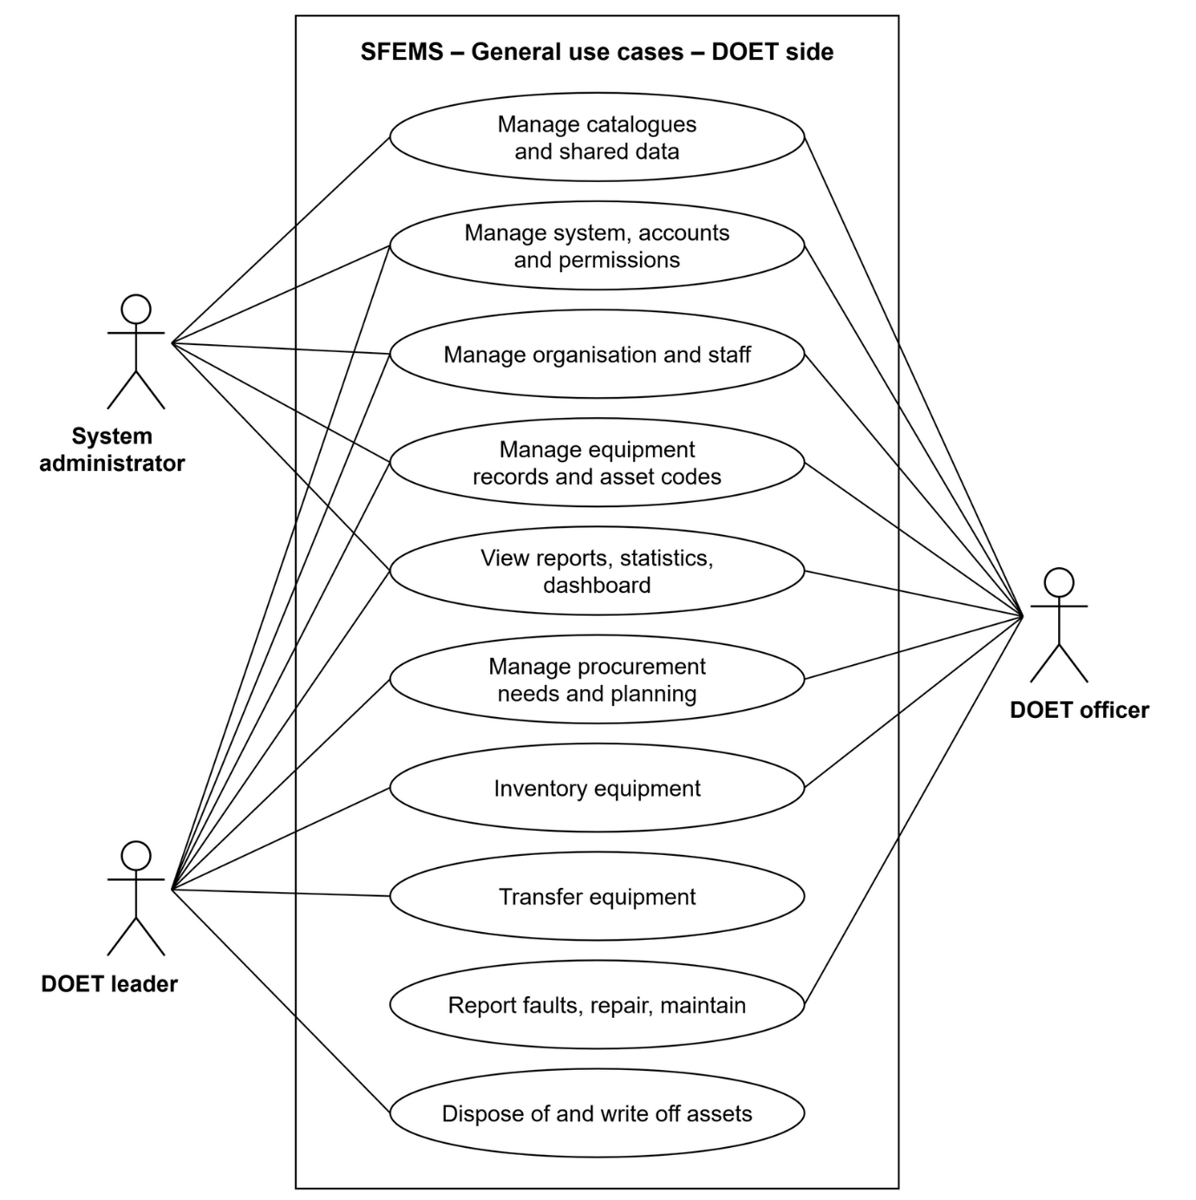
Figure 12: Use case overview diagram (1/2): DOET side
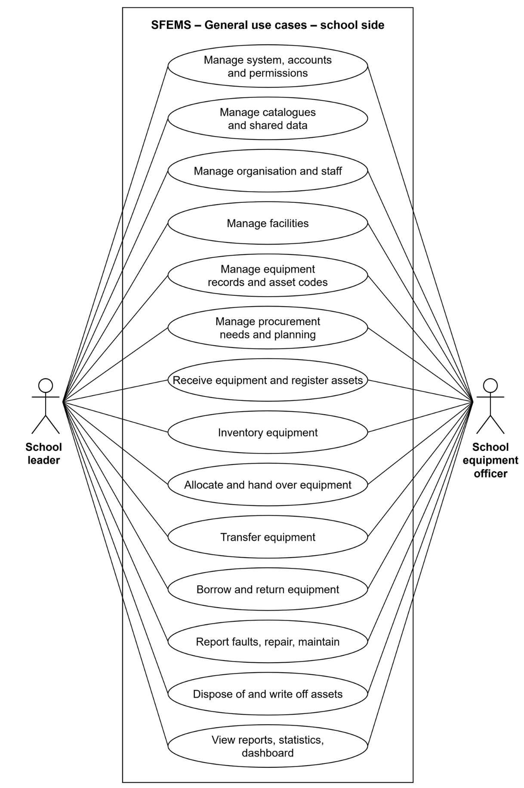
Figure 13: Use case overview diagram (2/2): school side

4.3.2 Signed-in Users
Sign in, sign out, change password, two-factor authentication, notifications, view the school overview, look up equipment and view its history, dashboard, reports, approval log and data export. All five actors can do these, within their own data scope.
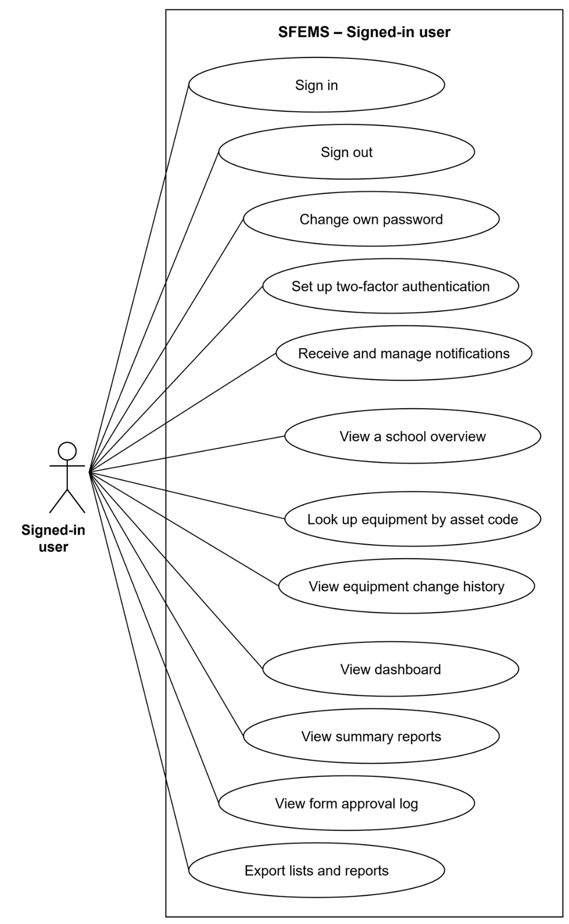
Figure 14: Common use cases of the signed-in user

4.3.3 System Administrator
The system administrator manages accounts, roles, permissions and data scope, the activity log, the shared catalogues and the school profiles. The system administrator does not do equipment work.
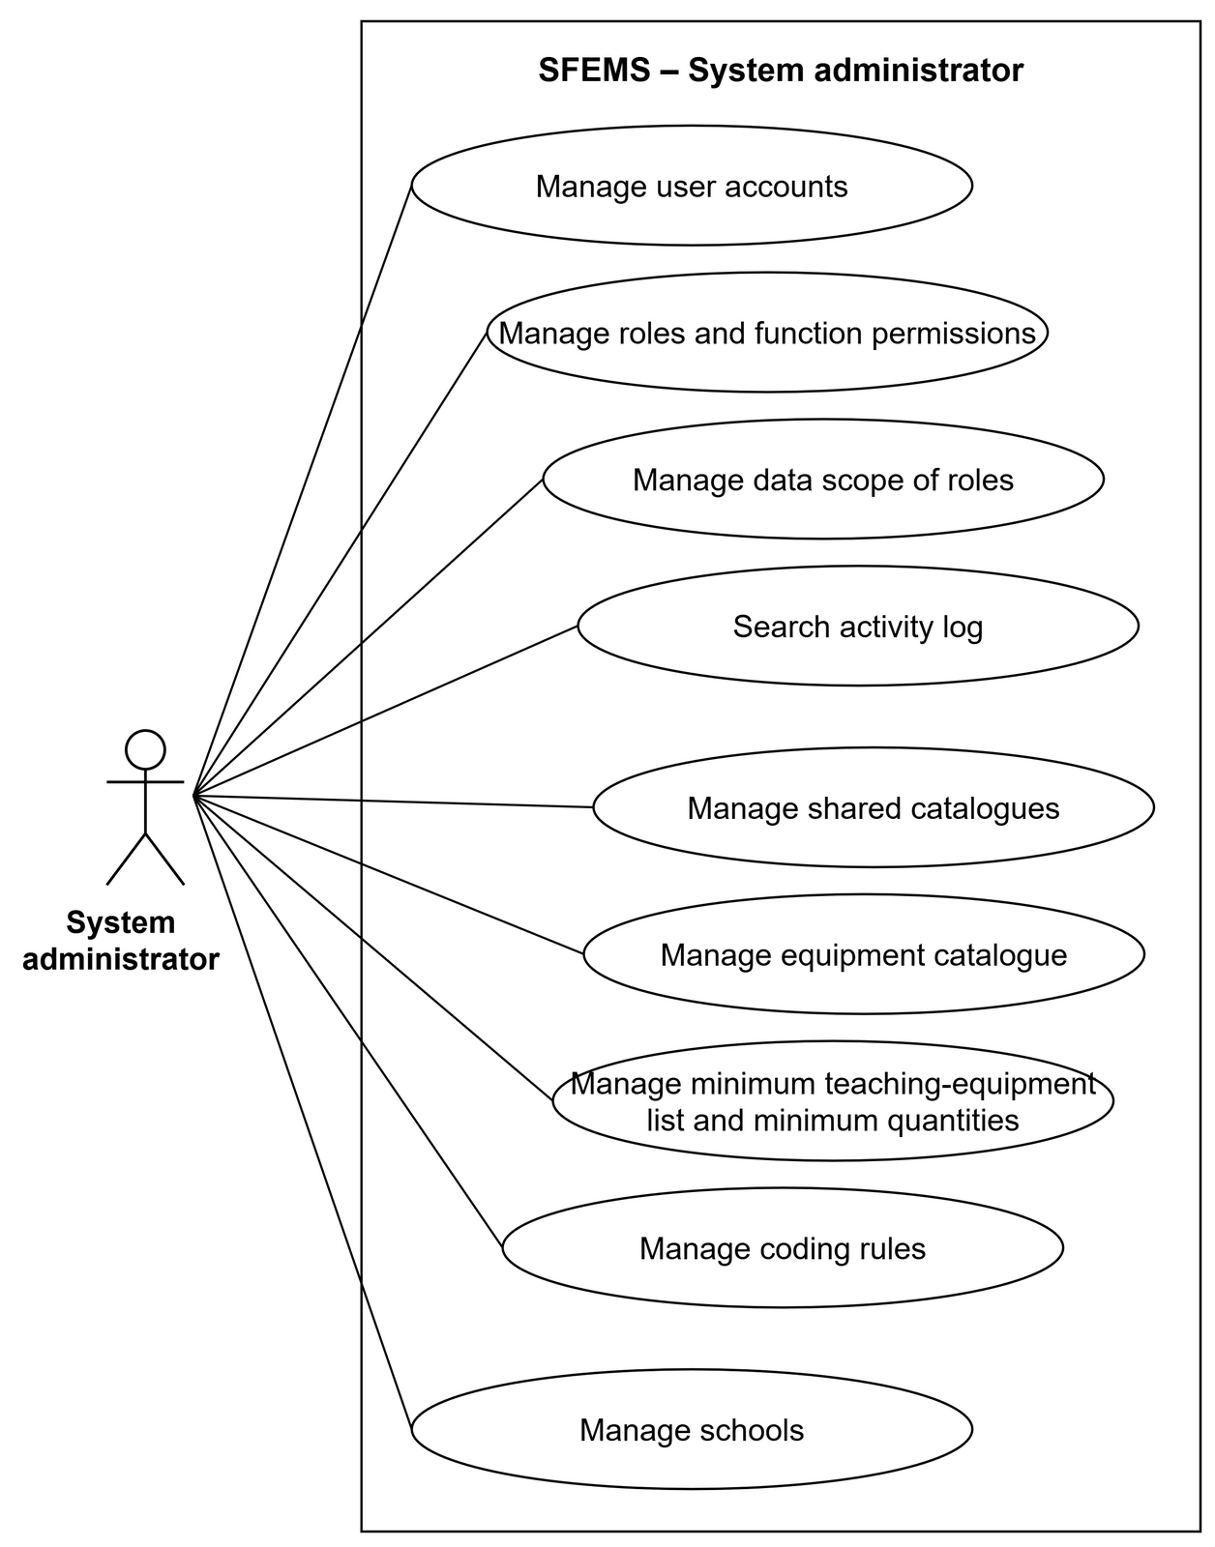
Figure 15: Use cases of the System administrator

4.3.4 DOET Leader
The DOET leader approves the procurement proposals of the schools, approves the DOET's procurement plan, approves transfers between two schools and approves disposal. The DOET leader also views the summary of needs and the inventory progress. Approving a disposal always writes off the asset (<<include>>).
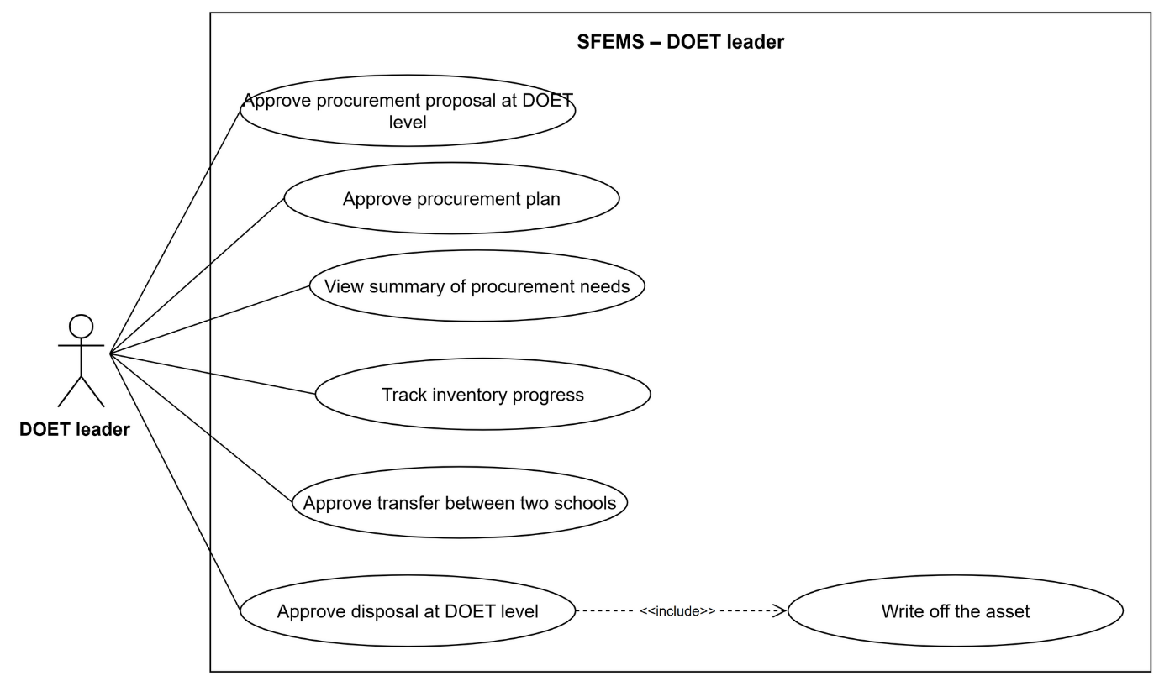
Figure 16: Use cases of the DOET leader

4.3.5 DOET Officer
The DOET officer manages the equipment catalogue, the minimum list and minimum quantities, and the school profiles; creates the DOET's procurement plan; starts and tracks city-wide inventory rounds; and looks up the repair and maintenance history of the schools.
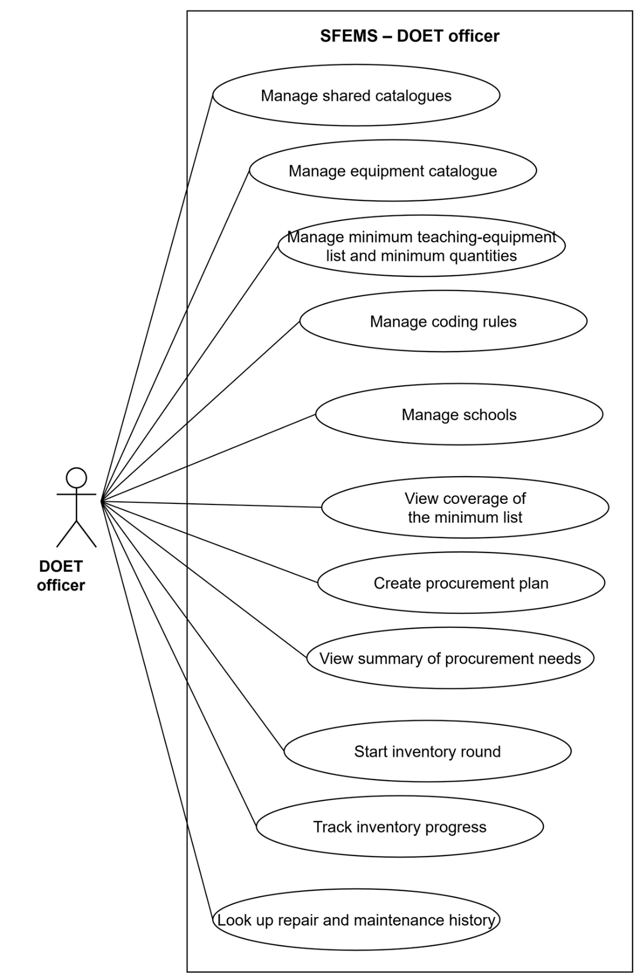
Figure 17: Use cases of the DOET officer

4.3.6 School Leader
The school leader manages the accounts, staff, facilities and coding rules of the school. The school leader approves the forms at school level: procurement proposals, receipt forms, inventory reports, allocation forms, transfer forms, repair forms and disposal requests. The school leader also tracks borrowing and return. The use cases are drawn as two figures: Figure 18 covers the school's management part and the three focus flows; Figure 19 covers the operations along the equipment life cycle. Approving a receipt form always generates asset codes for the new equipment (<<include>>).
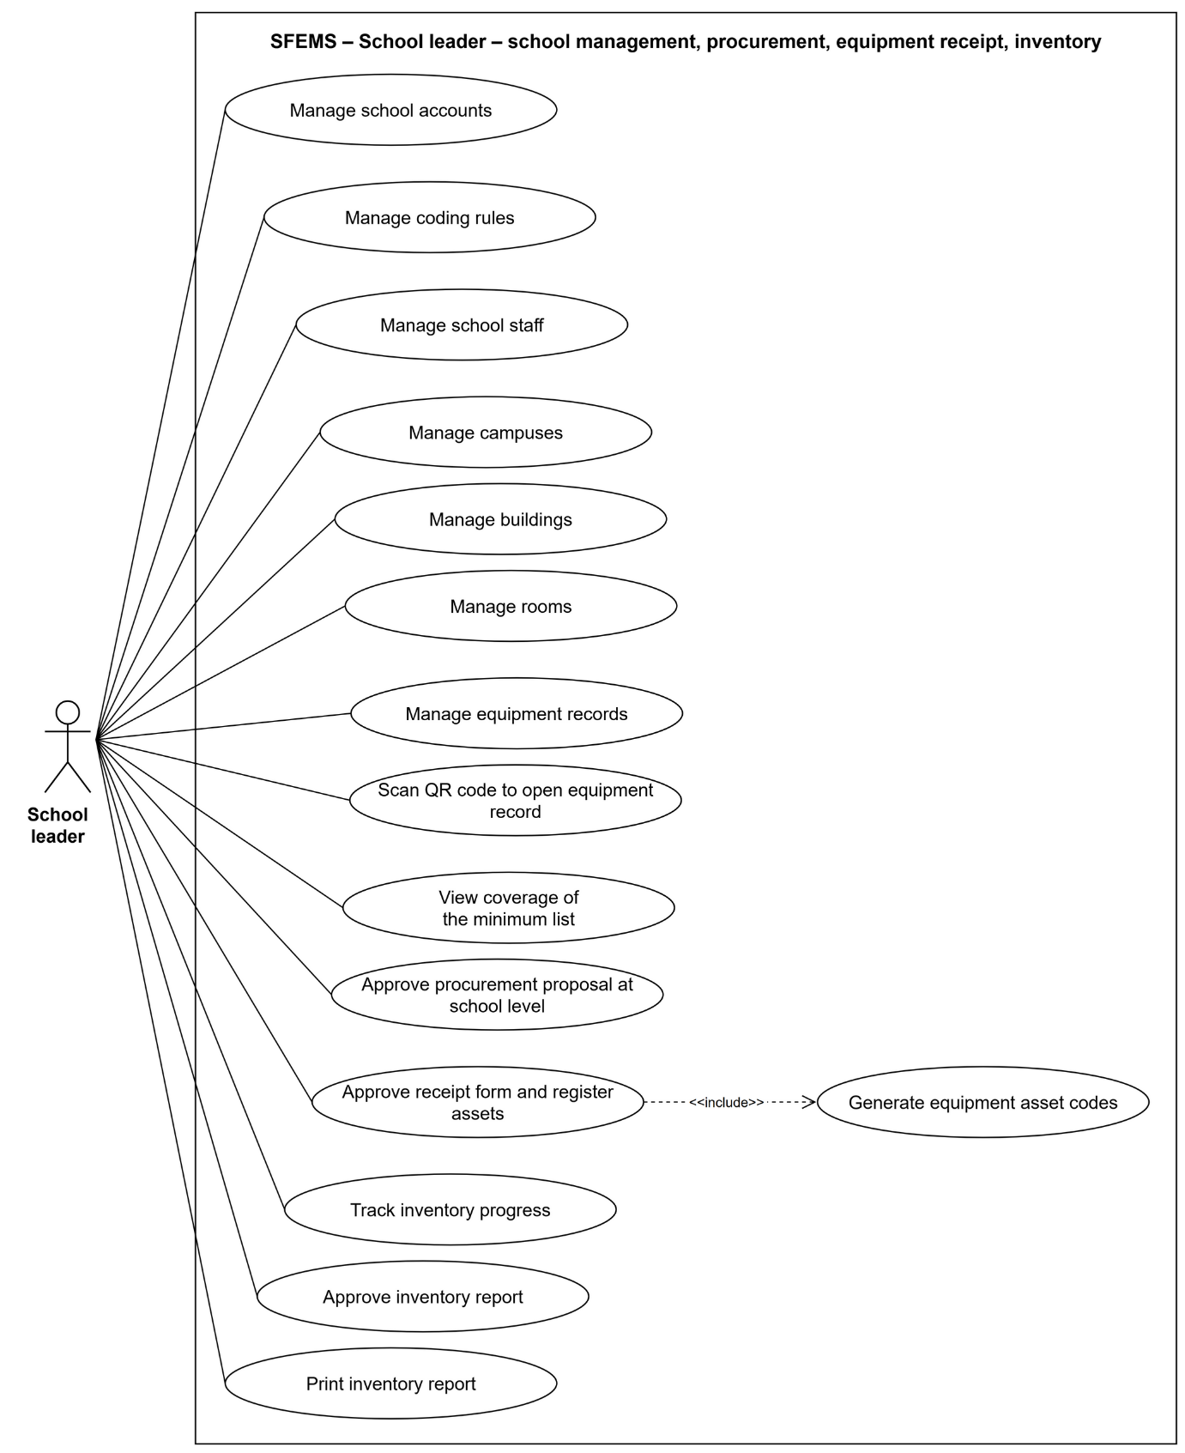
Figure 18: Use cases of the School leader (1/2): school management, procurement, equipment receipt, inventory
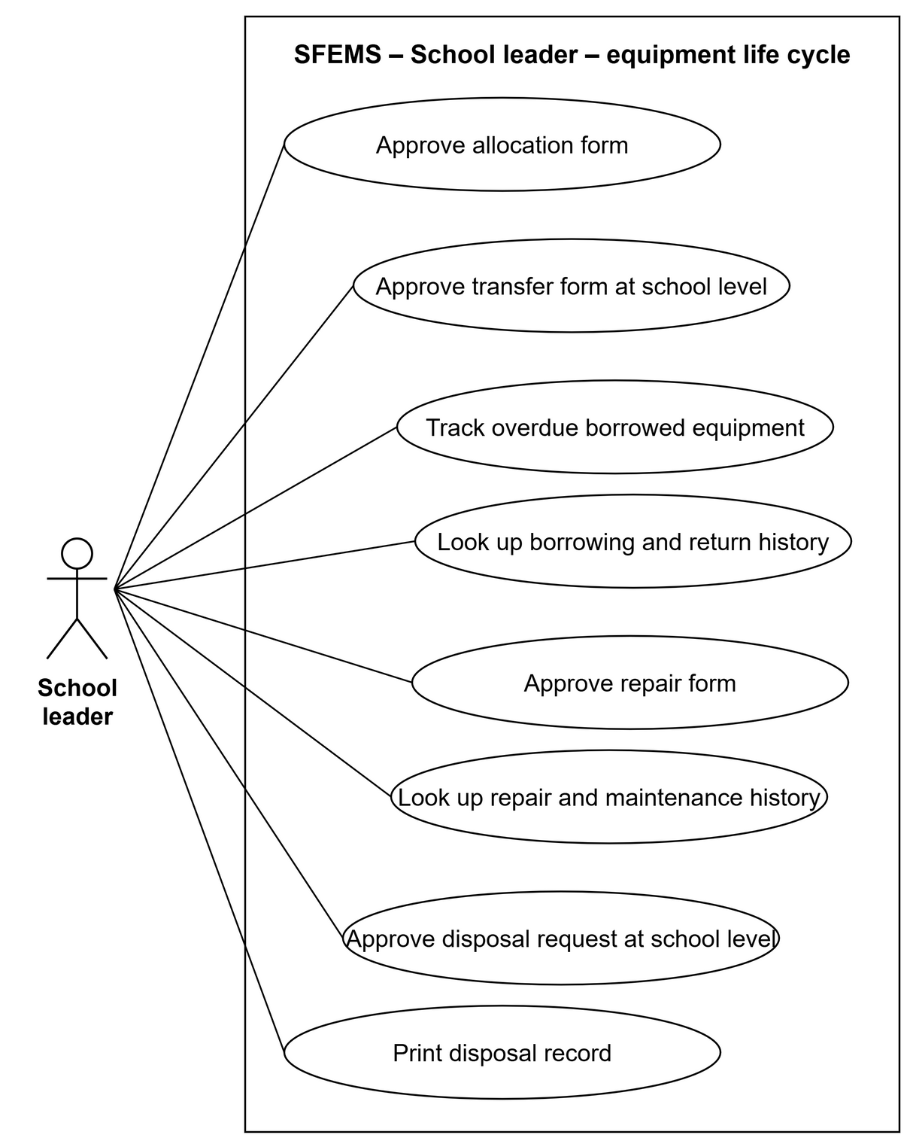
Figure 19: Use cases of the School leader (2/2): allocation, transfer, borrowing and return, repair, disposal

4.3.7 School Equipment Officer
The school equipment officer is the daily user and has the most use cases, so they are drawn as four figures: Figure 20 covers facilities and equipment records; Figure 21 covers the three focus flows – procurement, equipment receipt, inventory; Figure 22 covers allocation, transfer, and borrowing and return; Figure 23 covers repair, maintenance and disposal.
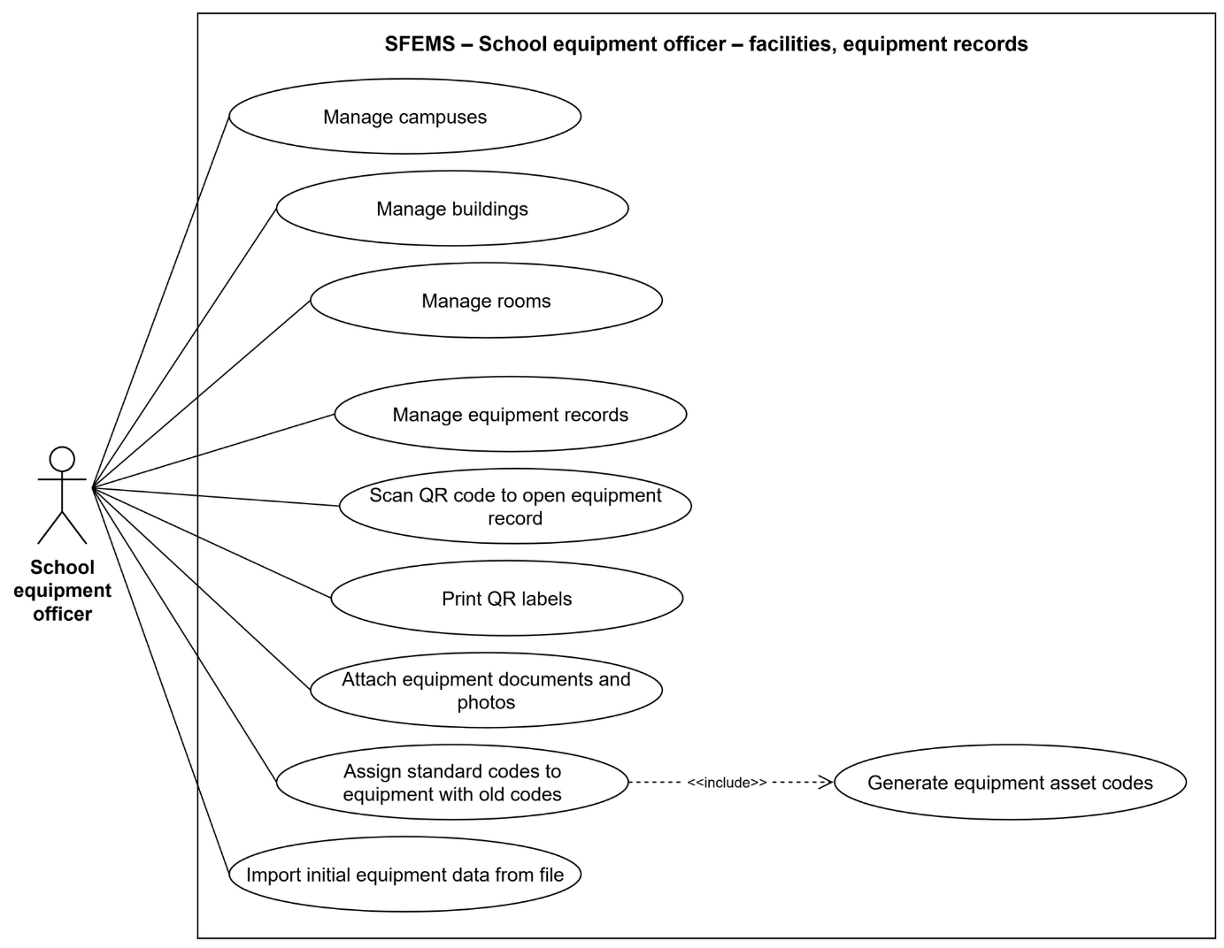
Figure 20: Use cases of the School equipment officer (1/4): facilities, equipment records
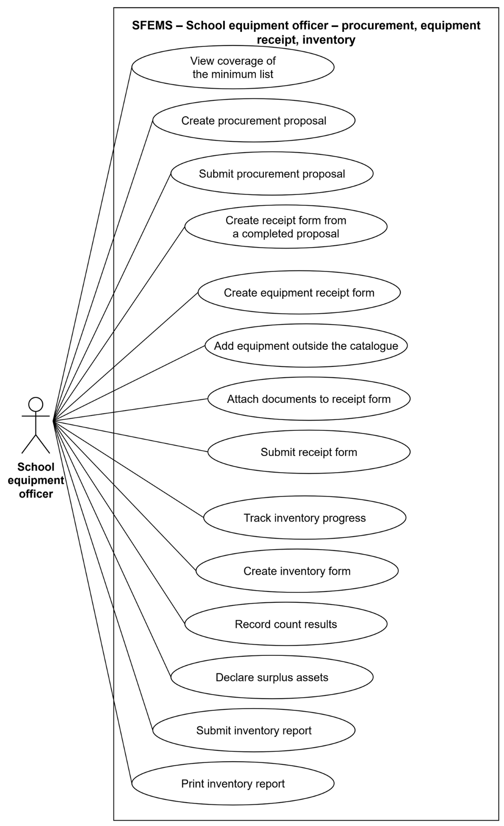
Figure 21: Use cases of the School equipment officer (2/4): procurement, receipt and asset registration, inventory
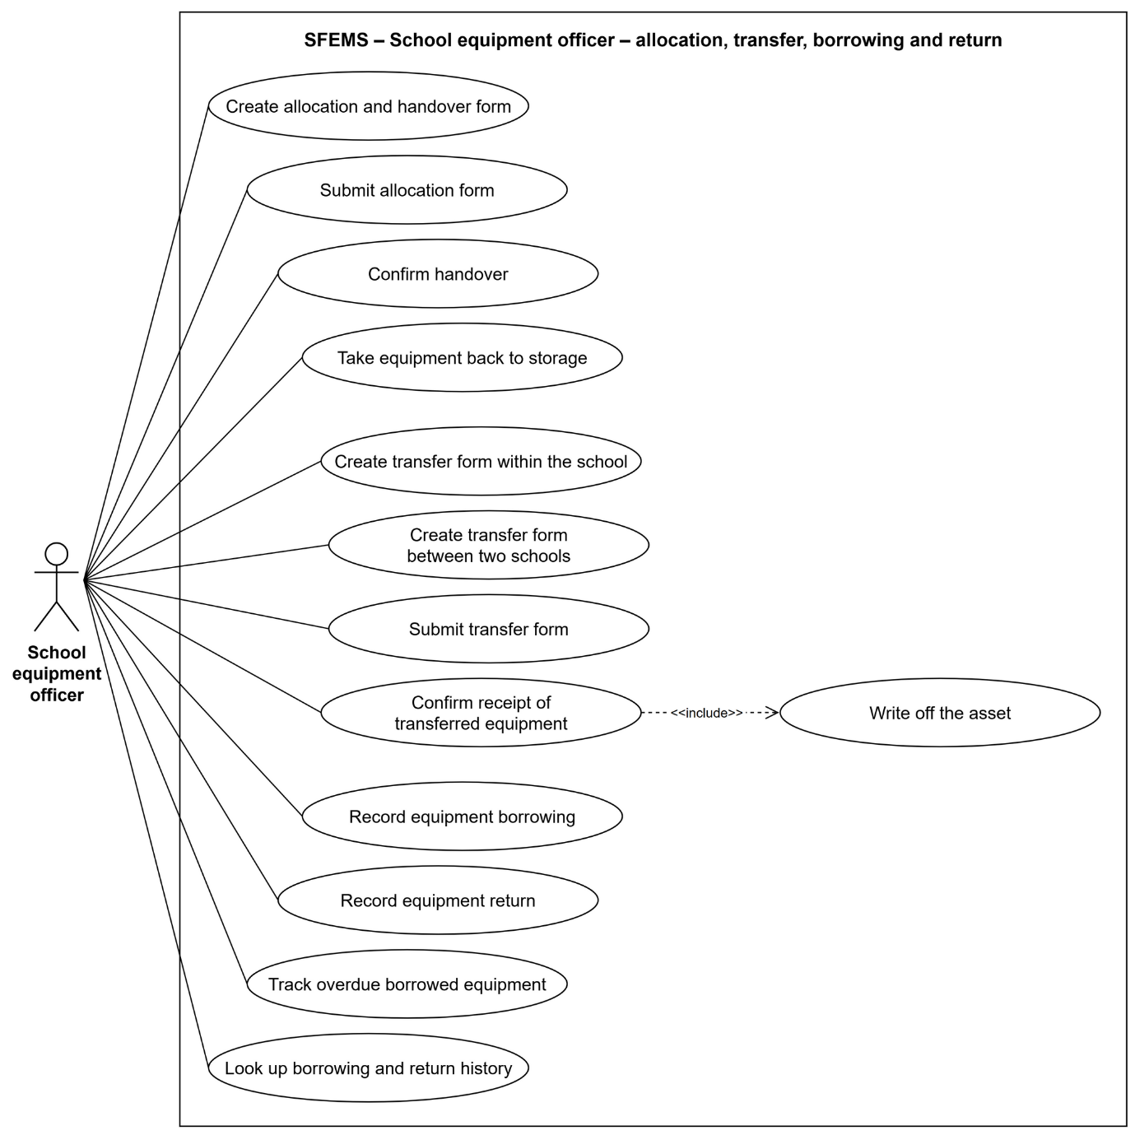
Figure 22: Use cases of the School equipment officer (3/4): allocation, transfer, borrowing and return
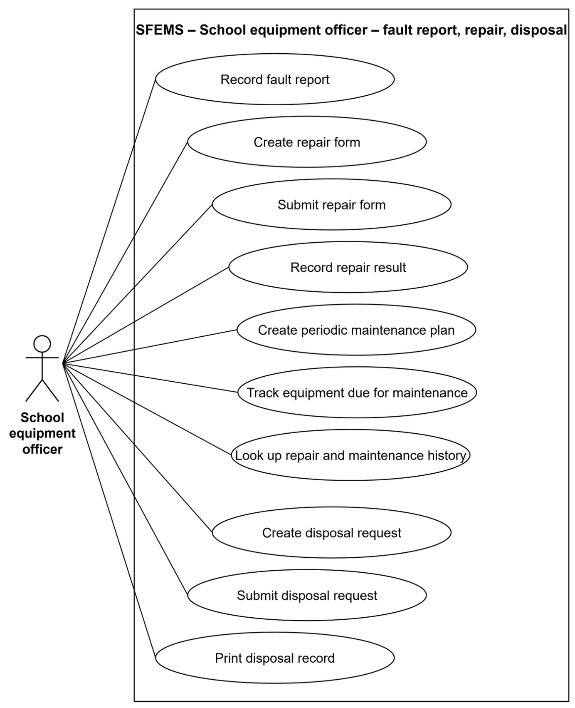
Figure 23: Use cases of the School equipment officer (4/4): repair, maintenance, disposal

4.4 Permission Matrix
Yes = allowed without conditions · Limited = allowed with conditions (see the notes) · No = denied. Each permission has two layers: the function permission code of the role and the row-level data scope. For approval actions there is a third layer: the account must belong to the level that the form is waiting for. The matrix below is the preset configuration; the system administrator can change it.
Object | Action | Admin | DOET leader | DOET officer | School leader | School equip. officer
User accounts | View | Yes | Yes | Yes | Limited ³ | None
User accounts | Create, edit, lock, reset password | Yes | None | None | Limited ³ | None
Roles, permissions, data scope | View | Yes | Yes | Yes | None | None
Roles, permissions, data scope | Create, edit, delete | Yes | None | None | None | None
Activity log | View | Yes | None | None | None | None
Shared catalogues, equipment catalogue, minimum quantities | View | Yes | Yes | Yes | Yes | Yes
Shared catalogues, equipment catalogue, minimum quantities | Create, edit, delete | Yes | None | Yes | None | None
Schools | View | Yes | Yes | Yes | Limited ¹ | Limited ¹
Schools | Create, edit | Yes | None | Yes | None | None
School staff | View | Yes | Yes | Yes | Limited ¹ | Limited ¹
School staff | Create, edit, delete | Yes | None | None | Limited ¹ | None
Campuses, buildings, rooms | View | Yes | Yes | Yes | Limited ¹ | Limited ¹
Campuses, buildings, rooms | Create, edit | Yes | None | None | Limited ¹ | Limited ¹
Equipment | View, look up, view history | Yes | Yes | Yes | Limited ¹ | Limited ¹
Equipment | Edit record, attach files | Yes | None | None | Limited ¹ | Limited ¹
Equipment | Delete | Limited ⁴ | None | None | None | Limited ⁴
Procurement proposal | View | Yes | Yes | Yes | Limited ¹ | Limited ¹
Procurement proposal | Create, edit, submit, cancel, create receipt form | Yes | None | None | None | Limited ¹
Procurement proposal | Approve, return, reject | Yes | Limited ² | None | Limited ² | None
Procurement plan | View | Yes | Yes | Yes | None | None
Procurement plan | Create, edit, select proposals, submit | Yes | None | Yes | None | None
Procurement plan | Approve, return | Yes | Yes | None | None | None
Receipt form | View | Yes | Yes | Yes | Limited ¹ | Limited ¹
Receipt form | Create, edit, submit, cancel | Yes | None | None | None | Limited ¹
Receipt form | Approve and register the asset, return, reject | Yes | None | None | Limited ² | None
Inventory round | View, view progress | Yes | Yes | Yes | Yes | Yes
Inventory round | Start, edit, delete | Yes | None | Yes | None | None
Inventory form | View | Yes | Yes | Yes | Limited ¹ | Limited ¹
Inventory form | Create, count, submit, cancel | Yes | None | None | None | Limited ¹
Inventory form | Approve, return, reject | Yes | None | None | Limited ² | None
Dashboard, reports | View, export | Yes | Yes | Yes | Limited ¹ | Limited ¹

– ¹ Only the data of their own school.
– ² Only at the approval step of their own level: the school leader approves the school step; the DOET leader approves the DOET step.
– ³ The school leader manages the accounts of their own school through the School accounts screen, and only with the school-side roles.
– ⁴ Only equipment records that have left the register can be deleted; only draft forms that have never been submitted can be deleted.

5. System Functionalities
This section gives an overview of the screens, the interfaces with external systems and the automatic processing of the in-scope part.

5.1 Screen Inventory

a. Screen Flow
After signing in, every role goes to the Dashboard. The content and the sidebar change with the view of the account: a school account sees the school's operating modules, a DOET account sees the management screens, and the system administrator sees everything. Each item on the sidebar appears only when the account has the matching view permission; opening a link without permission leads to the Access denied screen.
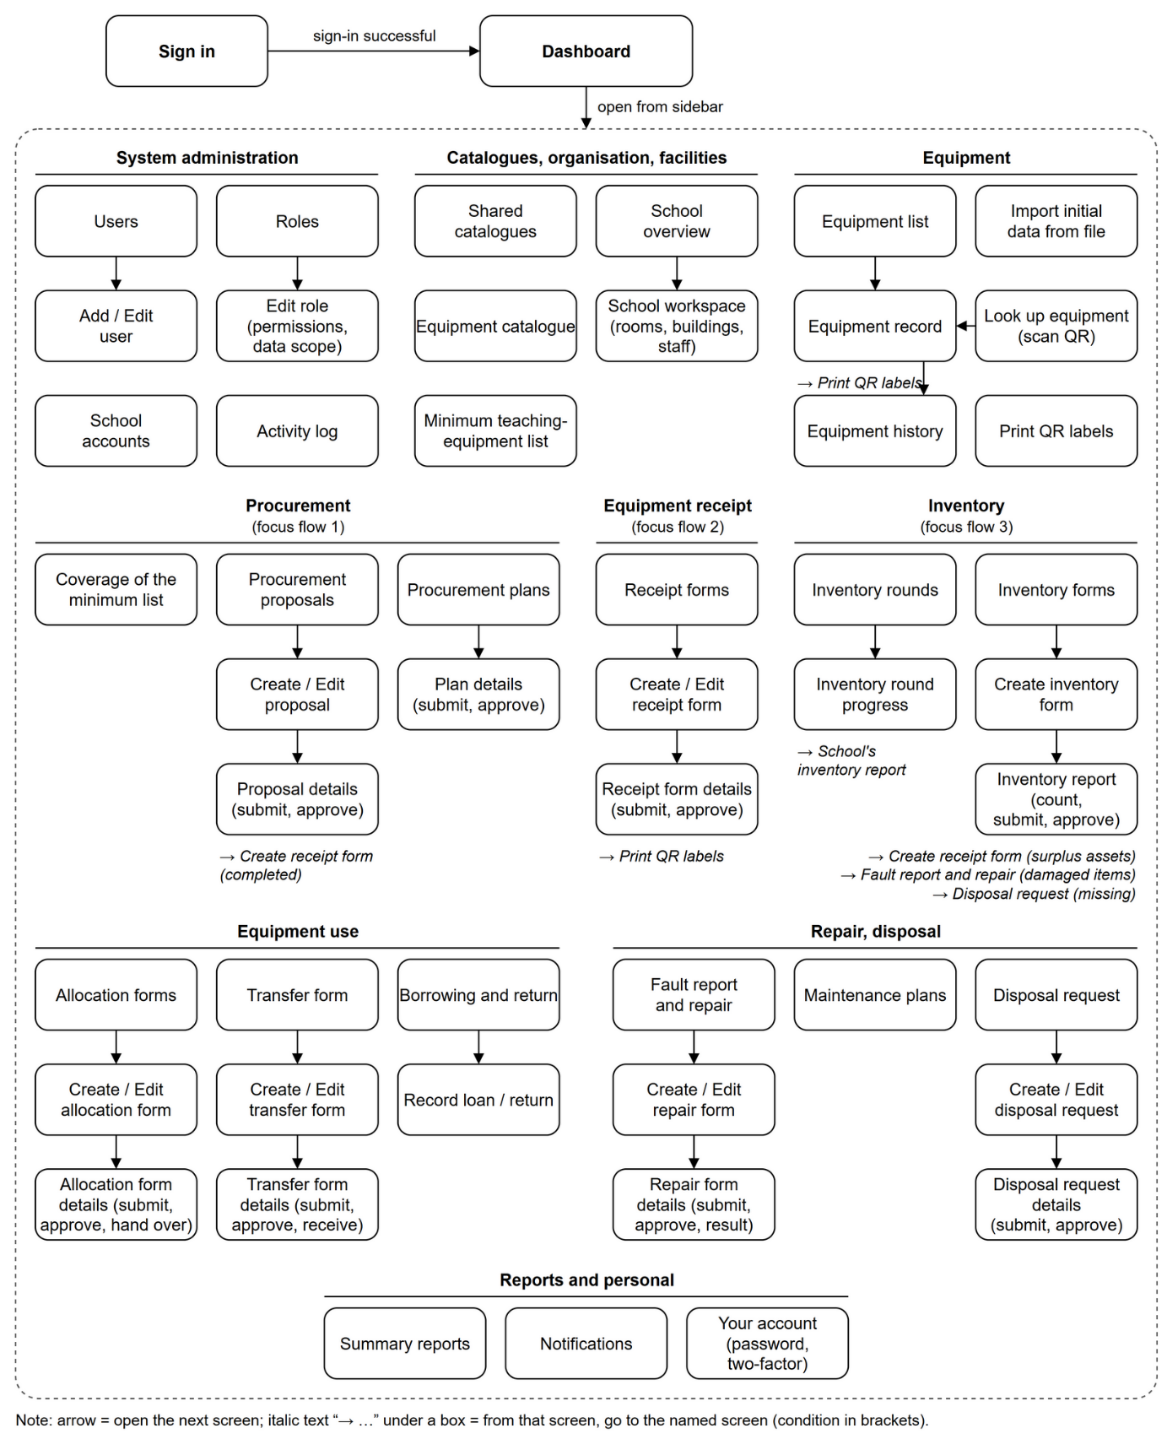
Figure 24: Screen flow diagram

b. Screen List
# | Screen | Feature group | Description
1 | Sign in | System | Enter the username or email and the password; add a 6-digit code when the account has two-factor authentication turned on.
2 | Your account | System | View your own profile and permissions, change the password, turn two-factor authentication on or off.
3 | Notifications | System | The notification bell at the top of the page and the notification list; mark as read, delete.
4 | Users | System | Account list: username, full name, school of work, status, role, last sign-in.
5 | Add / Edit user | System | Enter the account, place of work and role; reset the password and two-factor authentication.
6 | Roles | System | List of roles and the number of permissions granted.
7 | Add / Edit role | System | Role information, the permission matrix by resource and action, the data scope of the role.
8 | Row-level data permissions | System | List of data scope policies and the coverage grid by role.
9 | School accounts | System | The school leader adds, locks and resets the password of accounts that belong to their own school.
10 | Activity log | System | Read-only list of write actions and data exports.
11 | Shared catalogues | Catalogues | One common set of screens for the base catalogues: list, and dialogs to add, edit and view.
12 | Equipment catalogue | Catalogues | List and records of the equipment in the shared catalogues.
13 | Minimum teaching-equipment list | Catalogues | The standard set for the upper-secondary level, the basis documents and the minimum quantity lines by subject.
14 | Code generation rules | Catalogues | Prefix and length of the number part for the codes of each shared catalogue.
15 | School coding rules | Catalogues | Symbol and number length for the room, building, campus and staff codes of one school.
16 | School overview | Organisation | The DOET–school tree and the workspace of one school with tabs for facilities, staff and equipment.
17 | Schools | Organisation | School list in table view or card view; add, edit and view school details.
18 | Staff and teachers | Organisation | List and dialog to enter the staff of the school; give an account to a staff member.
19 | Campus / Building / Room | Facilities | List and form to enter the campuses, buildings and rooms of the school.
20 | Equipment list | Equipment | Three views: summary by equipment, by storage and room, details of each asset; filter columns by type and subject.
21 | Equipment record | Equipment | Identification, origin, value, minimum standard, attachments and history of one asset.
22 | Enter opening balance / Edit equipment | Equipment | Enter existing equipment that did not go through a receipt form; add more information to the record.
23 | Asset lookup | Equipment | Enter the code or scan the QR label to open the equipment record.
24 | Print QR labels | Equipment | Grid of labels for one receipt form, one room or a search result, printed from the browser.
25 | Minimum teaching equipment / Coverage of the minimum list | Procurement | School: enough, short or surplus compared with the minimum quantity. DOET: summary of all schools and summary of procurement proposals.
26 | Procurement proposal | Procurement | List of proposals, with the Waiting for my approval filter.
27 | Create / Edit procurement proposal | Procurement | General information, the proposed equipment lines and the coverage table of the school.
28 | Procurement proposal details | Procurement | Proposal content, approval history, attachments; submit, approve, return, reject, cancel, print the submission letter, create a receipt form when the goods arrive.
29 | Procurement plan | Procurement | List of the procurement plans of the DOET.
30 | Create / Edit procurement plan | Procurement | Plan name, budget year, notes.
31 | Procurement plan details | Procurement | Select approved proposals into the plan, summary by equipment; submit, approve, return.
32 | Receipt form | Asset Registration | List of receipt forms, with the Waiting for my approval filter.
33 | Create / Edit receipt form | Asset Registration | Form information, the table of received equipment, the delivery record, files; the right-hand column checks the items still missing before submission.
34 | Select equipment from the catalogue | Asset Registration | Dialog to search and select several items of equipment and choose the receiving room; add equipment that is not in the catalogue.
35 | Receipt form line details | Asset Registration | Dialog for the quantity, price, location, documents and source, and invoice of one line.
36 | Receipt form details | Asset Registration | Form content, approval history; submit, approve and register the assets, return, reject, cancel; view the registered assets, print QR labels.
37 | Inventory round | Inventory | List of inventory rounds started by the DOET.
38 | Start / Edit inventory round | Inventory | Round name, data cut-off date, submission deadline, instructions sent to the schools.
39 | Inventory round progress | Inventory | Progress of each school in the round and a link to the report of the school.
40 | Inventory form | Inventory | List of the forms of the school with the count progress and the number of discrepancies.
41 | Create / Edit inventory form | Inventory | Inventory date, round, scope, inventory team, conclusion.
42 | Inventory report | Inventory | Count sheet, results by discrepancy type, surplus assets; submit, approve, return, reject, print the report.
43 | Dashboard | Reports | Summary of the school, or city-wide overview for the DOET.
44 | Reports | Reports | One screen for the reports: indicators, charts, data tables, export to Excel, print.
45 | No permission / Page not found | System | Message screen shown when the user opens a link that they have no permission for or that does not exist.

5.2 External API Inventory
This version does not exchange business data with any external system (LI-01). The technical interfaces with the outside are:
# | Interface name | Call direction | Description
1 | File storage (S3) | SFEMS → MinIO | Save, read and delete the content of attachments. The database keeps only the file name, type, size and object key.
2 | Real-time notification channel | SFEMS → browser | One-way WebSocket (STOMP) connection: it pushes new notifications and permission changes to users who have the application open. The browser does not send business data through this channel.
3 | Issue access tokens to integrated systems | External system → SFEMS | Exchange an API key for a short-lived access token. It is already in the platform to prepare for later integration; it is not in the acceptance scope of the capstone project.

5.3 Background Job Inventory
The three focus flows have no scheduled jobs: work that waits for approval is shown by the "Waiting for my approval" filter on the list, not by automatic reminders. The automatic processing in scope runs on events, in the same transaction as the user's action. Two scheduled jobs already in the platform belong to operations (LI-05) and are listed for reference.
# | Process name | Group | Description
1 | Write the activity log | Event-driven | After each write action or data export
2 | Write the form approval log | Event-driven | Each time a form is submitted, approved, returned, rejected, cancelled or completed
3 | Create assets and asset codes | Event-driven | When the receipt form is approved at the last step
4 | Complete procurement proposals | Event-driven | When the procurement plan that contains the proposal is approved
5 | Update the register after inventory | Event-driven | When the inventory report is approved
6 | Refresh the user's permissions | Event-driven | When the role, permissions or place of work of the account changes
7 | Back up the database | Scheduled (outside the acceptance scope) | Every day at 01:30
8 | Check storage space and backups | Scheduled (outside the acceptance scope) | Every day at 06:00

II. Use Case Specifications
This part specifies in detail the use cases of the three focus flows and the sign-in use case. The other use cases are simple add, edit and view operations; they are described in the table in Section I.4.2 and in the matching screens in Part III. The MSG message codes and the GBR rules are listed in Part V.

1. Authentication

1.1 Sign in (HT-01)
Primary actor | All signed-in users
Secondary actor | None
Description | As a user, I want to sign in with the account given to me so that I can use the functions within my permissions and data scope.
Precondition | The account has been created, is in the Active status and has at least one role.
Focus flows | 1. The user opens the system; the system shows the Sign in screen.  2. The user enters the username or email and the password, then clicks Sign in.  3. The system checks the sign-in information (GBR-01, GBR-02).  4. If the account has two-factor authentication turned on, the system also shows the Verification code (6 digits) field; the user enters the code from the authenticator app and clicks Sign in again.  5. The system creates a session, loads the permissions and data scope of the account, and records the sign-in time.  6. The system goes to the Dashboard that fits the view of the account.
Alternative and exception flows | 3a. The username or password is empty: the system reports a required field (MSG01).  3b. The username or password is wrong, or the account is not in the Active status: the system shows the same message and does not say which part is wrong (MSG02).  4a. Wrong verification code: MSG03. Wrong 5 times in a row: the system locks code entry for 5 minutes (MSG04).  5a. The permissions cannot be loaded: the system cancels the session it has just created and reports an error (MSG05).  The connection to the server is lost at any step: MSG06.
Postcondition | The user is in the system with a new session; every later action is checked against the permissions and data scope of the account.

2. Procurement Needs and Planning

2.1 Create a procurement proposal (NC-02)
Primary actor | School equipment officer
Secondary actor | None
Description | As a school equipment officer, I want to create a proposal to buy the equipment the school still lacks, based on the coverage of the minimum list, so that I can submit it to the school leader.
Precondition | The user has permission to write procurement proposals of their own school. The school already has data on classes, teachers and rooms to calculate the minimum quantity (optional).
Focus flows | 1. The user opens Procurement proposals and clicks Add new.  2. The system shows the form with the school of the account, today as the proposal date, next year as the budget year, and the coverage table of the school already filtered to the equipment that is still short.  3. The user adds lines: selects the equipment, the type (new purchase, replacement), quantity, unit price and priority; or clicks + on the minimum quantity table to add exactly the quantity that is short.  4. The user enters the justification and notes, then clicks Save draft.  5. The system checks the data (GBR-08) and saves the proposal in the Draft state; for each line, the system also saves the quantity on hand and the quantity required by the minimum quantity at the time of saving.  6. The system goes to the Proposal details screen.
Alternative and exception flows | 3a. One item of equipment appears twice: MSG20.  5a. A line has no equipment selected, the quantity is not greater than 0 or the proposal date is missing: the system shows an error on that line (MSG21) and does not save.  The user can edit, cancel or delete the proposal while it is still a draft; a proposal that has been submitted before can only be cancelled, not deleted (GBR-06).
Postcondition | The proposal is in the Draft state and has no form number yet.

2.2 Submit a procurement proposal (NC-03)
Primary actor | School equipment officer
Secondary actor | None
Description | As a school equipment officer, I want to submit the proposal to the school leader for review and approval.
Precondition | The proposal is in the Draft state and belongs to the school of the user.
Focus flows | 1. The user opens Proposal details and clicks Submit for approval.  2. The system asks for confirmation: the form will get a number and cannot be edited while it waits for approval.  3. The user confirms.  4. The system checks that the proposal has at least one line and states the justification.  5. The system gives a form number in the format MS-year-sequence number if there is none yet (GBR-05), moves the proposal to Pending approval at the school leader step, and writes the approval log.  6. The system reports that the proposal has been submitted (MSG10).
Alternative and exception flows | 4a. The proposal has no lines: MSG22. The justification is not stated: MSG23. The proposal stays in the Draft state.  A returned proposal is submitted again: the form number stays the same, and the approval chain starts again from the school leader step.
Postcondition | The proposal is in the Pending approval state, at the school leader step; the creator cannot edit it.

2.3 Approve a procurement proposal at school level (NC-04)
Primary actor | School leader
Secondary actor | None
Description | As a school leader, I want to confirm the procurement needs of the school before they are sent to the DOET.
Precondition | The proposal is in the Pending approval state, at the school leader step; the user belongs to the school of the proposal and has permission to approve proposals.
Focus flows | 1. The user turns on the Waiting for my approval filter on the Procurement proposals list and opens the proposal.  2. The system shows the proposal content, the current coverage of the minimum list for the school, the approval history and the attachments.  3. The user clicks Approve, enters a comment (optional) and confirms.  4. The system moves the proposal to the DOET step, writes the approval log and reports that it has been approved (MSG11).
Alternative and exception flows | 3a. The user clicks Return and writes what needs to be edited (required, GBR-04): the proposal goes back to Draft and keeps its form number, and the note is shown at the top of the proposal for the creator.  3b. The user clicks Reject and writes the reason (required): the proposal moves to Rejected and stops for good.  4a. The account does not belong to the school of the proposal: MSG12.
Postcondition | The proposal waits for DOET approval; or it has gone back to Draft; or it is rejected.

2.4 Approve a procurement proposal at DOET level (NC-05)
Primary actor | DOET leader
Secondary actor | None
Description | As a DOET leader, I want to approve the proposals of the schools so that the DOET officer can put them into the procurement plan.
Precondition | The proposal is in the Pending approval state, at the DOET step; the user belongs to the DOET and has permission to approve proposals.
Focus flows | 1. The user opens the Procurement proposals list, turns on the Waiting for my approval filter and opens the proposal.  2. The user clicks Approve, enters a comment (optional) and confirms.  3. The system moves the proposal to Approved, writes the approval log and reports that it has been approved (MSG11).
Alternative and exception flows | 2a. Return or Reject as in NC-04.  3a. The account does not belong to the DOET: MSG12.
Postcondition | The proposal is in the Approved state and waits to be put into a procurement plan.

2.5 Create a procurement plan (NC-06)
Primary actor | DOET officer
Secondary actor | None
Description | As a DOET officer, I want to group the approved proposals into a procurement plan by budget year so that I can submit it to the DOET leader.
Precondition | The account belongs to the DOET and has permission to write procurement plans.
Focus flows | 1. The user opens Procurement plans, clicks Add new, enters the plan name, budget year and notes, then clicks Create plan.  2. The system saves the plan in the Draft state and opens Plan details.  3. The user clicks Add proposals; the system lists the approved proposals that are not in any plan yet.  4. The user selects proposals and clicks Add; the system links the proposals to the plan and updates the summary table by equipment.  5. The user clicks Submit for approval and confirms.  6. The system checks that the plan has at least one proposal and moves it to Pending approval (MSG10).
Alternative and exception flows | 1a. The account does not belong to the DOET: MSG24. The name or the budget year is missing: MSG25.  4a. The user removes a proposal from the plan while the plan is still a draft: the proposal goes back to the list that waits to be put into a plan.  4b. The proposal has already been put into another plan or is no longer in the Approved state: MSG26.  6a. The plan has no proposals: MSG27.
Postcondition | The plan is in the Pending approval state; the proposals in the plan cannot be removed or cancelled.

2.6 Approve a procurement plan (NC-07)
Primary actor | DOET leader
Secondary actor | None
Description | As a DOET leader, I want to approve the procurement plan of the DOET so that the schools know which proposals will be bought.
Precondition | The plan is in the Pending approval state; the user belongs to the DOET and has permission to approve plans.
Focus flows | 1. The user opens Plan details: the list of proposals, the summary by equipment, the total estimated cost.  2. The user clicks Approve, enters a comment (optional) and confirms.  3. The system moves the plan to Approved and saves the approver, the time and the comment.  4. In the same transaction, the system moves every proposal in the plan to Completed and writes the approval log for each proposal.  5. The system reports that the plan has been approved (MSG13).
Alternative and exception flows | 2a. The user clicks Return and writes the reason (required, MSG28): the plan goes back to Draft so that the officer can edit it.  3a. The account does not belong to the DOET: MSG29.
Postcondition | The plan is Approved; the proposals in the plan are Completed and ready for the school to create a receipt form when the goods arrive.

2.7 Create a receipt form from a completed proposal (NC-09)
Primary actor | School equipment officer
Secondary actor | None
Description | As a school equipment officer, when the purchased equipment has arrived I want to create a receipt form from the proposal so that I do not have to enter each line again.
Precondition | The proposal is in the Completed state and has no receipt form yet.
Focus flows | 1. The user opens Proposal details and clicks Goods arrived – create receipt form.  2. The system creates a Draft receipt form: the receipt date is today and the funding source follows the proposal. Each proposal line becomes one form line, with the document quantity and the received quantity equal to the proposed quantity, and the unit price taken from the proposal.  3. The system records the receipt form on the proposal, shows MSG14 and opens the Edit receipt form screen.  4. The user counts the goods, edits the received quantity, receiving room and documents, then continues with PN-01.
Alternative and exception flows | 1a. The proposal is not completed yet: MSG30. The proposal already has a receipt form: MSG31.
Postcondition | There is one Draft receipt form linked to the proposal; each proposal can have only one receipt form.

3. Equipment Receipt and Asset Registration

3.1 Create an equipment receipt form (PN-01)
Primary actor | School equipment officer
Secondary actor | None
Description | As a school equipment officer, I want to create a receipt form for the equipment the school receives, with the supporting documents, so that I can submit it to the school leader for asset registration.
Precondition | The user has permission to write receipt forms of their own school. The school already has a room or storage to receive the goods.
Focus flows | 1. The user opens Asset Registration and clicks Create receipt form.  2. The user enters the receipt date, the deliverer and notes.  3. The user clicks Select equipment from the catalogue, searches and selects one or more items of equipment, chooses the receiving room and clicks Add.  4. For each line, the user enters the quantity on the documents, received quantity, unit price, receiving room, supplier, invoice number, funding source, warranty and reason for the increase; the user can copy the documents to all lines.  5. The system calculates the line amount and the total amount, and lists the items still missing before submission in the right-hand column.  6. The user clicks Save draft; the system checks the data (GBR-09) and saves the form in the Draft state.  7. The user attaches the delivery record to the form and the invoice to each line (PN-03).
Alternative and exception flows | 3a. The equipment is not in the catalogue: the user clicks Add equipment outside the catalogue and enters the name, origin, type, unit of measure and management method (PN-02); the equipment has the same name as an item in the catalogue of the DOET or of the school: MSG32.  6a. The received quantity differs from the document quantity and no reason is given: MSG33. The receiving room does not belong to the school: MSG34. The form is not saved.  The user can edit, cancel or delete the form while it is still a draft; a form that has been submitted before can only be cancelled.
Postcondition | The receipt form is in the Draft state, has no form number yet and has not created any assets.

3.2 Submit the receipt form (PN-04)
Primary actor | School equipment officer
Secondary actor | None
Description | As a school equipment officer, I want to submit the receipt form to the school leader when the form has all the data it needs.
Precondition | The receipt form is in the Draft state, and the Check before submitting column has no missing items.
Focus flows | 1. The user clicks Submit on the Edit receipt form screen (save, then submit) or Submit for approval on the Receipt form details screen.  2. The system checks that the form has at least one line and that every line is valid. The form must have a deliverer, and each line must have a reason for the increase. Each line of equipment managed per item must have a funding source and a unit price, and the equipment must have a unit of measure (GBR-09).  3. The system checks that an asset code can be generated for each line and that the code series still has enough sequence numbers for the quantity actually received (GBR-10).  4. The system gives the form the number NK-year-sequence number, moves the form to Pending approval at the school leader step, and writes the approval log (MSG10).
Alternative and exception flows | 2a. The form has no lines: MSG35. A required field is missing: MSG36 with the list. The funding source, unit price or unit of measure is missing: MSG37 with the line.  3a. The school does not have a two-character code yet, or the subject of the equipment does not have a subject code yet: MSG38. The code series does not have enough numbers: MSG39. The form stays in the Draft state.
Postcondition | The receipt form is in the Pending approval state and has a form number; the creator cannot edit it.

3.3 Approve the receipt form and register the asset (PN-05)
Primary actor | School leader
Secondary actor | System (generates the asset code, TS-08)
Description | As a school leader, I want to approve the receipt form so that the equipment is registered in the school's asset register with a standard asset code.
Precondition | The receipt form is in the Pending approval state; the user belongs to the school of the form and has permission to approve receipt forms.
Focus flows | 1. The user turns on the Waiting for my approval filter on the Receipt forms list and opens the form.  2. The system shows the lines of received goods, the delivery record, the attachments and the total amount.  3. The user clicks Approve and register. The system asks for confirmation. It shows how many units will be registered and says that the form can no longer be edited.  4. The user enters a comment (optional) and confirms.  5. The system checks the data and the code series again, as in PN-04.  6. For each line with a received quantity greater than 0: for equipment managed per item, the system creates N equipment records, each with its own asset code, quantity 1 and original cost equal to the unit price. For supplies managed by quantity, it creates one record with quantity N and one code. An asset in the receiving room has the status In use; an asset in storage has the status In storage.  7. The system writes an Asset registration history entry for each asset, with the form number. It moves the form through Approved to Completed and writes the approval log. Steps 5–7 run in one transaction (GBR-11).  8. The system reports that the form is approved and the assets are registered (MSG15); the user can view the assets created and print QR labels.
Alternative and exception flows | 4a. Return or Reject as in NC-04; a rejected form does not create assets.  5a, 6a. Any error during the check or while creating assets: the whole transaction is cancelled, the form stays Pending approval, and the system shows the matching error (MSG37 – MSG39).  The account does not belong to the school of the form: MSG12.
Postcondition | The form is Completed and locked; the assets are in the school's register with an asset code, a room and an Asset registration history entry.

4. Inventory

4.1 Start an inventory round (KK-01)
Primary actor | DOET officer
Secondary actor | None
Description | As a DOET officer, I want to start an inventory round for the schools and set the deadline for sending the inventory report.
Precondition | The account belongs to the DOET and has permission to write inventory rounds.
Focus flows | 1. The user opens Inventory rounds and clicks Add new.  2. The user enters the round name, the data cut-off date, the deadline for schools to send the report and the instructions, then clicks Start.  3. The system checks the data and saves the round with the status Open; the round applies to all schools.  4. The system opens the Inventory round progress screen.
Alternative and exception flows | 2a. The name, cut-off date or deadline is missing: MSG40. The deadline is before the cut-off date: MSG41.  3a. The DOET already has an open round with the same data cut-off date: MSG42.  3b. The account does not belong to the DOET: MSG43.  The user edits or closes the round; the round can be deleted only when no school has created a form for it (MSG44).
Postcondition | The inventory round is Open; the schools in scope see the round when they create an inventory form.

4.2 Create an inventory form (KK-03)
Primary actor | School equipment officer
Secondary actor | None
Description | As a school equipment officer, I want to create an inventory form so that I have a count sheet of the assets in the register as the basis for the count.
Precondition | The user has permission to write inventory forms of their own school.
Focus flows | 1. The user opens Inventory and clicks Create inventory form.  2. The user enters the inventory date and the round name, selects the DOET round (optional), selects one room or leaves it empty to count the whole school, and enters the inventory team.  3. The user clicks Save and take register snapshot.  4. The system saves the form in the Draft state and creates the count sheet: one line for each asset still in the register of the school (or of the selected room), with the room and condition in the register at this moment (GBR-12).  5. The system opens the Inventory report screen.
Alternative and exception flows | 2a. The name or the inventory date is missing: MSG45. The room does not belong to the school: MSG46.
Postcondition | The inventory form is in the Draft state with a fixed count sheet; every line has the status Not counted.

4.3 Record the count results (KK-04)
Primary actor | School equipment officer
Secondary actor | None
Description | As a school equipment officer (on behalf of the inventory team), I want to record the actual count result for each asset so that the system can find the discrepancies.
Precondition | The inventory form is in the Draft state and belongs to the user's school.
Focus flows | 1. The user opens the Inventory report; the system shows the Results tab and the count table with 50 lines per page.  2. The user filters by the room in the register or searches by code or name.  3. For each line, the user selects Found or Not found. When Found, the user selects the room found and the condition found if they differ from the register, and enters a note.  4. The user can click to mark Found, as in the register for all the uncounted lines currently shown.  5. The user clicks Save results.  6. The system saves the results and works out the discrepancy of each line: Missing (not found), Wrong location (found in another room), Damaged (found damaged while the register does not record it as damaged). It updates the counts on the Results tab (MSG16).
Alternative and exception flows | 3a. The room found does not belong to the school: MSG46.  3b. An asset is found in reality but is not in the register: the user records it on the Surplus assets tab: equipment, quantity, room (KK-05).  The form is no longer a draft: the count table is view-only (GBR-03).
Postcondition | The count results are saved on the form; the discrepancies appear on the table at once.

4.4 Submit the inventory report (KK-06)
Primary actor | School equipment officer
Secondary actor | None
Description | As a school equipment officer, I want to submit the inventory report to the school leader when the count is finished.
Precondition | The inventory form is in the Draft state.
Focus flows | 1. The user enters the conclusion of the inventory team, clicks Submit report and confirms.  2. The system checks that every line has been marked Found or Not found.  3. The system gives the form the number KK-year-sequence number, moves the form to Pending approval at the school leader step, and writes the approval log (MSG10).
Alternative and exception flows | 2a. Some lines are not counted yet: MSG47 with the number of lines; the form stays in the Draft state.
Postcondition | The report is in the Pending approval state; the count results are locked.

4.5 Approve the inventory report (KK-07)
Primary actor | School leader
Secondary actor | System
Description | As a school leader, I want to approve the inventory report so that the asset register shows the correct inventory results.
Precondition | The report is in the Pending approval state; the user belongs to the school of the report and has permission to approve inventory forms.
Focus flows | 1. The user opens the report: results by discrepancy type, count table, surplus assets, conclusion.  2. The user clicks Approve report; the system shows how each type of discrepancy will be handled.  3. The user enters a comment (optional) and confirms.  4. The system writes an Inventory history entry for each asset in the count sheet. Assets that were not found change to the status Reported lost. Assets found damaged change to the condition Damaged.  5. If there are surplus assets, the system creates one Draft receipt form for those assets (go to PN-01).  6. The system moves the report through Approved to Completed, writes the approval log and shows MSG17. Steps 4–6 run in one transaction.
Alternative and exception flows | 3a. Return or Reject as in NC-04. If the report is rejected, the asset register stays unchanged.  The account does not belong to the school: MSG12.
Postcondition | The report is Completed; the asset register has recorded the inventory results; the inventory round updates the progress of the school.

III. Functional Requirements
This part describes the screens by function group. Each screen has an interface sketch, a short description linked to the use cases, and a table that describes the fields. The sketch shows the layout and the content; it is not the final graphic design. The behaviours shared by all screens are described once in Section 7.

1. System and Accounts

1.1 Authentication

1.1.1 Sign In
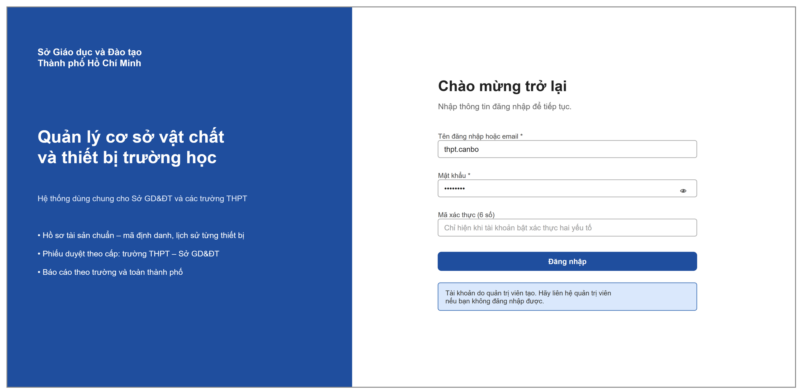
Figure 25: Sign In screen
This screen lets every user sign in (HT-01). The left column introduces the system; the right column is the form. The Verification code box appears only after the password is correct and the account has two-factor authentication turned on. There is no self-registration or forgotten-password function: the system administrator or the school leader creates accounts and resets passwords.
Field description:
Field | Description
Username or email | Text, required. Accepts the username or the email of the account.
Password | Text, required; has a button to show or hide the password.
Verification code (6 digits) | Accepts only 6 digits; required when shown.
Sign in | Sends the sign-in information; while waiting, the button is locked and shows "Signing in…". Errors follow MSG02 – MSG06.

1.2 User and Role Management

1.2.1 User Details
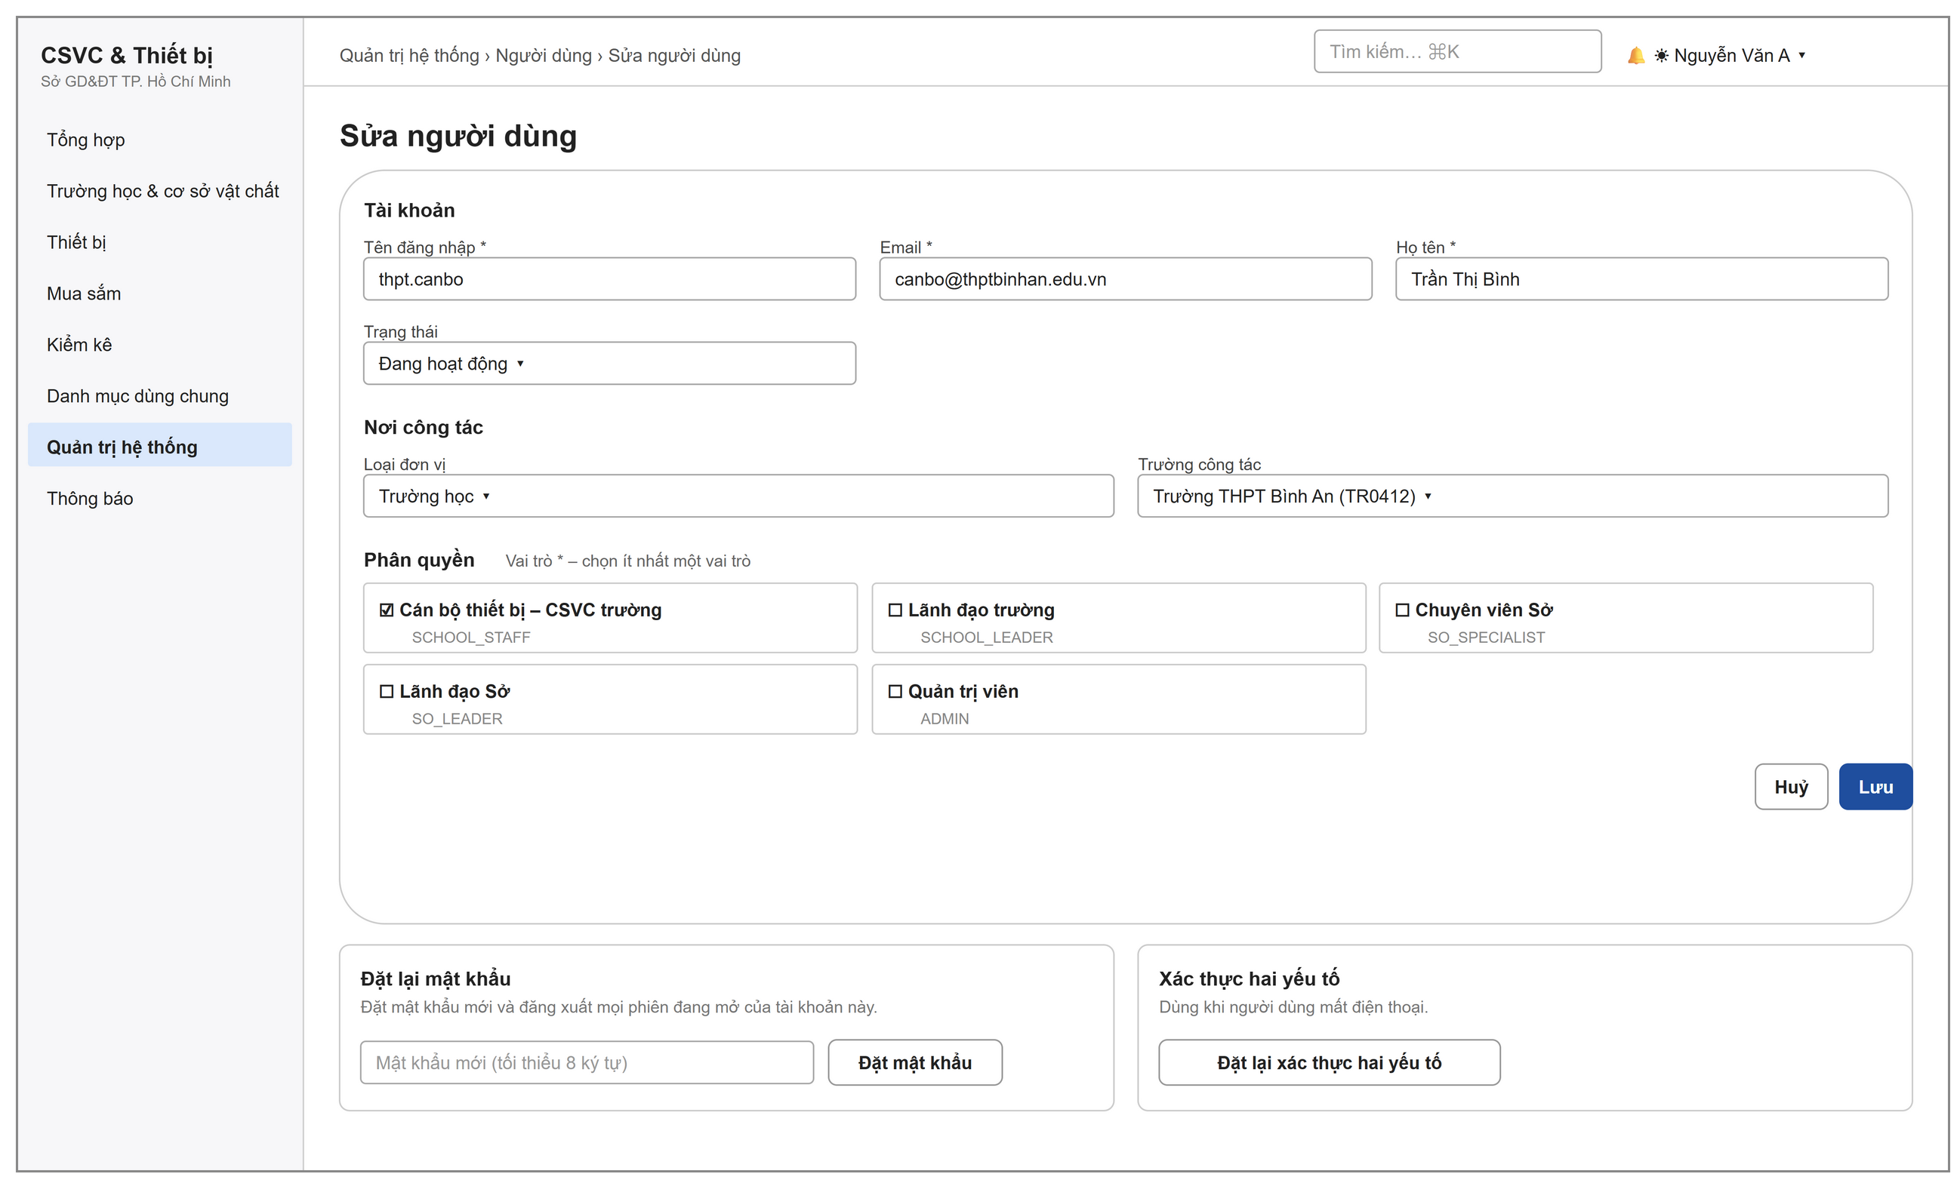
Figure 26: Add / Edit user screen
The system administrator enters the account, the workplace and the roles (HT-05). The workplace decides which school's data the account can see: select the Unit type, DOET or School; for a school, also select the School of work. The Edit screen has two more tabs, to reset the password and to reset two-factor authentication; both end all open sessions of the account. The Users screen lists the username, full name, school of work, status, roles and last sign-in.
Field description:
Field | Description
Username | Required, 3–100 characters, only letters, digits, dots, underscores and hyphens; unique (DR-01).
Email | Required, valid email format, unique.
Full name | Required, at most 255 characters.
Initial password | Only on the Add screen; required; follows the password policy (Section IV.2.3).
Status | Active (default) / Inactive / Locked.
Unit type / School of work | Select DOET or School; for a school, also select the school. A system administrator may leave this empty. An account that belongs to no unit sees no data rows.
Roles | Select at least one role.

1.2.2 Role Details
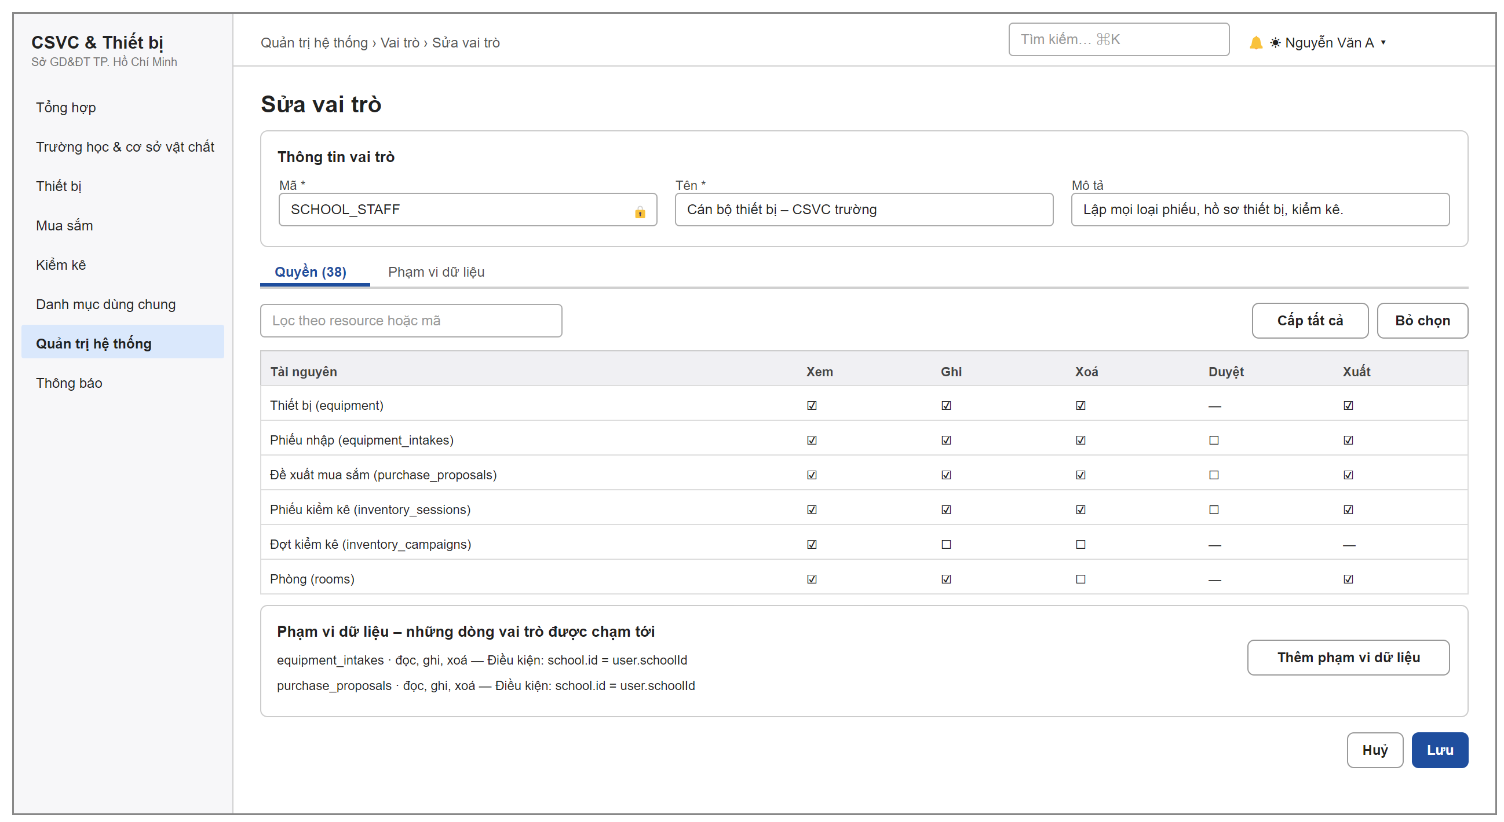
Figure 27: Edit role screen
The system administrator enters the role and grants permission codes and data scopes (HT-07, HT-08). The Permissions tab is a resource × action matrix. The Data scope tab lists the row filter conditions of the role; each scope is saved separately in a dialog.
Field description:
Field | Description
Code | Required; capital letters, digits and underscores, starting with a letter; locked for system roles.
Name | Required.
Permissions | Each cell is one permission code resource:action; has filter, grant all and clear selection; warns when write is granted without the view permission.
Data scope | Resource, action and row filter condition built with selection boxes (no free typing of expressions), turned on or off.

2. Organisation, Facilities and Catalogues

2.1 School Workspace
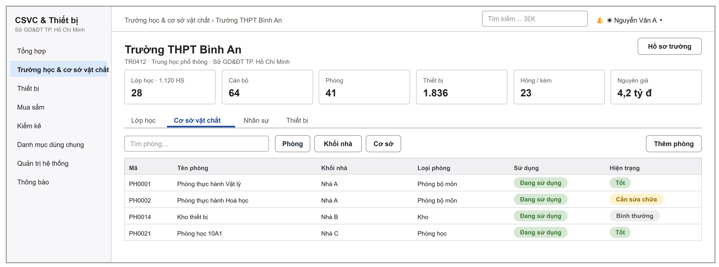
Figure 28: School overview screen – the workspace of one school
This screen brings together the data of one school (TC-03, CS-01 – CS-03, TC-02): summary figures and the tabs Classes, Facilities (rooms, buildings, campuses), Staff and Equipment. An account that sees many schools opens this screen from the DOET – school tree. Rooms, buildings, campuses and staff are added and edited in dialogs; if the code is left empty, the system gives one by the school's coding rule.
Field description:
Field | Description
Room code | If left empty, it is given automatically by the school's rule (default PH + 4 digits); if the user types a code already in use, the system rejects it and suggests a free code.
Room name | Required, at most 255 characters.
Building, floor | Select a building of the school, then select the floor.
Room type | Select from the room type catalogue; the Storage type is treated as storage when equipment is received.
Area, capacity | Non-negative number.
Condition / Usage status | Good, Normal, Needs repair, Run-down, Badly damaged / In use, Vacant, Under repair, Out of use.

2.2 Minimum Equipment List
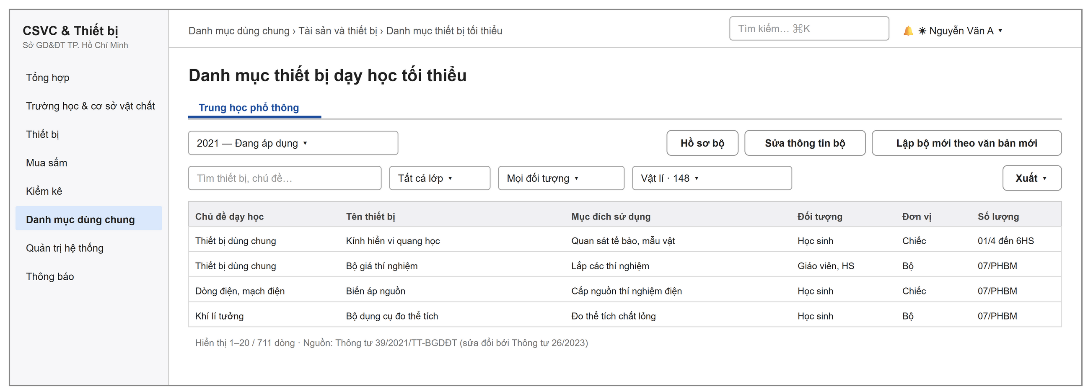
Figure 29: Minimum teaching-equipment list screen
The DOET officer manages the standard set for the upper-secondary level and its minimum quantity lines (DM-03). The set in force is view-only. To change it, the officer creates a new set based on the new legal document, edits the draft and then applies it. Other roles view it for reference.
Field description:
Field | Description
Version of the set | Select a set to view; the label shows Draft, In force or Expired.
Filter | Search by equipment name or topic; filter by grade, target user or subject.
Minimum quantity line | Topic, equipment name, purpose, description, target user, unit and quantity as in the appendix; optional equipment has its own label.
Export | Excel, or print and save as PDF.

3. Equipment Records

3.1 Equipment List
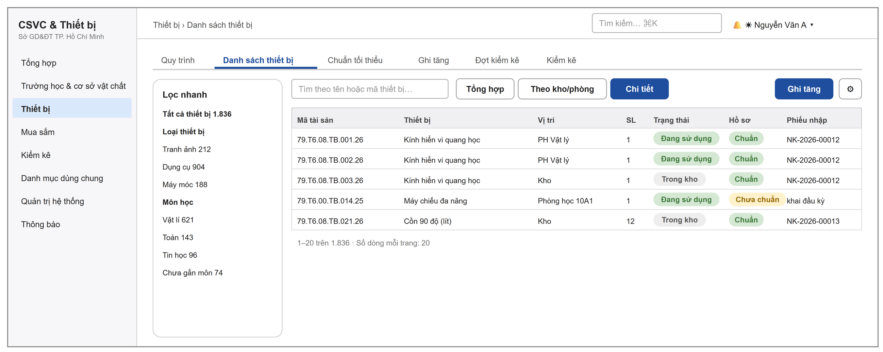
Figure 30: Equipment list screen (Detail mode)
The list of assets in the user's data scope (TS-01) with three view modes: Summary by equipment, By storage or room, and Detail of each asset. The left column gives a quick filter by equipment type or subject, or by unit for an account that sees many schools. The Register asset button opens the Create receipt form screen; the gear menu has Look up / scan code, Print QR labels and Enter opening balance. There is no button to add an asset directly.
Field description:
Field | Description
Asset code | Standard code TT.TR.MH.LT.ST.NC.
Location | The room where the equipment is kept, or Storage.
Status | In storage, In use, Reported lost…
Record | Standard: has the standard code, unit of measure, funding source, date received and original cost. Not standard: with the list of missing items.
Receipt form | The number of the form that created the asset, or "opening balance entry".

3.2 Equipment Record
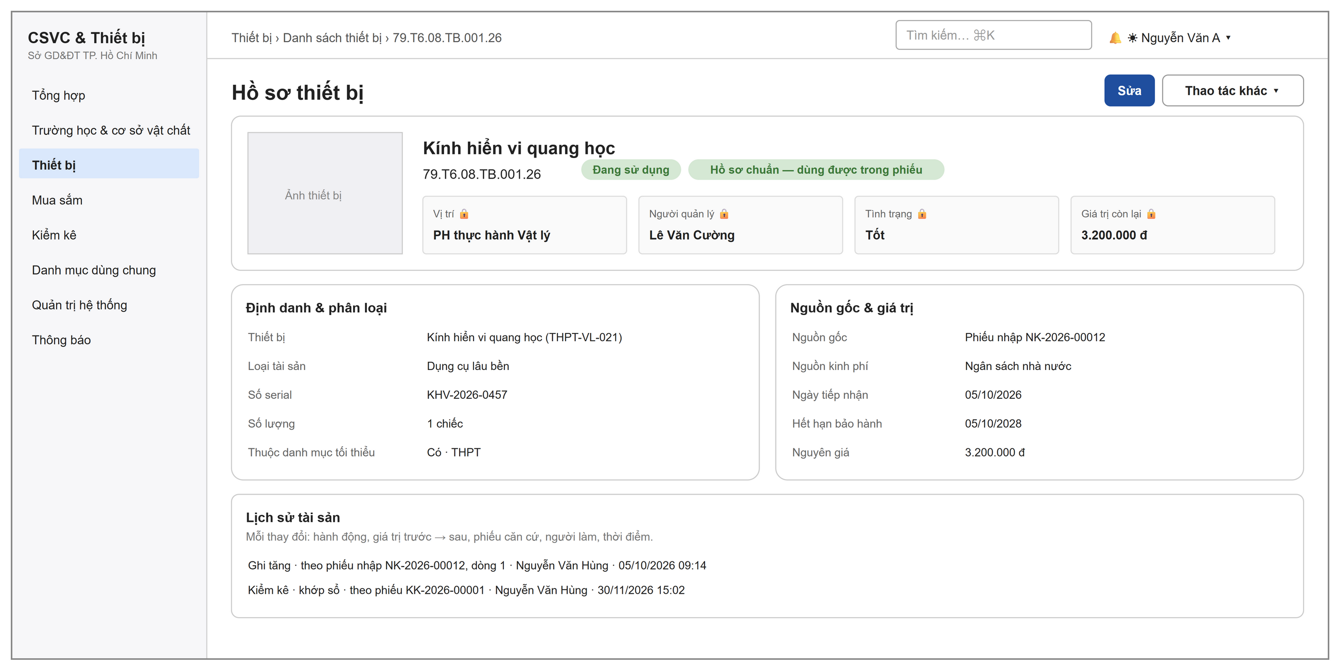
Figure 31: Equipment record screen
The record of one asset (TS-01, TS-05, TS-06): photo, code, status, the Usage box with a lock icon for information that changes only through forms (GBR-14), identification and classification, origin and value, minimum standard, attachments and history. Equipment with an old code has the Assign standard code button (TS-07).

3.3 QR Label Printing and Lookup
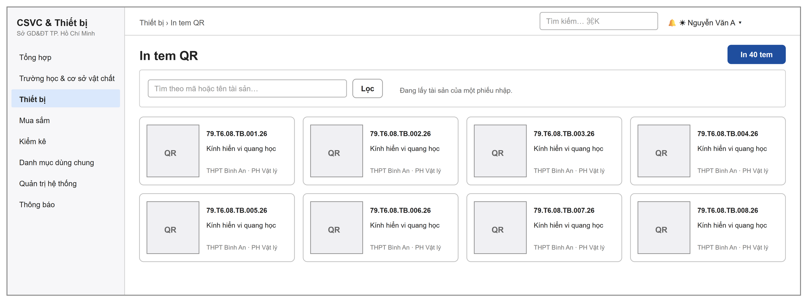
Figure 32: Print QR labels screen
The school equipment officer prints labels for the assets of one receipt form, of one room or from a search, at most 300 labels each time (TS-04); when printed, each row has 3 labels. The QR code holds a link to the Asset lookup screen with the code. Scanning it with a phone camera opens the equipment record directly if the person scanning has signed in and has the view permission (TS-02, TS-03). The Asset lookup screen has one code box where the cursor is always ready, so it can be used with a handheld scanner.

4. Procurement Needs and Planning

4.1 Procurement Proposal List
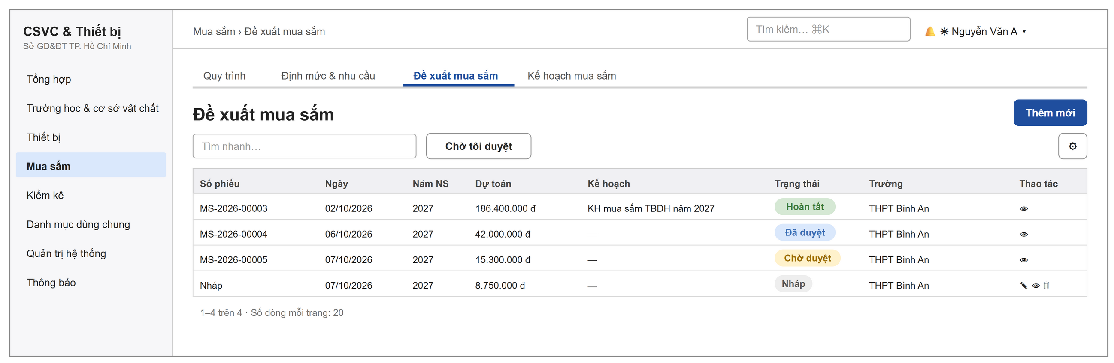
Figure 33: Procurement proposals list screen
The list of proposals in the data scope (NC-02 – NC-05). A proposal not yet submitted shows "Draft" in the form number column. The Waiting for my approval button appears only for accounts with the approval permission.
Field description:
Field | Description
Form number, Date, Budget year | Sortable.
Estimate | Total of unit price × quantity of the lines.
Plan | The procurement plan that contains the proposal.
Status | Draft, Pending approval, Approved, Completed, Rejected, Cancelled.

4.2 Procurement Proposal Form
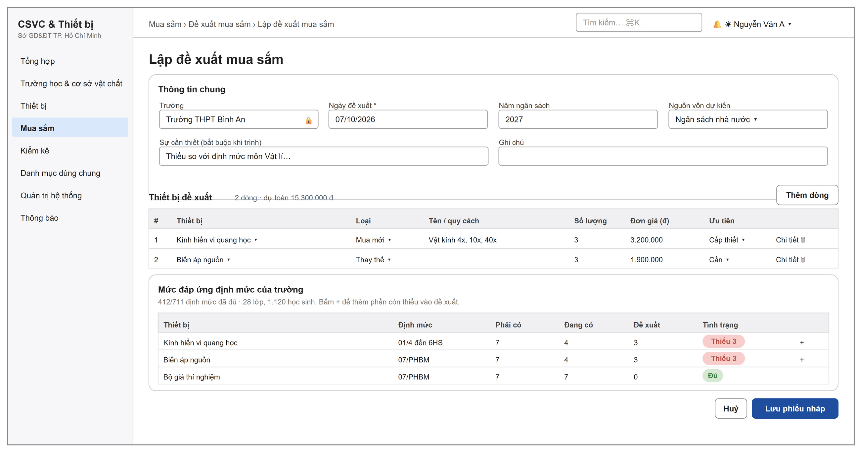
Figure 34: Create procurement proposal screen
The school equipment officer creates and edits draft proposals (NC-02). The coverage table below is already filtered to the equipment that is still short. The + button adds a line with a suggested quantity equal to the shortage minus the quantity already proposed. Submitting for approval is done on the Proposal details screen.
Field description:
Field | Description
Field | Filled in automatically and locked for an account that belongs to one school.
Proposal date | Required, default today.
Budget year | 2000–2100, default next year.
Expected funding source | One of the six funding sources; default State budget.
Justification | Required when submitting.
Line: Equipment | Select from the equipment catalogue; one line for each equipment.
Line: Type | New purchase / Replacement.
Line: Quantity, Unit price | Quantity greater than 0; unit price not negative.
Line: Priority | Urgent / Needed (default) / Nice to have.

4.3 Procurement Proposal Details
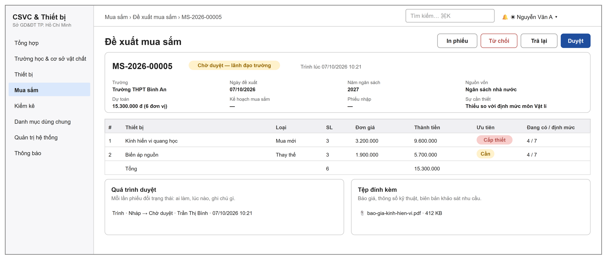
Figure 35: Procurement proposal details screen
This screen is for viewing and handling a proposal (NC-03, NC-04, NC-05, NC-09). The buttons at the top of the page appear according to the state and the permissions: Submit for approval, Approve, Return, Reject, Cancel form, Edit, Delete, Print form and Goods arrived – create receipt form. A returned proposal shows the approver's message at the top of the page. The printed copy is the equipment procurement proposal letter, with places for the signatures of the creator and the head of the unit.

4.4 Approval Dialogs
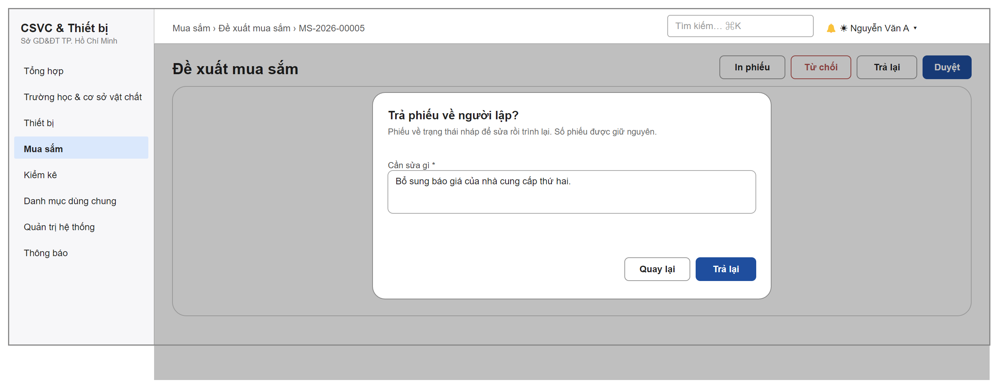
Figure 36: Return form dialog
All forms share one set of confirmation dialogs for Submit for approval, Approve, Return, Reject and Cancel form; each dialog states clearly the result of the action. The note box is required for return and reject (MSG18, MSG19), and optional for approve and cancel.

4.5 Procurement Plan Details
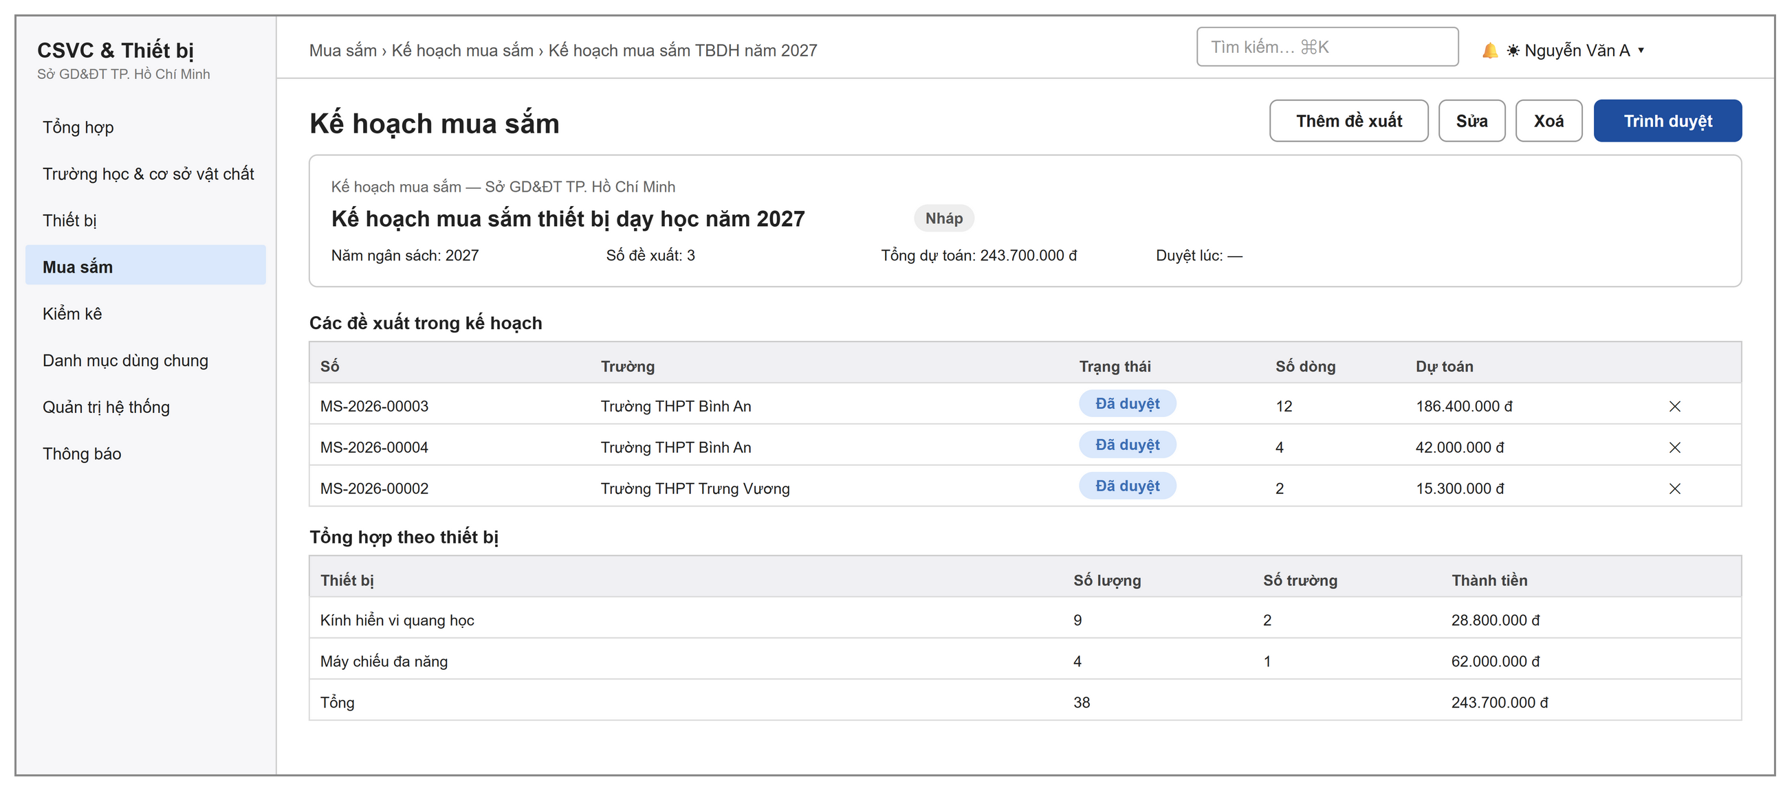
Figure 37: Procurement plan details screen
The DOET officer collects approved proposals into a plan and submits it; the DOET leader approves or returns it (NC-06, NC-07). The Add proposal button opens a dialog that lists the approved proposals not yet in a plan. While the plan is still a draft, each proposal has a button to remove it from the plan. The Create plan screen has Plan name (required), Budget year (required, default next year) and Note.

5. Equipment Receipt and Inventory

5.1 Receipt Form List
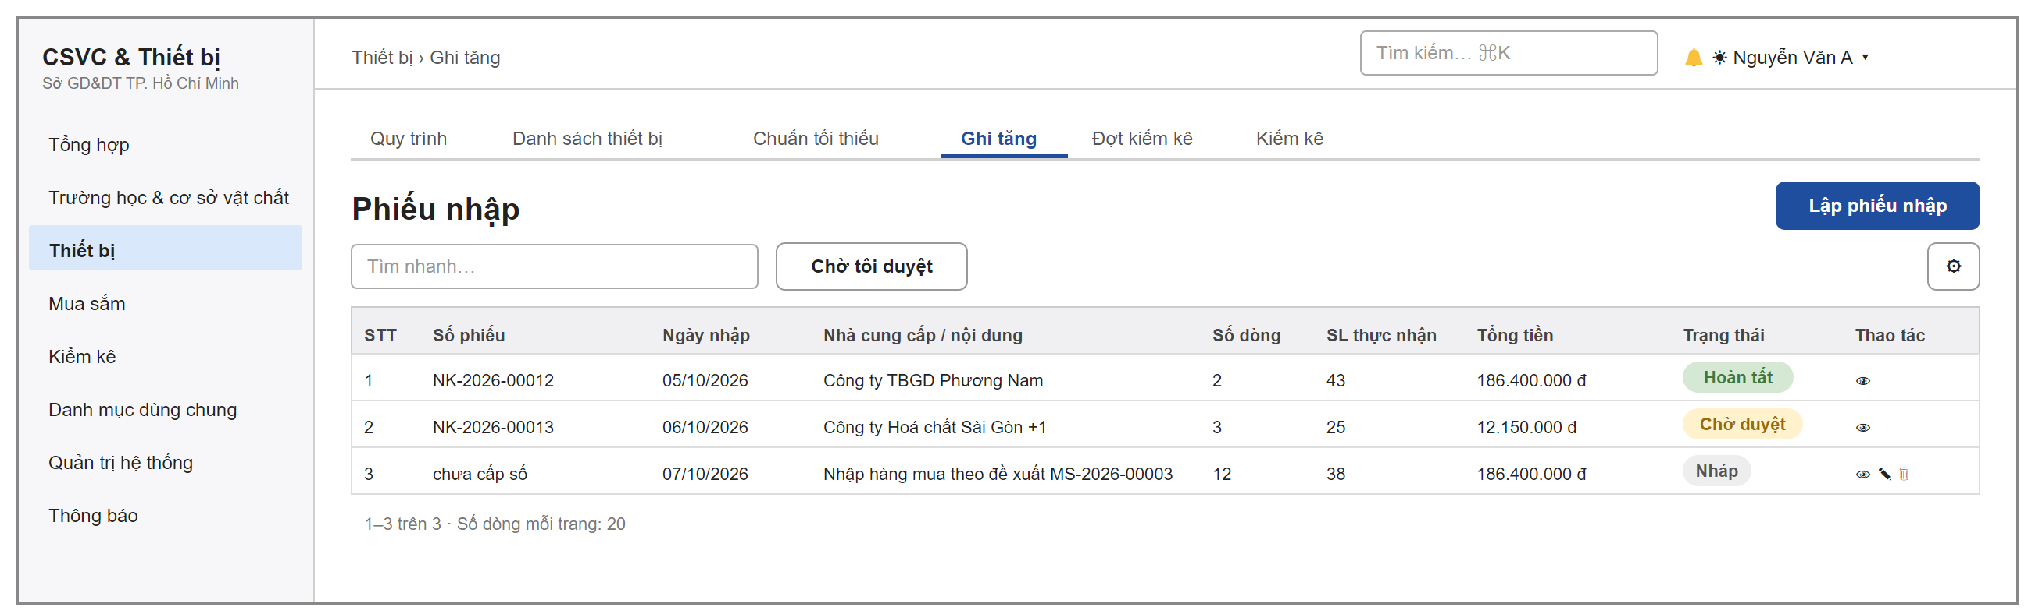
Figure 38: Receipt forms list screen
The list of receipt forms in the data scope (PN-01, PN-05), with the Waiting for my approval filter.

5.2 Receipt Form
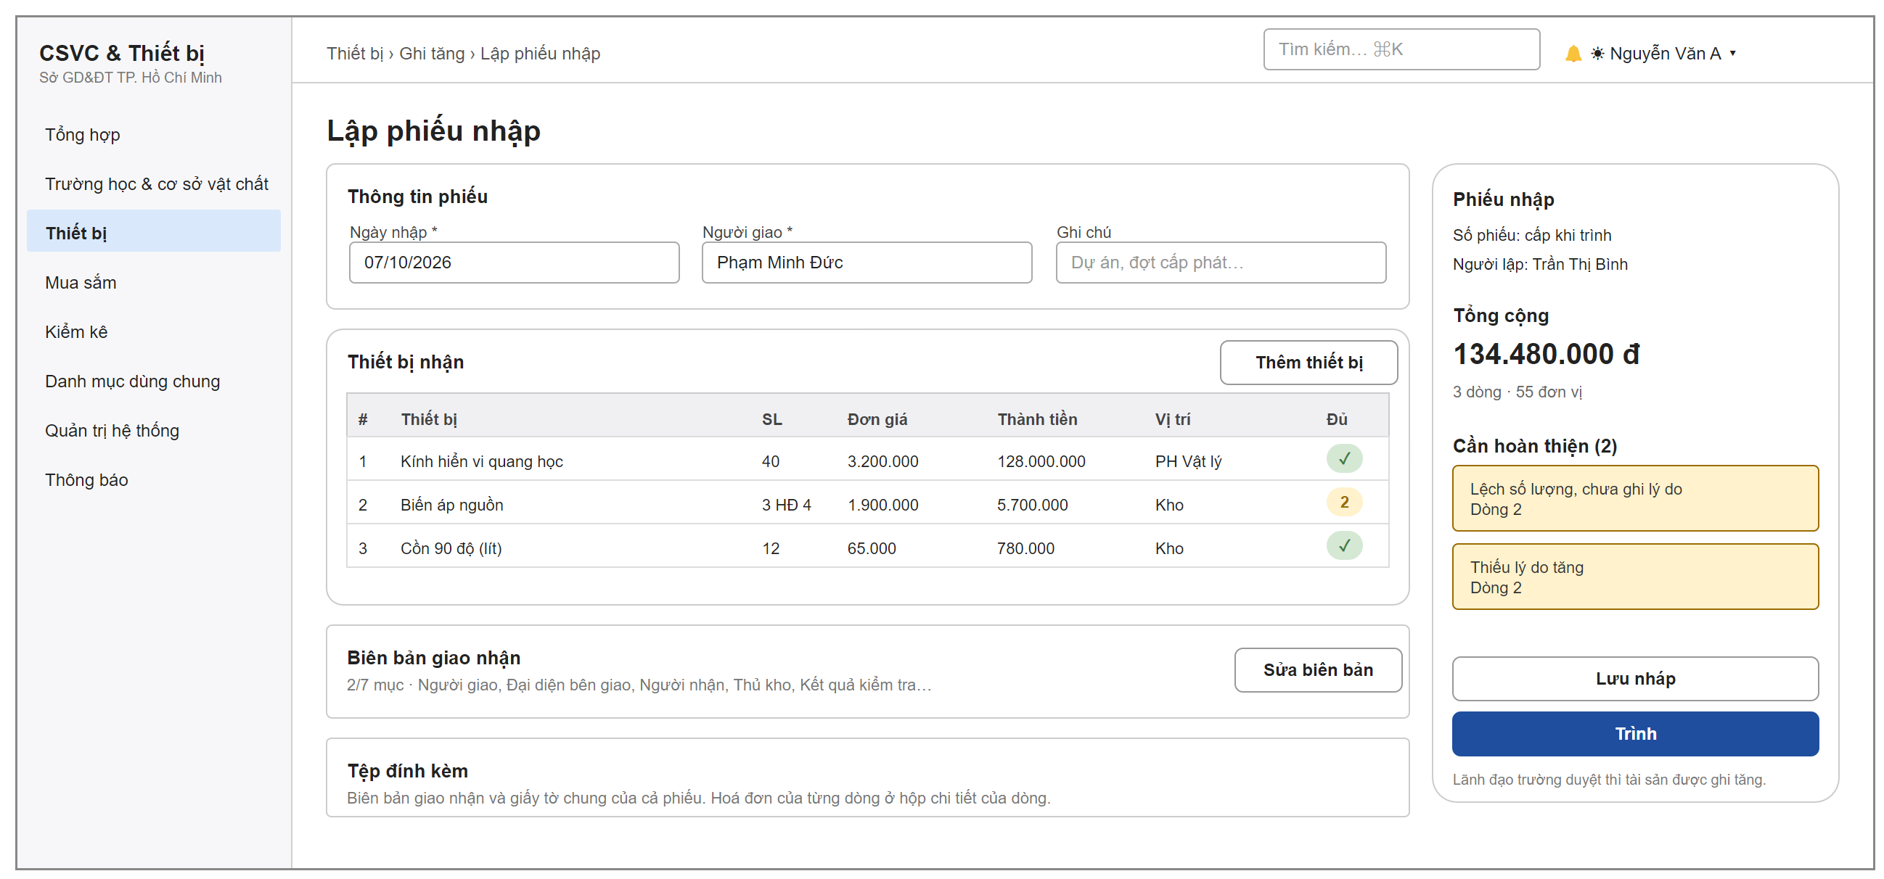
Figure 39: Create receipt form screen
The school equipment officer creates and edits draft receipt forms (PN-01, PN-02, PN-03, PN-04). The right column always shows the form number, the total amount and the list of items to complete; clicking an item jumps to the place that needs fixing. The Submit button is locked while items are missing; Submit means save, then submit. Attachments can be added after the draft is saved for the first time.
Field description:
Field | Description
Receipt date | Required, default today.
Delivered by | Required when submitting, at most 255 characters.
Note | At most 500 characters.
Received equipment table | Each line: equipment, quantity actually received (with the invoice quantity when it is different), unit price, amount, location (Storage when empty). The Complete column shows whether the line has all its data or how many items are still missing.
Delivery record | Delivered by, representative of the delivering party, received by, position, storekeeper, check result (Passed / Partly passed / Failed), record number.

5.3 Receipt Line Dialog
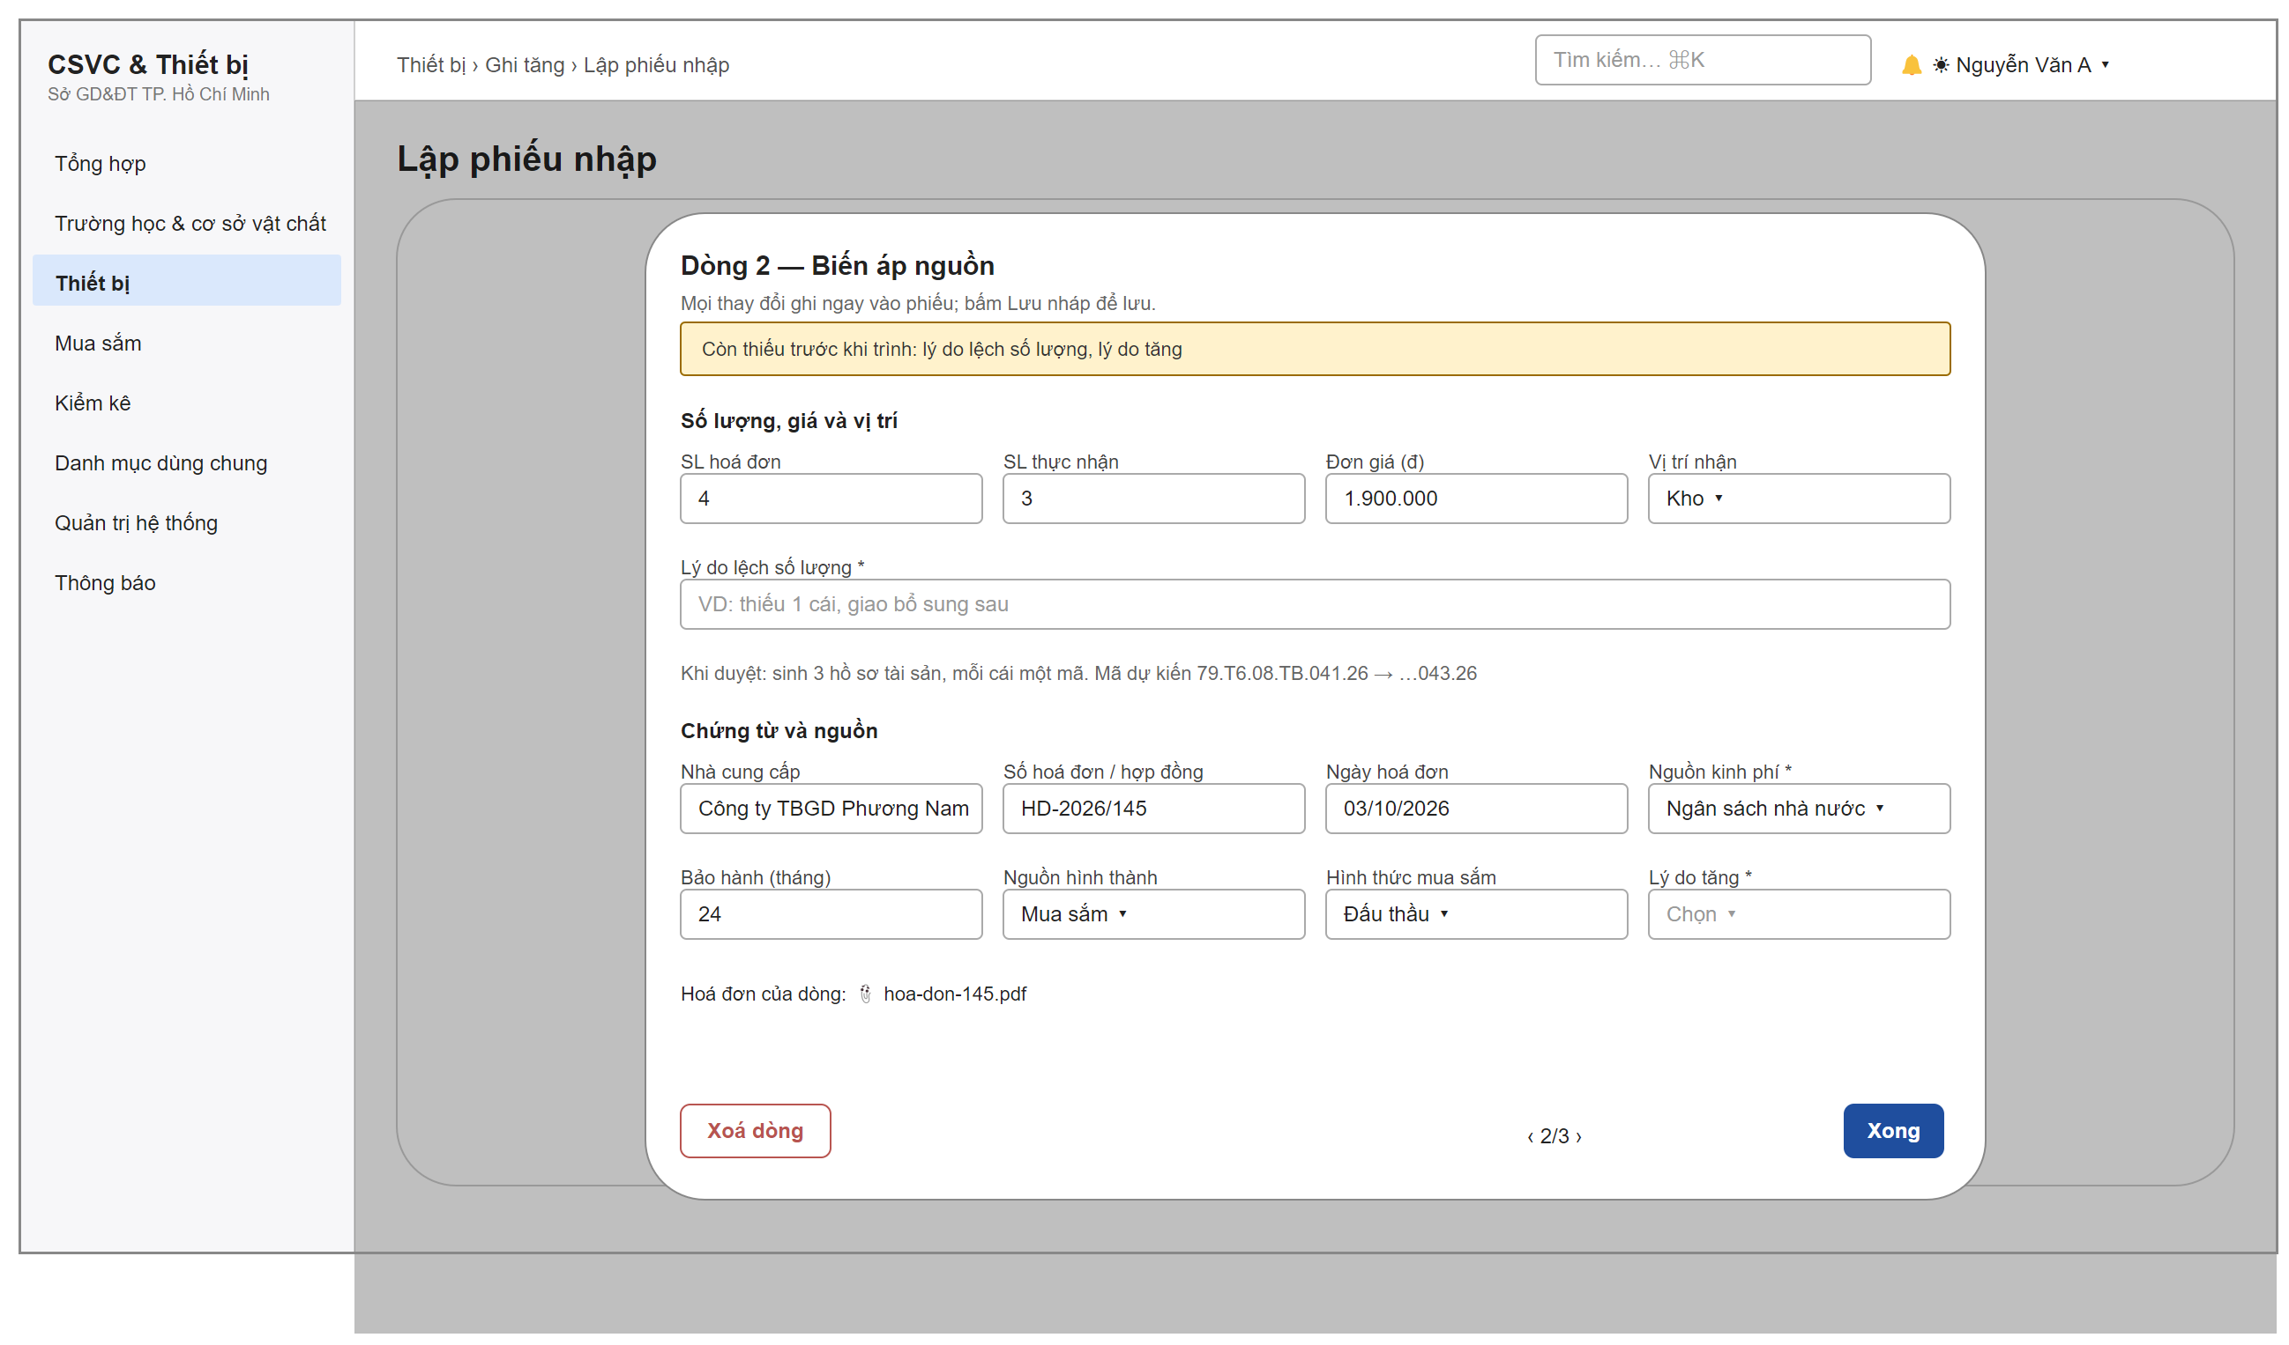
Figure 40: Detail dialog of one receipt form line
A dialog to edit one line of the receipt form. It has buttons to go to the previous line and the next line, and a button to copy the document data to all lines. The note under the quantity part shows how many records the system will create on approval and the expected codes.
Field description:
Field | Description
Invoice qty | Whole number, at least 1.
Received qty | Whole number, not negative; if it is 0, the line does not register any asset.
Unit price (VND) | Not negative; required for equipment managed per item – it is the original cost of each asset.
Receiving location | A room of the school; if left empty, the equipment goes into storage.
Reason for quantity difference | Shown and required only when the two quantities are different; at most 255 characters.
Supplier, invoice number and invoice date | Not required; invoice number at most 100 characters.
Funding source | Required for equipment managed per item (of the line or of the form header).
Warranty (months) | 0–600; the warranty end date of the asset is counted from the receipt date.
Reason for increase | Required when submitting; chosen from the catalogue of change reasons.

5.4 Receipt Form Details
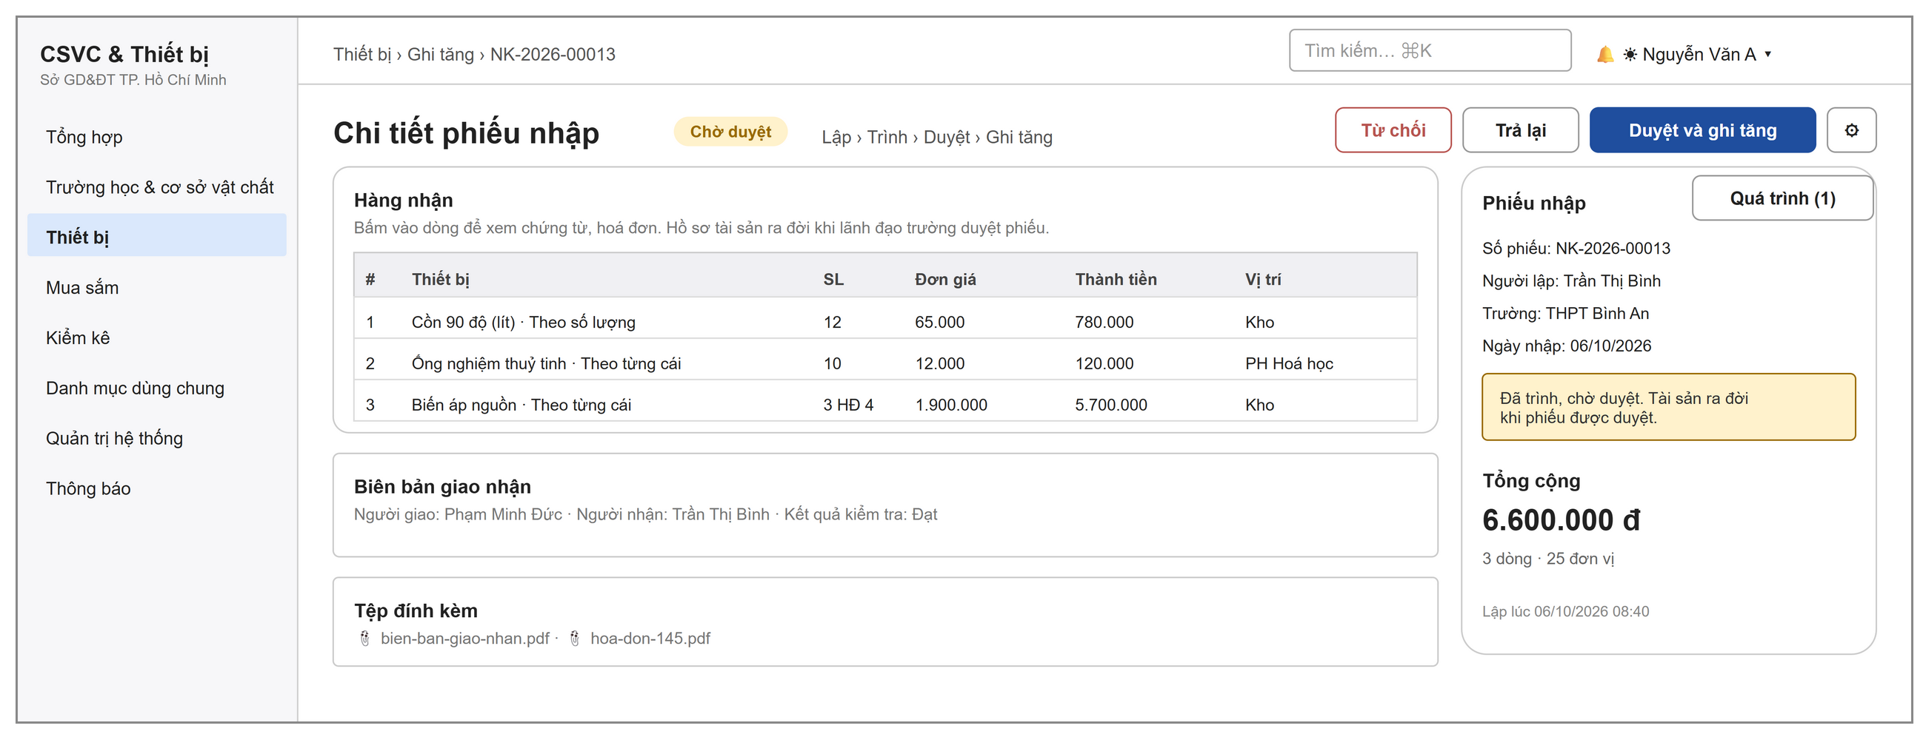
Figure 41: Receipt Form Details screen
The screen to view and approve a receipt form (PN-04, PN-05). The step bar Create › Submit › Approve › Register asset shows where the form is. After the form is completed, the gear menu has View registered assets and Print QR labels. The last column of the received goods table shows how many equipment records each line has created.

5.5 Inventory Round Progress
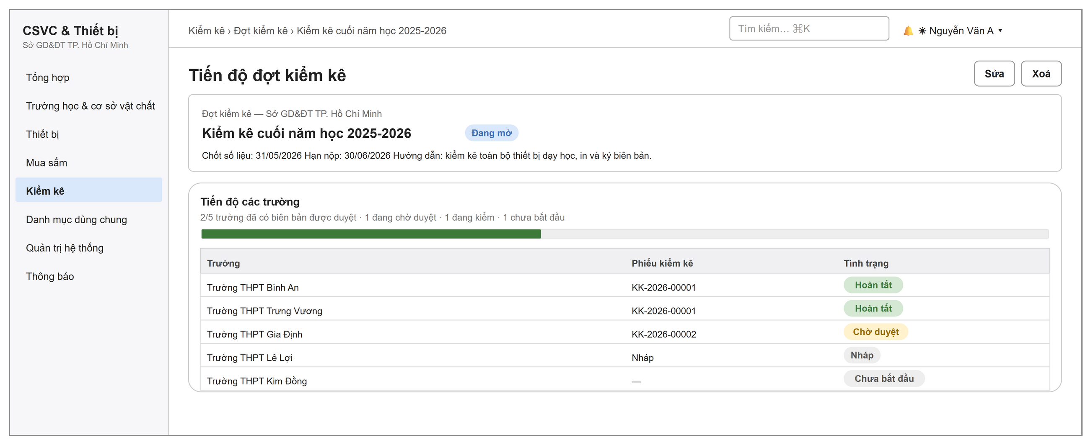
Figure 42: Inventory Round Progress screen
DOET officers and DOET leaders follow the schools in the round (KK-01, KK-02): the number of schools that are completed, pending approval, counting or not started, and the latest inventory form of each school. The Start Round screen has Round name, Data cut-off date, Submission deadline (all required) and Instructions for schools.

5.6 Inventory Report
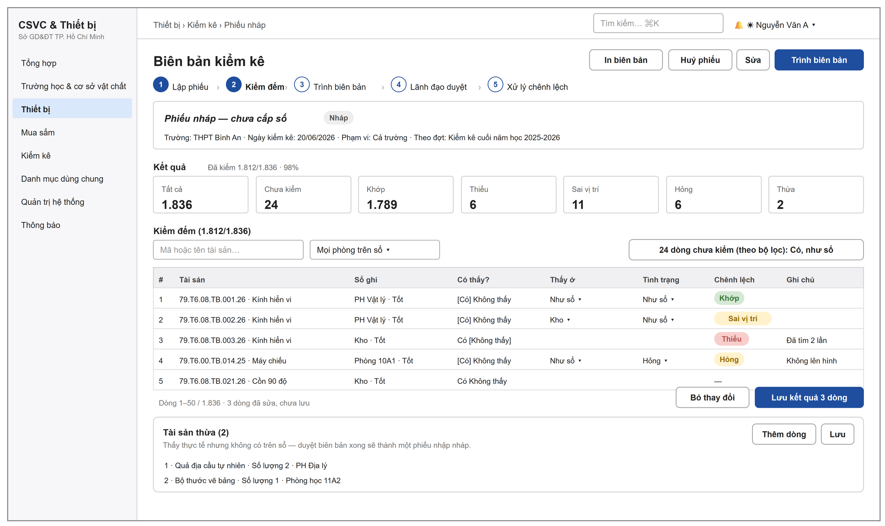
Figure 43: Inventory Report screen
One screen for the whole inventory work of the school (KK-03 – KK-07): a bar of 5 steps, a Results card with 7 count boxes that can be clicked to filter, the count table, surplus assets and the process buttons. Lines that are edited but not saved have a light background; the Save results button saves them as a batch. The printed version is the Asset Inventory Report with places to sign for the person who did the inventory, the accountant and the head of the unit.
Field description:
Field | Description
Found? | Yes / Not found; if Not found, the found room and found condition are cleared.
Found at | As in the register or a room of the school; only when Yes.
Condition | As in the register or Good, Fair, Average, Poor, Damaged, Not in use; only when Yes.
Discrepancy | Calculated by the system: Match, Missing, Wrong location, Damaged.
Surplus assets | Equipment in the catalogue (required), actual name, quantity at least 1, note.

6. Dashboard and Reports

6.1 Dashboard
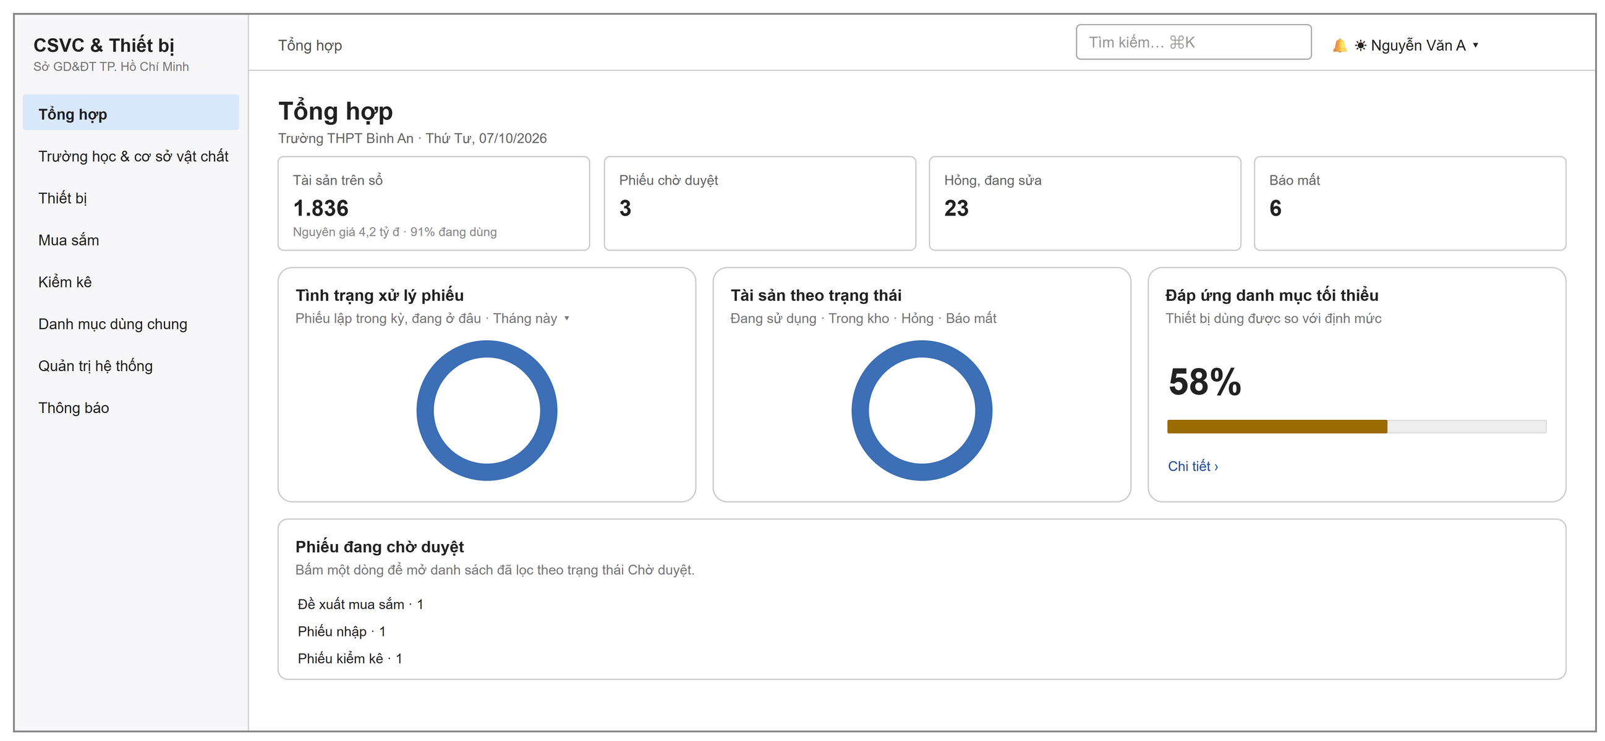
Figure 44: School Dashboard screen
The first screen after sign-in (BC-01). A school account sees the data of its school. A DOET account sees the City-wide Overview with the schools that need attention and shortcuts to the DOET's tasks. Click a form type in the Forms pending approval card to open the filtered list.

6.2 Reports
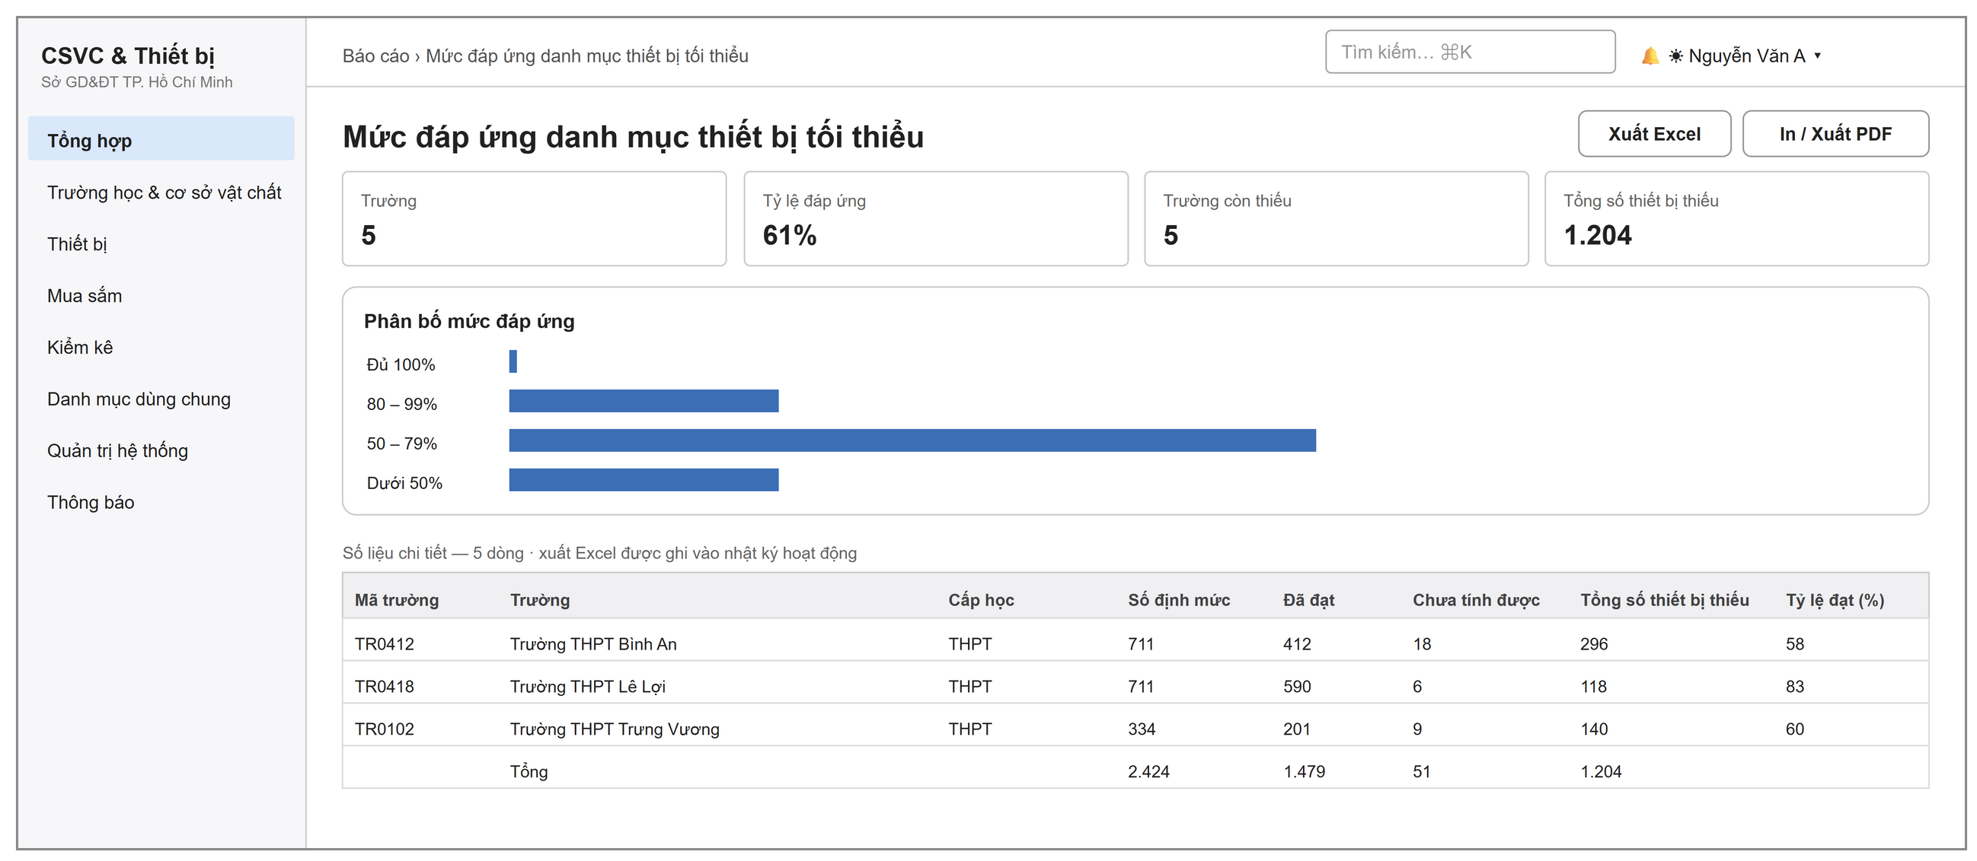
Figure 45: Reports screen (coverage of the minimum equipment list)
One screen for the reports in scope (BC-02): asset summary by school, asset summary by equipment, coverage of the minimum list, form processing status, summary of procurement needs. Each report has indicator boxes, a chart and a data table with a total row; it can be exported to Excel and printed.

7. Common Screen Behaviours
– Lists: the quick search box filters after the user stops typing; click a column header to sort; paging from 10 to 50 rows (default 20 for form lists); double-click a row to open its details; the gear menu lets the user choose the columns to show and export data.
– Buttons by permission and state: the Edit, Delete, Submit, Approve, Return, Reject and Cancel buttons are shown only when the account is allowed and the form is in a state that allows that action. Hiding a button is not a security measure: the server checks every action again.
– Waiting for my approval: the lists of procurement proposals, receipt forms and inventory forms have a button to filter the forms that are waiting at the level of the account; the dashboard shows the number of forms pending approval by type.
– Leaving a screen without saving: when a create or edit screen has unsaved changes, the system asks "Discard unsaved changes?" before leaving.
– Attachments: one file block is shared by all records; add several files at once, preview images and PDF files, set the main image; the limit of 10 MB per file and the file types are in GBR-13.
– Notifications: the bell at the top of the page shows the number of unread notifications and the 20 latest notifications; new notifications and permission changes are pushed at once while the application is open.
– Interface: Vietnamese; light and dark modes; usable on computer screens and phone browsers; the sidebar can be collapsed.

IV. Non-Functional Requirements

1. External Interfaces
– User interface: a web application that runs on the current versions of the Chrome, Edge and Firefox browsers; no software is installed on the user's computer (HSMT 3.3). The interface is in Vietnamese and supports Unicode.
– Devices: an office printer to print QR labels (3 labels per row on A4 paper) and records; a phone camera to scan labels; a handheld code scanner that works like a keyboard can be used on the Asset Lookup screen.
– Software: PostgreSQL database; S3-compatible file storage (MinIO); data exchange through a REST API in JSON format (HSMT 3.8).
– File export and import: export lists to CSV, export reports and the coverage of the minimum quantity to Excel (.xlsx); print or save as PDF with the print function of the browser (HSMT 3.5.8).

2. Quality Attributes

2.1 Usability
– A school equipment officer who is used to computers can create and submit a receipt form of 10 lines in no more than 10 minutes after one training session.
– Each form clearly shows its state, the approval step it is waiting for and the approval history; a returned form shows the approver's message at the top of the page.
– The screens to create a receipt form and an inventory report list the missing items before submission and point to the exact line to fix.
– Business error messages say clearly what is wrong and what to do (Section V.2).

2.2 Performance
The targets come from HSMT 3.4. In this capstone project they are tested on the team's test server with sample data of 1,000 schools.
Requirement | Target | Condition
Open lists and forms | 95% of actions respond within 2 seconds | Sample data of 1,000 schools
Complex summary reports | Respond within 10 seconds | Whole city
Approve a receipt form | A form of 100 units is registered within 5 seconds | One transaction
Create an inventory form | A register of 2,000 assets is captured within 5 seconds | Whole school
Lists | At most 1,000 rows per load | Paging on the server

2.3 Security
Requirement | Description
Sign-in required | Every screen and every API, except the Sign-in screen, requires a signed-in user.
Password protection | Passwords are not stored in a readable form. A password must have at least 8 characters, with uppercase letters, lowercase letters, digits and special characters, and must not contain the username.
Two-factor authentication | Users can turn on a 6-digit TOTP code. After 5 wrong codes in a row, code entry is locked for 5 minutes. The administrator can reset it when the user loses the phone.
Sessions | A short-lived access token (15 minutes) is renewed automatically; a session lasts at most 7 days; when the password is changed or the account is locked, all open sessions are ended.
Permission checks on the server | For every action, the server checks the function permission code, the data scope by row and, for approval, the correct approval level. A record outside the scope is returned as if it does not exist.
Attachments | A file can be opened only through the system, after the permission to view the parent record is checked; there is no public link.
Activity log | Every write action and every data export is logged: who, when, which data, the result and the IP address.
Protection against account probing | A failed sign-in always returns the same message and does not show whether the account exists.

V. Requirement Appendix

1. Business Rules
Code | Rule | Applies to | Reason | Enforced by
GBR-01 | A failed sign-in does not show whether the username or the password is wrong. | Sign in | Do not reveal which accounts exist. | System, at every sign-in
GBR-02 | An account that is not in the Active state cannot sign in, even with the correct password. | Sign in | People who have left or moved to another job lose access at once. | System, at every sign-in and every request
GBR-03 | A form can be edited only in the Draft state; a submitted form must be returned before it can be edited. | Proposals, receipt forms, inventory forms, plans | The content that the approver sees is not changed behind their back. | System, at every edit
GBR-04 | A return must say what to fix; a rejection must give the reason. | Every approval step | The creator knows what to do; there is a basis for later checks. | System, on return and rejection
GBR-05 | The form number is given at the first submission. It is numbered separately by school, form type and year, and it stays the same when the form is returned. | Proposals, receipt forms, inventory forms | The number series has no gaps caused by abandoned draft forms. | System, on submission
GBR-06 | A form that has been submitted at least once cannot be deleted, only cancelled. | Proposals, receipt forms, inventory forms | Keep the trace of forms that already have a number and an approval log. | System, on deletion
GBR-07 | Only an account at the level that the form is waiting for can approve it; under the preset configuration, the creator has no permission to approve a form that he or she created. | Every approval step | Separate the creator and the approver. | System, on approval, return and rejection
GBR-08 | Proposal: one line per equipment; quantity greater than 0; priority 1–3; a submitted proposal must have lines and a statement of necessity. | Procurement proposal | The proposal has enough basis for the DOET to review. | System, on save and submission
GBR-09 | A receipt form must have enough data to create standard equipment records: funding source, unit price, unit of measure, delivered by, reason for increase, reason for quantity difference. | Receipt form | The created assets can be used at once in all later operations. | System, on submission and approval
GBR-10 | The system gives the asset code in the format TT.TR.MH.LT.ST.NC; no temporary codes are given and no codes are typed by hand. | Equipment | Codes are consistent across the whole sector and are not duplicated. | System, on asset registration and when giving the standard code
GBR-11 | Approval of a receipt form, approval of a plan and approval of an inventory report are each done completely in one transaction. | The three focus flows | No form or asset is left half-written. | System, on approval
GBR-12 | The inventory count sheet is fixed from the asset register at the time the form is created; every line must be counted before the form can be submitted. | Inventory form | The inventory is compared with one fixed set of data. | System, on form creation and submission
GBR-13 | An attachment is at most 10 MB and is one of these types: PDF, image, office document, CSV, ZIP; its permissions follow the parent record. | Attachments | Control file size and file access. | System, on upload and open
GBR-14 | The code, room, quantity, status and condition of equipment change only through approved forms. | Equipment | Every change has an approver and a history. | System, when a record is edited

2. System Messages
# | Code | Type | Context | Content
1 | MSG01 | Below the input field | A required field is left empty | Field * is required.
2 | MSG02 | Pop-up message | Wrong username or password, or the account is not active | The username or password is incorrect.
3 | MSG03 | Below the input field | Wrong two-factor authentication code | The authentication code is incorrect.
4 | MSG04 | Pop-up message | Wrong authentication code 5 times in a row | Too many wrong codes — try again in a few minutes.
5 | MSG05 | Pop-up message | Sign-in works but the permissions cannot be loaded | You are signed in, but your permissions could not be loaded. Please try again.
6 | MSG06 | Pop-up message | Connection to the server is lost | Cannot connect to the server. Check your connection and try again.
7 | MSG07 | Screen | Opening a link without permission | You do not have permission to access this page.
8 | MSG08 | Pop-up message | Saved successfully | Saved.
9 | MSG09 | Dialog | Leaving a screen with unsaved changes | Discard unsaved changes?
10 | MSG10 | Pop-up message | Form submitted successfully | Form submitted.
11 | MSG11 | Pop-up message | One approval step done successfully | Form approved.
12 | MSG12 | Pop-up message | Approve, return or reject at the wrong level | The form is waiting for approval by {level} — your account does not belong to this level.
13 | MSG13 | Pop-up message | Procurement plan approved successfully | Plan approved.
14 | MSG14 | Pop-up message | Creating a receipt form from a proposal | Draft receipt form created — count the quantity actually received, then submit.
15 | MSG15 | Pop-up message | Receipt form approved successfully | Approved, the assets have been registered.
16 | MSG16 | Pop-up message | Saving count results | Results of {n} lines saved.
17 | MSG17 | Pop-up message | Inventory report approved successfully | Report approved, the forms to handle discrepancies have been created.
18 | MSG18 | Pop-up message | Return without a message | Say clearly what to fix before returning.
19 | MSG19 | Pop-up message | Rejection without a reason | Enter the reason for rejection.
20 | MSG20 | Pop-up message | A proposal has the same equipment on two lines | Equipment type {name} appears twice — merge into one line.
21 | MSG21 | Pop-up message | Invalid proposal line | Line {n}: no equipment type selected / the quantity must be greater than 0 / the priority must be from 1 to 3.
22 | MSG22 | Pop-up message | Submitting a proposal with no lines | The proposal has no lines.
23 | MSG23 | Pop-up message | Submitting a proposal without the statement of necessity | State the necessity of the proposal before submitting.
24 | MSG24 | Pop-up message | Creating a plan with an account that does not belong to the DOET | Only DOET accounts can create a procurement plan.
25 | MSG25 | Below the input field | Plan without a name or year | Enter the plan name and the budget year.
26 | MSG26 | Pop-up message | Selecting an invalid proposal for a plan | Proposal {number} is not approved yet or is already in another plan.
27 | MSG27 | Pop-up message | Submitting an empty plan | The plan has no proposals.
28 | MSG28 | Pop-up message | Returning a plan without a reason | Enter the reason for the return so that the officer knows what to fix.
29 | MSG29 | Pop-up message | Approving a plan with an account that does not belong to the DOET | Only a DOET leader can approve this plan.
30 | MSG30 | Pop-up message | Creating a receipt form from a proposal that is not completed | A receipt form can be created only for a proposal that is in an approved plan.
31 | MSG31 | Pop-up message | The proposal already has a receipt form | This proposal already has a receipt form.
32 | MSG32 | In the dialog | Equipment outside the catalogue with a duplicate name | The DOET catalogue already has the equipment "{name}" (code {code}) — select that equipment.
33 | MSG33 | Pop-up message | Quantity difference without a reason | Line {n} ({name}): the quantity actually received is different from the quantity on the document; the reason for the discrepancy is required.
34 | MSG34 | Pop-up message | Receiving room belongs to another school | Line {n} ({name}): the receiving room does not belong to the school of the form.
35 | MSG35 | Pop-up message | Submitting an empty receipt form | The form has no lines to register.
36 | MSG36 | Pop-up message | Required fields missing on submission | Still missing: {field list}.
37 | MSG37 | Pop-up message | Data to create equipment records is missing | Line {n} ({name}): select a funding source / enter the unit price / the equipment type has no unit of measure.
38 | MSG38 | Pop-up message | The asset code cannot be created yet | Line {n} ({name}): the asset code cannot be created yet — the school has no EMIS code, or the subject of the equipment type has no teaching code.
39 | MSG39 | Pop-up message | The code series does not have enough sequence numbers | Line {n} ({name}): {x} asset codes are needed but the code series has only {y} left. Move part of the quantity to another form.
40 | MSG40 | Below the input field | Inventory round with missing information | Enter the round name, the data cut-off date and the submission deadline.
41 | MSG41 | Below the input field | Submission deadline before the cut-off date | The submission deadline must be after the data cut-off date.
42 | MSG42 | Pop-up message | Duplicate of an open round | The DOET already has an open inventory round with the data cut-off date {date} — open that round instead of creating a new one.
43 | MSG43 | Pop-up message | Starting a round with an account that does not belong to the DOET | Only DOET accounts can start an inventory round.
44 | MSG44 | Pop-up message | Deleting a round in which a school has already created a form | A school has already created an inventory form for this round — close the round instead of deleting it.
45 | MSG45 | Below the input field | Inventory form without a name or date | Enter the inventory round name / Select the inventory date.
46 | MSG46 | Pop-up message | Room of another school during inventory | The room does not belong to the school of the form.
47 | MSG47 | Pop-up message | Submitting the report while some lines are not counted | {n} assets are not counted yet — enter "yes" or "not found" for every line before submitting the report.
48 | MSG48 | Pop-up message | File over the limit or of the wrong type | A file is at most 10 MB / Only PDF, image, office document, CSV or ZIP files are accepted.

3. Other Requirements
– Initial data: the minimum teaching-equipment list for the upper-secondary level, under the consolidated text of Circular 39/2021/TT-BGDĐT (including the amendments of Circular 26/2023); the list of wards and communes under Resolution 1685/NQ-UBTVQH15; the public list of upper-secondary schools.
– Data storage: the official data is stored in Vietnam (HSMT 3.9); in this capstone project, the system runs on the team's development and test server.
– Open issues: the case where goods for one proposal arrive in several deliveries; the templates of the inventory report and of the procurement submission letter under the DOET's rules. The system follows the description in Section I.2; any change is handled as a change request.

